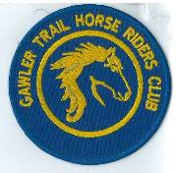**October 2018 Newsletter**

***Club Postal Address***

**P.O. Box 55**

**Gawler SA 5118**

Image result for world wide web logo athra.com.au  Email: [Gawler.THRC@gmail.com](mailto:Gawler.THRC@gmail.com)   
President - Julie Jackson 0419850793 Vice President -Tamara Godfrey 0417869695 Treasurer - Sandra East 0400884402 Secretary - Kath McCullagh 08 82807046

**AGM**

**& GENERAL MEETING** (1st Thursday of the month) **8pm**  **Wednesday 3 October 2018**

**General Meeting All welcome**

**Southern Hotel** (next to Cafe Nova)

Come early for tea – 7pm

**August Meeting**

AGM changed to Wed from Thursday to allow for members to go to Horse SA event.

Want to encourage General Committee members for succession planning in club.

ATHRA advised there reduced rate for visitors/day members to continue at $15 indefinitely.

Ride planning for 2019, to look for Camps closer to home.

To arrange a closed Facebook page for members only to allow for internal info & directions etc to be posted.

**Coming Events**

**October Moonlight Ride: Gawler River – Saturday 20 October 2018**

**RSVP to** [Gawler.THRC@gmail.com](mailto:Gawler.THRC@gmail.com) **by 16 October**

Host & Boss – Julie Jackson              0419850793           5pm arrival for 6pm ride

Ride description:   Riding out on various properties and quiet gravel/sandy roads in the district with slight undulation.   Ride will be duration of about 3 hrs, walk & some trot.  It will be a 6pm start with an unmounted briefing at 5.45pm. Moonrise is at 3.14pm (meridian ~10p) and sunset is at 7.33pm (expecting 83% moon if no clouds) so we should have good light for an enjoyable ride.

Any riders wishing to come at 4pm for a BBQ are more than welcome. If you don’t want the BBQ you can arrive at 5pm.

To participate - Rider must wear reflective clothing (hi-vis with reflective strips), and it is advisable to take a torch or head light (worn on helmet).  (Some spare vests should be available for those who do not have hi-vis reflective gear).  For your information/safety here is the link for road rules for riding horses on roads from DPTI:      <http://www.dpti.sa.gov.au/towardszerotogether/safe_road_users/horses>

Ride Grade: Hazards will be Kangaroos and rubbish dumped on the sides of the very quiet back roads. Terrain mainly flat out our way but a bit of undulation. Roads and tracks are of limestone and dirt which are ok for seasoned bare foot horses. We do have to cross the bitumen Two Wells Road twice but William will control the traffic as he has done in the past.

Directions Gawler River area

– Full Directions to be sent to those that RSVP to [Gawler.THRC@gmail.com](mailto:Gawler.THRC@gmail.com)

Club sign will be posted at entrance.  Clean up of manure and hay afterwards as usual.

Cost-ATHRA member $2 Ride fee. Non ATHRA member riding visitor fee $25/day (please be advised that if you are not a member of ATHRA you will need to be sponsored by an ATHRA member to ride & pre-register as a day member 3 days prior with ATHRA online - $15 direct to ATHRA & $10 to club on the day). Please bring the correct change & place in tin at sign on book.

**RIDE CALENDAR FOR 2018 HOST MEETING DATES 2018**

Rides are usually held on the 3rd weekend (Sunday calculated) & 5th Sunday of the month (if there is one).

Camps held ~1st or 5th weekend of the month. Meeting dates are held on the 1st Thursday of the month

|  |  |  |  |
| --- | --- | --- | --- |
|  |  |  |  |
| Oct 20 | Moonlight Ride: Gawler River | Julie J | AGM 3 Oct |
| Nov 18 | Kuitpo Forrest | Lainie R | 1 Nov |
| Dec 1 (Sat) | Christmas Dinner (TBC) |  |  |
| Dec 8 | Christmas ride - Rosedale | Lisa C |  |
|  |  |  |  |



**RIDE CALENDAR FOR 2019**

Time to get those thinking caps on – Planning starts at the October meeting - all suggestions happily received.

Woo Hoo – Looking forward to another great year of riding in our great state ☺

**Past Events**

**September Ride out: Mintaro – Sunday 16 Sept 2018 –** by Sandy Jones

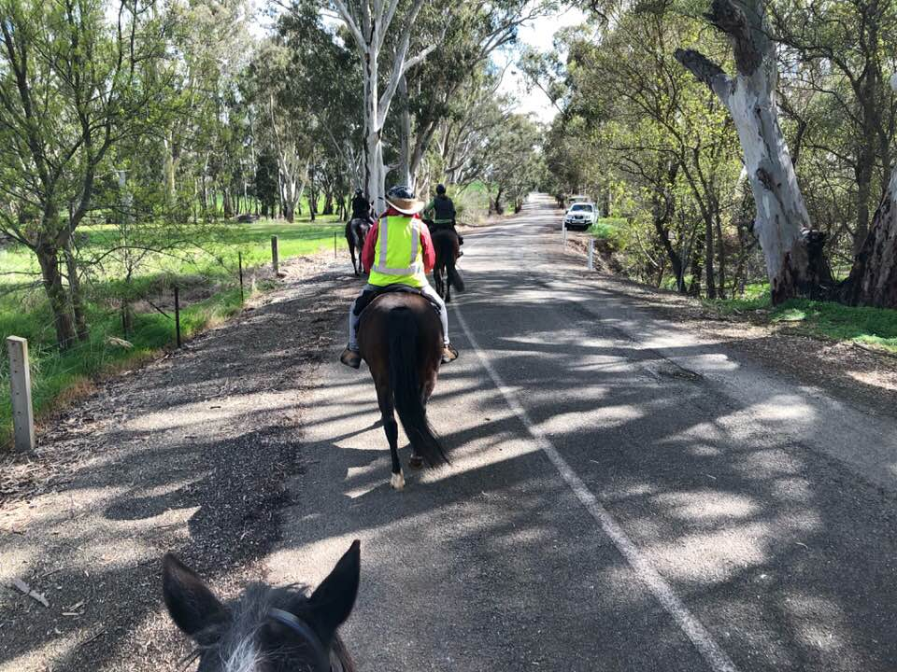Saturday’s weather had me trying to decide whether to cancel the ride or not, but the weatherman promised a lovely day for the Sunday and lo and behold a lovely day we had. With only 12k to get to Mintaro I actually managed to get there before everyone else for a change. Not long after I arrived the other 11 riders turned up.

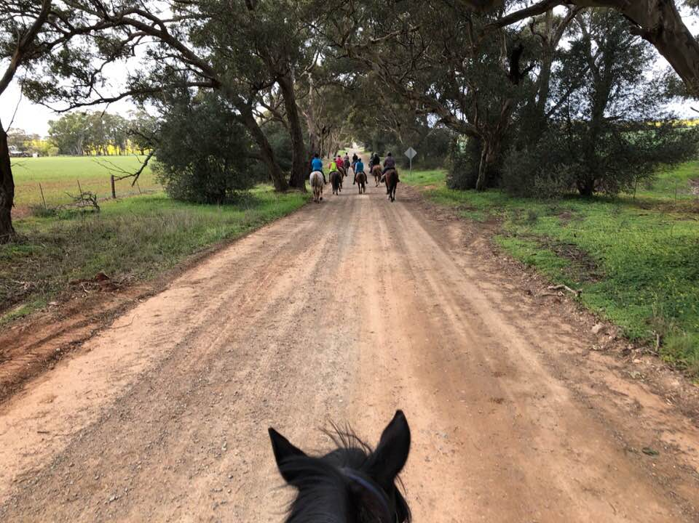The shorter option of 15k was chosen so no need to carry lunch. With well wishes for a good ride from Mintaro Wines as we passed, we then had to contend with the huge hedge trimmer in someone’s drive. Nothing to worry about said all the horses as we sauntered by. After the quarry the bitumen road gave way to nice dirt roads for the rest of the ride. A science lesson was given as we passed the truck entrance to the snake venom farm. Unfortunately the trees were too tall to get a glimpse of Martindale Hall.

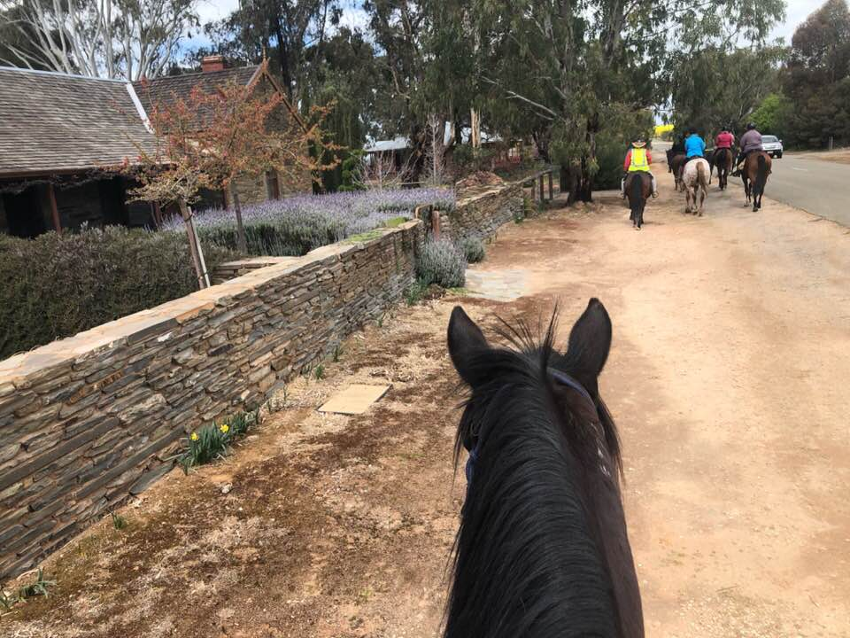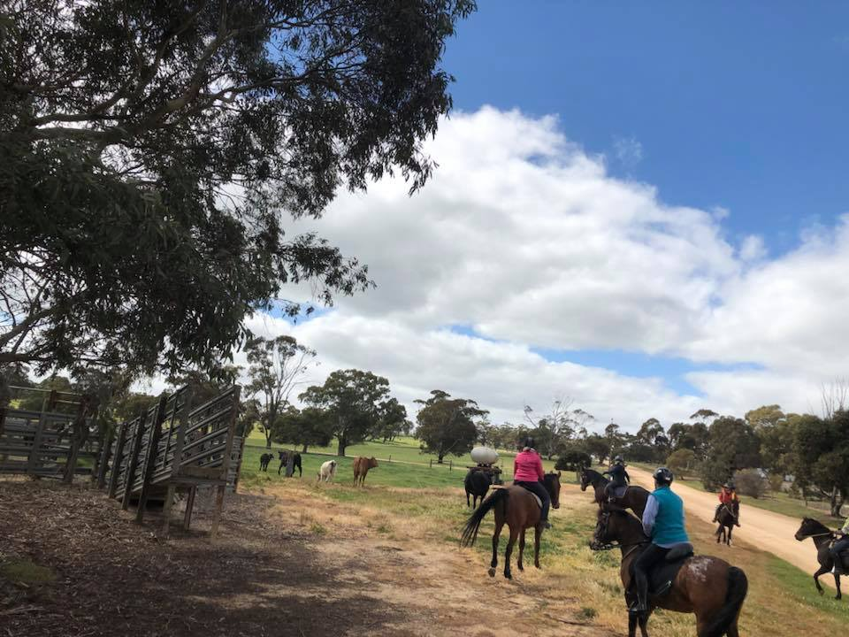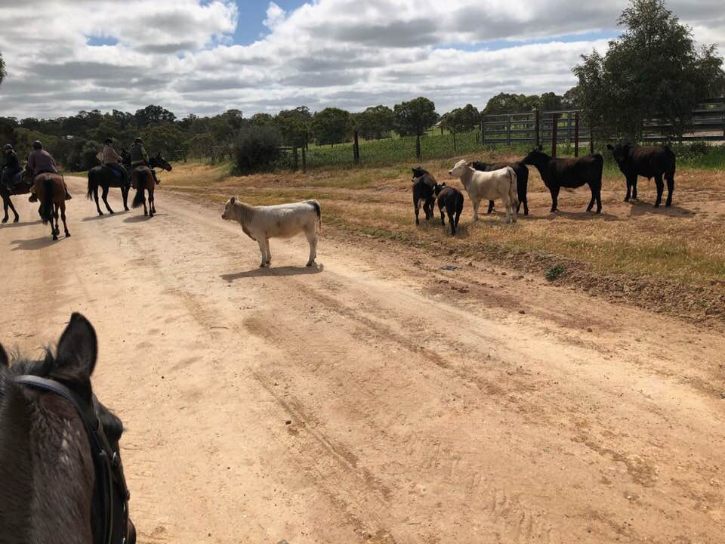Hare road corner had a small herd of curious cows that had escaped from their paddock and thought it would be a good idea to follow us. So we turned our trail riding ponies into cow ponies and herded them back into a paddock. Of course it had to be the biggest cow which decided to confront a horse before being coaxed back into the paddock with the others. A quiet ride along tree lined roads back to Mintaro, where the planned route was altered so Sandra S could see more of the township.

Our ponies now became vehicles as we made our way up the main street with Tamara and Barry bringing up the rear and keeping the motorbikes to a slow crawl behind us. We did feel a bit like royalty with both the locals and visitors waving us on our way. A big sightseeing circle around the pub and bowling green, back onto the main road and back to the oval for something to eat and drink before heading for home.

**September CAMP: Bendleby Ranges (via Orroroo) – Friday 21 – Sunday 23 September 2018**

Not available at time of publication – next month ☺

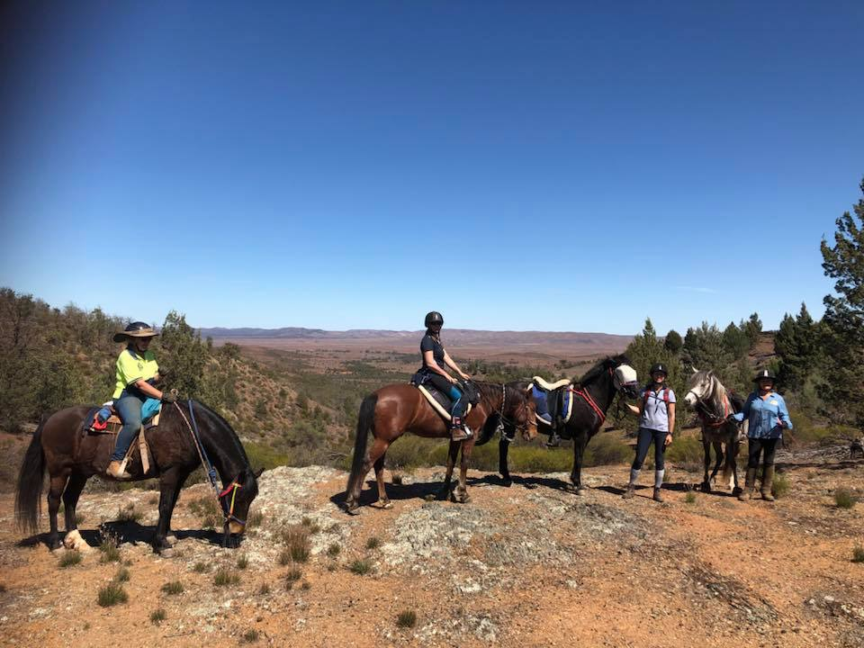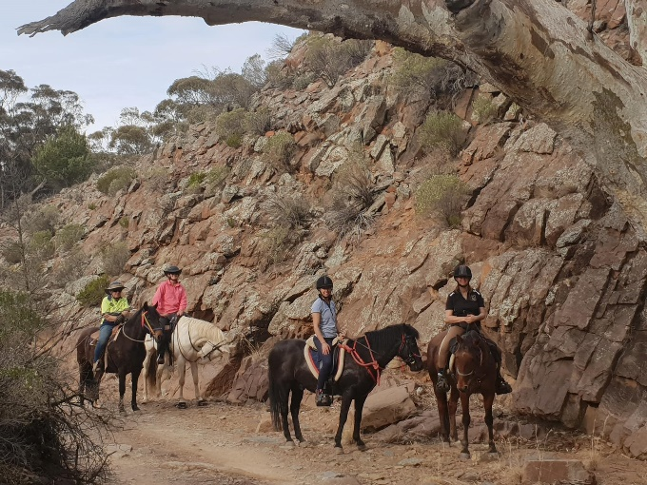

**Horse Health & Wellbeing**

**Groom Your Horse with His Comfort in Mind**

“Optimized” grooming led to as many as 177 times more positive behaviors on average per horse per 10-minute grooming session than standard grooming, researchers found. By [Christa Lesté-Lasserre, MA](https://thehorse.com/1author/christa-leste-lasserre-ma/)    Extract from “the horse.com”

If your horse doesn’t like being groomed, he’s not alone. French researchers recently found that [only 5% of horses showed positive behaviors during a standard grooming session](https://www.thehorse.com/articles/39871/study-many-riders-dont-groom-horses-properly-or-safely). And those that didn’t often demonstrated negative or even dangerous behaviors.

That’s why the same research group developed an “optimized” grooming method that includes massages. Perhaps the most enhanced aspect, though, is incorporating equine feedback—the handlers learned to pay attention to their horses’ signs of comfort and discomfort and to respond accordingly. The result? Optimized grooming led to as many as 177 times more positive behaviors on average per horse per 10-minute grooming session than standard grooming.

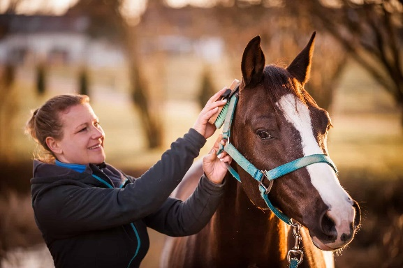“Horses in our study receiving optimized grooming clearly sought contact with the handler and never showed signs of discomfort or defense,” said Léa Lansade, PhD, of the French Horse and Riding Institute and the National Institute for Agricultural Research’s behavior science department, in Tours.

“By contrast, the horses receiving standard grooming showed many more behaviors of discomfort and rapidly developed defense responses, which could lead to accidents or incidents like those we’ve already observed in the field,” she said during her presentation at the 2017 French Equine Research Day, in Paris.

In their study, Lansade and colleagues worked with 27 2- or 3-year-old Welsh pony mares. The mares had had very little contact with humans other than for basic management (feeding, housing, and veterinary care). They divided the mares into two experimental groups, each of which was groomed for 10 minutes, once a day for 11 days.

In the “standard” grooming group (14 horses), handlers:

* Started on the left side;
* Rubbed the whole body with a curry comb (1 minute, 40 seconds);
* Brushed the whole body with a stiff brush (2 minutes, 12 seconds);
* Brushed the whole body with a soft brush (1 minute, 8 seconds);
* Repeated on the right side; and
* Continued their actions regardless of the horse’s reactions.

In the “optimized” group (13 horses), handlers:

* Started on the left side;
* Massaged various parts of the body with the hand (4 minutes);
* Brushed the whole body with a curry comb (1 minute);
* Repeated on the right side; and
* Paid attention the horse’s reactions and responded accordingly.

The handlers learned to recognize if the mares expressed comfort or discomfort based on their body language. When the horse showed discomfort (such as laid-back ears, avoidance, or back muscle contraction), the handler immediately modified the massage by trying something else—a different movement or part of the body. When the horse showed comfort (seeking contact with handler or trying to groom the handler, for instance), the handler continued that movement, increasing the pressure of the massage within the limit of the horse’s positive reactions.

The scientists also recorded each horse’s [facial expressions](https://www.thehorse.com/articles/36248/researchers-study-horses-facial-expressions) during the grooming session and took blood samples at the start of the experiment and before and after the final session.

They found that horses in the optimized group had much lower levels of oxytocin (indicating less anxiety-related stress) in their blood by the end of the experiment. Not only was this oxytocin level lower after the grooming session but it was also lower just before the final grooming session, compared to the standard group.

“This suggests that these horses had developed a better relationship with humans and so were less stressed by the simple fact that humans were coming into the stall with a halter and a needle for a blood test than the horses in the standard grooming group,” Lansade said.

Furthermore, the horses receiving optimized grooming showed far more positive facial expressions, such as protruding lips, half-closed eyes, and ears back (but not flat). Their standard-grooming counterparts exhibited more negative expressions, including pursed lips, raised neck, and wide-open eyes, Lansade said.

“Sensitizing handlers to these kinds of facial expressions could help them read the emotional state of their horses and adapt their grooming practices themselves to make their horses more comfortable,” she said.

Finally, horses in the optimized group showed considerably more positive and considerably fewer negative behavioral reactions than those in the standard group. On average, for each 10-minute session, optimized-grooming horses made 29 contacts with the handler and attempted contact 144 times. These horses also showed two bouts of stretching and two leg lifts (indicating pleasure). By contrast, the standard grooming horses made only one contact with the handler and exhibited none of the other positive behaviors.

As far as negative behaviors go, during each 10-minute standard grooming session, horses showed avoidance behavior on average 97.5 times, back muscle contractions 22.5 times, and defensive behavior (i.e., biting or kicking) three times. The average during the optimized grooming session was one avoidance behavior, a single back muscle contraction, and no defensive behaviors.

“Grooming that takes into account the horse’s reactions and includes massages of preferred zones leads to numerous positive behaviors and no defensive reactions,” Lansade said. Incidentally, the optimized grooming also resulted in equally clean horses, which is a primarily goal of grooming, she added.

“Repeated on a daily basis, these manipulations could probably have lasting impact on equine welfare and the horse-human relationship,” she said. “But standard grooming can lead to defensive actions and, hence, accidents and a compromised interspecies relationship.”

**Horse Humour**

**POTENTIAL DANGER OF HORSE HAIR** ~ In a press release today, the National Institute of Health has announced the discovery of a potentially dangerous substance in the hair of horses. This substance, called "amo-bacter equuii" has been linked with the following symptoms in female humans: *reluctance to cook

*reluctance to perform housework

*reluctance to wear anything but boots

*reluctance to work except in support of a horse

*physical craving for contact with horses (may be an addiction)

Beware! If you come in contact with a female human affected by this substance be prepared to talk about horses for hours on end.

This was a public service announcement ...

Surgeon General's Warning: Horses are expensive, addictive, and may impair the ability to use common sense.

**NEWSLETTER DEADLINE**

The deadline for any items that members want printed in the **November 2018** newsletter will be ***Thursday 25 October so*** please ensure that your emails reach Kath [kathryn.mccullagh@hotmail.com](mailto:kathryn.mccullagh@hotmail.com) before that date to avoid disappointment.

**Policies**

A reminder to all members that our club has some policies that we endorse. These include a **NON SMOKING**, **SAFETY** & **HOT WEATHER** policy. These can all be viewed on the ATHRA web site, via the state page - [www.athra.com.au](http://www.athra.com.au).

Previous Newsletters, photos & club information can also be viewed at any time on the ATHRA web site.

**WEATHER**

The ride host/leader for the day will have the final say regarding weather (including inclement weather).

The hot weather policy states, if the weather forecast in **ELIZABETH** for the next day is to be **over 32** deg (as per the news the night before) the club rally/ride will be cancelled (unless the ride is scheduled to commence prior to 9am or after 6pm). This is for the safety of all riders and horses. Also, any club rides in **FOREST** areas on **TOTAL FIRE BAN** days will be cancelled.

Please check with the Trail Boss if in any doubt. They have the final word!

**CLUB UNIFORM**

Our club uniform currently comprises of a lime yellow high-vis shirt (long or short sleeve), club badges available for $12. Gawler Club Members & their visitors are required to wear Safety Helmets whilst mounted - helmet must be no more than five years old from Date of Manufacture.

**RIDE FEE & DAY MEMBERS**

ATHRA members - a ride fee of $2 per ride is applicable.

Non ATHRA Members (Day Members) – a ride fee of $25/person/day is applicable ($10 to club on the day & $15 to ATHRA with pre-registration) (*Non-refundable fee, maximum 2 days as a day member*).

The important things to note: 1. Day Members must be sponsored and accompanied at all times by an ATHRA member during the ride or event.

2.  The Sponsoring member must make the Day Member aware of ATHRA rules and requirements of the Code of Conduct.

3.  They may only sponsor 1 Day Member per ride.

4.  By participating as a sponsor, the sponsoring member acknowledges responsibility for the conduct and behaviour of the Day Member

5. Day Members must contact the trail boss to discuss attendance & then pre-register with ATHRA Online at least 3 days prior to ride.

**RIDE HOST CHECKLIST**

A ride host’s checklist is in the green bag, in which is kept the sign in book, ride fee tin, saddle bags, first aid kits, safety vests, etc. Trail Bosses are to check the list to make sure all is in order prior to your ride. It is also the Hosts responsibility to ensure a ride report is arranged to be submitted to Newsletter Editor prior to next publication date.

**DISCLAIMER**

The material in this newsletter is for the benefit and information of our members. The items are in the nature of general comments only and are not to be used, relied or acted upon without written permission of GTHRC. The club accepts no responsibility for any errors or omissions or for any damage suffered as a result of any person acting without written advice. All opinions and views in the newsletter are not necessarily the view of the club, but are personal opinions only.