May 2019 Newsletter
Club Postal Address
P.O. Box 55
Gawler SA 5118
athra.com.au Email: Gawler.THRC@gmail.com
President - Julie Jackson 0419850793 Vice President -Tamara Godfrey 0417869695 Treasurer - Sandra East 0400884402 Secretary - Kath McCullagh 08 82807046
General Committee Maria Pearce & Lisa Rothe

GENERAL MEETING (1st Thursday of the month) 8pm Thursday 2 May 2019

All welcome Southern Hotel (next to Cafe Nova)
Come early for tea – 7pm

April Meeting
Ride organisation.
Club re-joined as member of Horse SA

Members for 2019 Welcome
Welcome to New Members
Margot Scott of Mt Torrens, Alison Kay of Gumeracha & Patricia Daly of Reid,
& hope you enjoy may days of riding (& socialising) with the club

Coming Events
April BAROSSA WINERY RIDE 27th April Arrive 8am for departure at 9am
RSVP by 22nd April 2019 to: gawler.thrc@gmail.com
(Further information & Directions will be supplied to those who RSVP nearer the ride date).

This ride incorporates a tranquil ride out through rolling hills and peaceful back roads; After the ride we have the opportunity to indulge in a wine tasting experience (Wine tasting is free but if there are suitable numbers a personalised wine tasting will be offered), followed by enjoying different varieties of Wood Oven Pizzas (at a cost) that will be ordered prior to riding – we can relax on the outdoor lounging furniture sprawled over lawns of this amazing winery. You can also enjoy tea/coffee and more restaurant food if that is your taste.

Choices of Pizza flavours are: Cheese, Garlic, Rosemary $18
Shaved SA smallgoods, tomato, smoky BBQ sauce $20
Pork, caramelised onion, chilli, beetroot, apple $20
Pumpkin, chickpea, sage, bocconcini, shaved zucchini $20
Please include your pizza choice for ordering when you RSVP for this ride.
It is hoped that we get a group discount price!

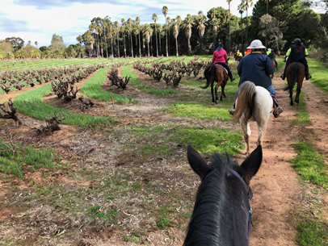
The Ride : (time is approx. 2 to 2.5 hours) and is a distance of 11km or a bit longer with an extra 3.5km (if everyone agrees to add further at the time). Covering undulating countryside on dry weather only roads and also some white metal, but mostly with safe wide verge roadways. Suitable for walk/trot and a canter to cater for those who wish to. A very pretty ride out in wide open spaces. (You may need to consider warm clothing due to wind if the weather is cool).

Hazards should be minimal – possibly ducks on water that might take flight!!, well if we have rain…maybe water over the road !!! Joke !!, some limited traffic on a small portion of the journey and maybe the odd kangaroo.

Parking: the parking area is limited and it will require orderly parking arrangements. Where possible it is asked if those with double floats to buddy up with riders in your area to limit the number of floats to assist with the parking area situation.

Cost:- ATHRA member $2 Ride fee. Only limited Non ATHRA member riding visitors: fee $25/day (please be advised that if you are not a member of ATHRA you will need to be sponsored by an ATHRA member to ride & pre-register as a day member 3 days prior with ATHRA online - $15 direct to ATHRA & $10 to club on the day). Please bring the correct change & place in tin at sign on book

MAY RIDE OUT: Kapunda – Sunday 19 May 2019 RSVP to gawler.thrc@gmail.com 16 May
Host & Boss – Sandy Jones phone 0401 672241 Ride time – 9am > for a 10am start

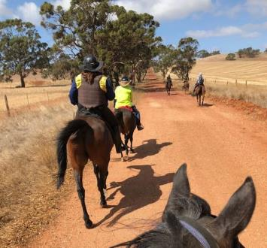
Ride Description: The ride will depart 10am for an ~10 to 15k ride stopping for a drink at a pub as we pass. Mostly the ride will be on dirt roads but we do have to cross reasonably main roads and use the fairly wide verge of a main road for about 100 metres. Will need to bring some money if you want a drink from the pub.

Hazards: There is a steep dry river crossing so unfortunately the ride is not suited for carts.

Directions: provided to those that RSVP

Cost: ATHRA member $2 Ride fee. Only limited Non ATHRA member riding visitors: fee $25/day (please be advised that if you are not a member of ATHRA you will need to be sponsored by an ATHRA member to ride & pre-register as a day member 3 days prior with ATHRA online - $15 direct to ATHRA & $10 to club on the day). Please bring the correct change & place in tin at sign on book

RIDE CALENDAR FOR 2019 host MEETING DATES 2019
Rides are usually held on the 3rd weekend (Sunday calculated) & 5th Sunday of the month (if there is one).
Camps held ~1st or 5th weekend of the month (negotiable) Meeting dates are held on the 1st Thursday of the month

The following is a work in progress – dates, location & hosts to be continually confirmed
Please nominate a date if you have nominated to host rides
& MANY More rides needed to complete the calendar

April 27 | Winery Ride | Lisa B
May 18/19 | Kapunda | Sandy | 2 May
June 16 | Mt Crawford - Cromer | Sandra S | 6 June
June 29 & 30 | Belvidere Camp | Richard
July 21 | Rosedale to Seppeltsfield (TBC) | Lisa C | 4 July
Aug 18 | Truro Gorge | Julie J | 1 Aug
Sept 14/15 | Leasingham | Sandy | 5 Sept
Sept 27-30 | Camp – Southern Flinders? | Kath
Oct 19 & 20 | Owen Camp & obstacle day | Julie J | 3 Oct
Nov | Forest Ride/Camp – Kuitpo (not 16-17/11) | Laine | 7 Nov
Dec 7 (Sat) | Christmas Dinner (TBC)
Dec 14/15 | Christmas ride (TBC)
? | Camp – Point Pass – (TBC) | Maria P

Past Events
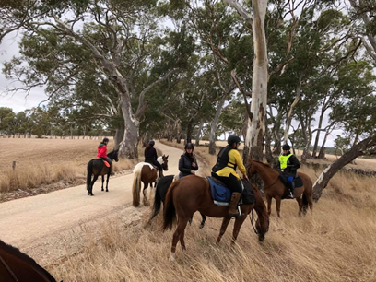
March RIDE OUT – Birdwood – Sunday 31 March 2018 - by Sandra S
Well, the day for my club ride at Birdwood dawned just perfect!
New member Geraldine and her gorgeous Clydesdale/Gypsy Cob mare Bobby arrived first, and then everyone else turned up. We had nine riders in all, so quite a nice amount. I warned the riders it was going to be about a three and a half hour ride with four main road crossings. Luckily Chris Pearce helped Robert get us all across them safely.

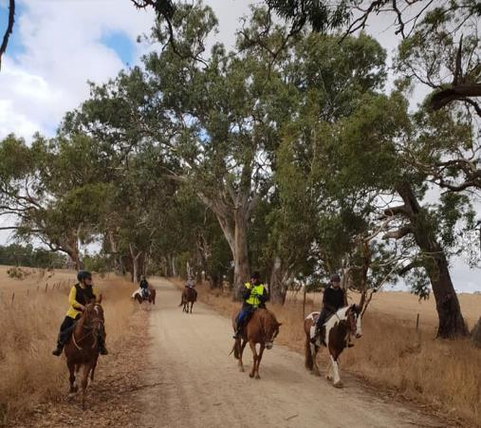
We set off down the paddock to avoid our rocky driveway and made our way down McLean Road and safely over Randell Road. We then meandered down lovely tree-lined roads till the next road crossing. Robert and Chris helped us across again and we made our way to Cromer, crossing the Torrens River.

We had a few trots and suddenly heard the Cromer Gun Club in action! Oh dear, I heard them at the end of the month last time so thought we would be okay! Luckily all the horses coped really well, thank goodness. We then made our way up the hill and parallel to Cricks Mill Road, where we stopped for a photo shoot of the lovely dry stone wall.

Everyone seemed happy with the ride so far, so on we went, looking forward to the bbq, which was still a while off!
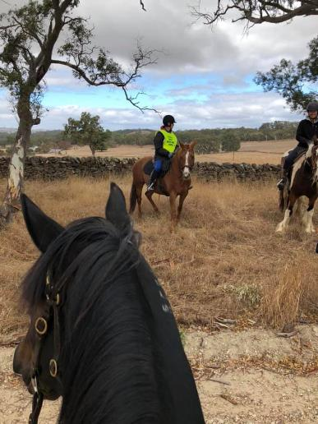
The ride stirred a few horses up in the paddock, after me warning the riders about a little pony who usually just emerges! No sign of the pony this time! Down the hill we went and crossed the River Torrens again which was a bit scarier for some horses. Over the Torrens Valley Road again and we surprised a couple of kangaroos. All good, one more main road to cross and we were almost home. Thankfully everyone survived but were glad to get off and enjoy the Mt Pleasant Butcher's gourmet sausages and chicken patties.

We found a couple of visitors we we got back - Sandra East and Diane Schaeffer, who thought they would come for lunch. They amused themselves for an hour before we all turned up. Thanks to Robert and Chris for being excellent traffic wardens and to Robert for cooking the bbq. Also thanks to all who brought salad and sweets. Sorry Kathy, but you missed out on my Swedish cake!

Hopefully no-one was put off by my LONG ride!

APRIL - TRAIL RIDE CHALLENGE/OBSTACLE DAY–14 April 2019 - by Di
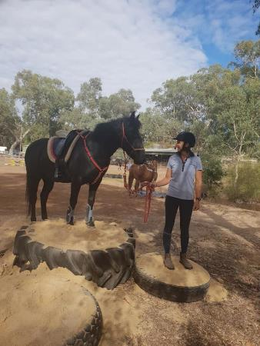
The weather forecast was for a fine, warm, autumn day, which sounded just great for an adventure filled Riding Club Rally Day. Instead of the usual Trail Ride this Rally Day was set up at the one location. The intensions of this type of Rally Day is to provide a number of obstacles and unusual challenges, which one may encounter when out on a trail ride. As well as the various ‘challenges’, a Dressage Test and a small Show Jumping course was set up for riders test their more ‘advanced’ riding skills.

At 8.30 a.m. I drove up to open my top gate and put a Club sign out, and I calculated that I had enough time to go to the shop and get a Sunday Mail. As I was getting back into my ute to come home, a float went past and turned off into Goldfields Road. I did some rally driving to get back home in time to direct the first cars and floats onto the car parking area in an orderly fashion.

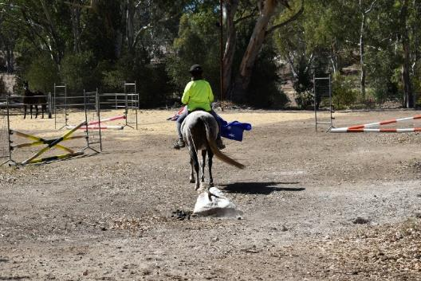
By 9.30 a.m., most of the members had arrived and assembled ready to hear Sandra give the customary Club welcome and outline the day’s activities.
Kath, Tamara, Sandra, Lisa and Keith had come along on the Saturday and set up an obstacle course with pool-noodles to walk through, an archway of plastic streamers, blue plastic tarp to walk over, pink pig to pick up, bags of cans, flags, and host of other interesting challenges to either lead the horse through, or do whilst mounted (which is the ultimate aim….).
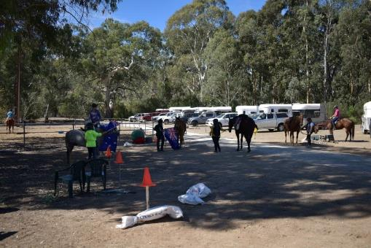
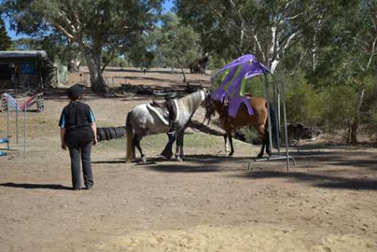
They also set up a small show-jumping course, and the ATHRA Trail Course, complete with cavallettis, a gate to open, a lead horse to pony, tree logs to negotiate and many other natural obstacles. Members could choose whatever they liked to do on the day. Jenny, the local, well renown and hugely respected Dressage Judge, came along and once again did a splendid job of assisting, encouraging and marking the Dressage Test. It was fantastic to see so many riders ‘have a go’, at either one of the two tests and well done to Gail Bates on her lovely Q/H mare Molly, for winning the Dressage Prize, which happened to be a book on….. ‘effective communication with your horse’……
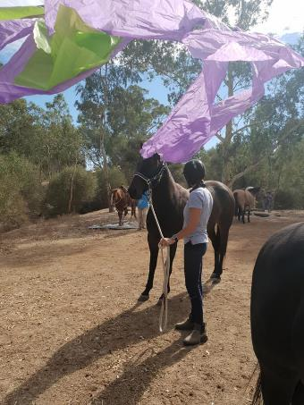
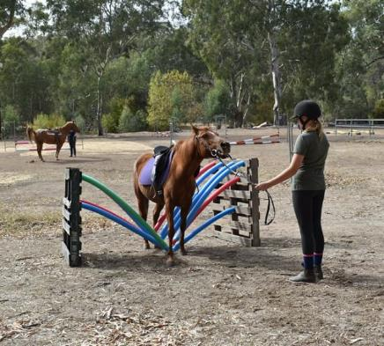
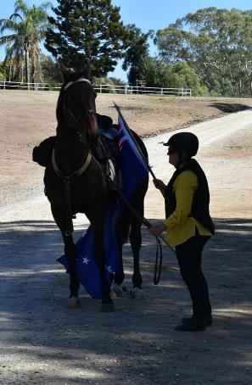
Some of the members tried out the Show Jumping Course, and without a doubt, Jess, who was the youngest rider, on her lovely little chestnut pony Hali, was the most competitive and consistent Show Jumper on the day. It was great to see her mother and young brother come along and watch. The Obstacles proved to be very ‘interesting’ for many of the members, and they got a great sense of achievement when they managed to get their horses through or over the challenges. Thank you to Keith for offering his patient assistance with the pool-noodles.

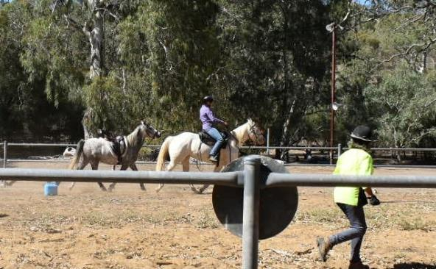
The ATHRA Trail was also a lot of fun, with many members completing the course. Nearing lunch-time, Kath on Joey and Tamara on Barry created quite the entertainment when they tried to do a P.B. over the course, with stop-watches out, they became quite competitive!!!!

Shortly before lunch Sandra had organised two motor- bikes to come along and ride around the area to do some motor-bike ‘noise desensitising’, which was also a rather unique and interesting addition to the day. Thank you to Daniel (Sandra’s son) and Darren, (Tamara’s husband) for taking the time to come out and ride through the creek-beds and up and over the banks…..a task they seemed to have enjoyed!!!
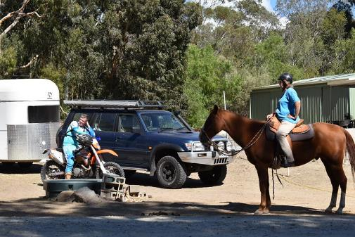
By early afternoon, everyone was ready for lunch, so the horses were unsaddled and made comfortable. Many thanks to our guest chefs for the day, Vanja and Mick, who had the gourmet B.B.Q. cooked and ready, all set up with the various salads and sweets members had brought along to share. Sitting under the shade of the big river gums we all enjoyed a social lunch together, recalling the thrills, excitement and achievements from the morning activities.

It was nice to see Lisa and Maria, who rode over from Lyndoch, join us for lunch and then rode back home again. Chris (Maria’s husband) and Adrian (Lisa’s dad) came along as support drivers. Richard so came along early in the afternoon, with Rheygum, after they had attended Belvedere Pony Club in the morning.

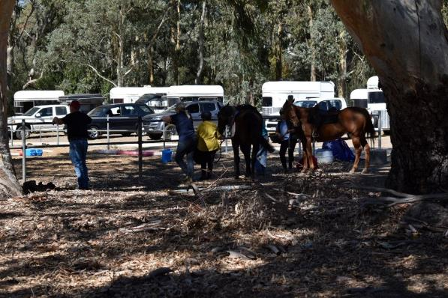
Thank you to all of the helpers who came along on the Saturday and set everything up. Thank you to Jenny the (incorruptible???) Dressage Judge, the wonderful (MKR quality) chefs, Vanja and Mick, and also to all of the members and guests who came along and made a contribution towards the luncheon and participated with their horses on the day. Hopefully everyone had an enjoyable time.

Participants on the day were: Sandra East on Ace and Diamond, Kath on Joey, Tamara on Barry, Gail Bates on Molly, Lisa Z with Buddy & partner Keith, Natalie Bennison on Nugget? , Lisa James on Armani, Kylie Kleemann, Lisa Laughton, Alison Kay, Patricia Daly with partner Patrick, Maria Pearce on Ted, Lisa Crinion on Lucky, and Richard Grimson. Along with day member Jessica Hall on Hali.

NEWSLETTER DEADLINE
The deadline for any items that members want printed in the June 2019 newsletter will be Monday 27 May so please ensure that your emails reach Kath kathryn.mccullagh@hotmail.com before that date to avoid disappointment.

Policies
A reminder to all members that our club has some policies that we endorse. These include a NON SMOKING, SAFETY & HOT WEATHER policy. These can all be viewed on the ATHRA web site, via the state page - www.athra.com.au.
Previous Newsletters, photos & club information can also be viewed at any time on the ATHRA web site.
WEATHER
The ride host/leader for the day will have the final say regarding weather (including inclement weather).
The hot weather policy states, if the weather forecast in ELIZABETH for the next day is to be over 32 deg (as per the news the night before) the club rally/ride will be cancelled (unless the ride is scheduled to commence prior to 9am or after 6pm). This is for the safety of all riders and horses. Also, any club rides in FOREST areas on TOTAL FIRE BAN days will be cancelled.
Please check with the Trail Boss if in any doubt. They have the final word!
CLUB UNIFORM
Our club uniform currently comprises of a lime yellow high-vis shirt (long or short sleeve), club badges available for $12. Gawler Club Members & their visitors are required to wear Safety Helmets whilst mounted - helmet must be no more than five years old from Date of Manufacture.
RIDE FEE & DAY MEMBERS
ATHRA members - a ride fee of $2 per ride is applicable.
Non ATHRA Members (Day Members) – a ride fee of $25/person/day is applicable ($10 to club on the day & $15 to ATHRA with pre-registration) (Non-refundable fee, maximum 2 days as a day member).
The important things to note: 1. Day Members must be sponsored and accompanied at all times by an ATHRA member during the ride or event.
2. The Sponsoring member must make the Day Member aware of ATHRA rules and requirements of the Code of Conduct.
3. They may only sponsor 1 Day Member per ride.
4. By participating as a sponsor, the sponsoring member acknowledges responsibility for the conduct and behaviour of the Day Member
5. Day Members must contact the trail boss to discuss attendance & then pre-register with ATHRA Online at least 3 days prior to ride.
RIDE HOST CHECKLIST
A ride host’s checklist is in the green bag, in which is kept the sign in book, ride fee tin, saddle bags, first aid kits, safety vests, etc. Trail Bosses are to check the list to make sure all is in order prior to your ride. It is also the Hosts responsibility to ensure a ride report is arranged to be submitted to Newsletter Editor prior to next publication date.

DISCLAIMER
The material in this newsletter is for the benefit and information of our members. The items are in the nature of general comments only and are not to be used, relied or acted upon without written permission of GTHRC. The club accepts no responsibility for any errors or omissions or for any damage suffered as a result of any person acting without written advice. All opinions and views in the newsletter are not necessarily the view of the club, but are personal opinions only.

