TAMWORTH BUSHRANGERS TRAIL RIDING CLUB

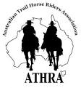
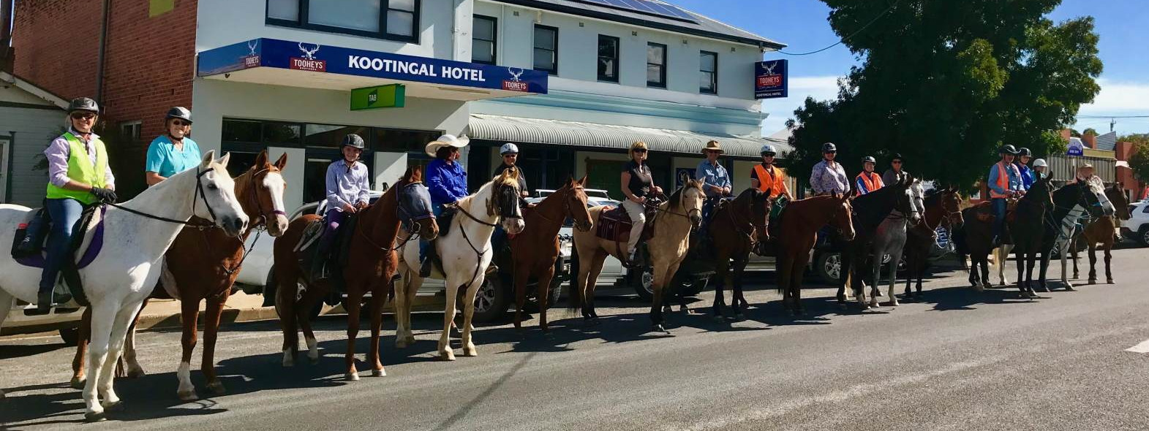
Newsletter – APRIL 2018
President: Angela Witherdin
0418234854
awitherd@bigpond.net.au
Vice President: Bev Fletcher
Secretary: Francie MacLean
0407660334
Treasurer: Anthony Read
0409362434/67665448

Thank you to all those members who completed the 2 minutes survey looking for expressions of interest in the First Aid Course and the Accreditation weekend and if you weren’t one of the members who responded then ………
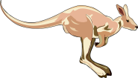 | HOP TO IT AND DO IT NOW!  https://www.surveymonkey.com/r/7Q9JQLX
Message from our President
Many of us are due next year for our Trail Boss reaccreditation. To be able to be reaccredited and not have to do another Trail Boss course you must meet the following conditions set out by ATHRA
- The member has been an ATHRA member continuously for entire period of their accreditation, and
- The member has regularly performed a role as Trail Boss, Ride Co-ordinator, Lead Rider, Drag Rider or Ride Steward at ATHRA sanctioned trail rides or events, and
- The member has performed these roles in a safe and satisfactory manner.

BUSHRANGERS OUT AND ABOUT ….

Quite a few members have been busy with their horses this month …. Thank you for your contributions – guess it must be the warm sunny days now that the relentless heat has gone. The lack of rain this summer has left us all with issues involving lack of feed and/or water for our horses or other livestock. With no rain in sight and winter just around the corner and with hay and other feed supplies tight remember to look out for our fellow members by asking “R U OK”.
If you see something interesting or are involved in other horsey events or attend a ride at another club send a note to barlowpark2@gmail.com to be included in the Newsletter – and don’t forget the ‘selfies’

APRIL MONTHLY RIDE …. SUNDAY 22ND APRIL 2018

MOONBI SHOWGROUND to KOOTINGAL HOTEL

Last Sunday the 22nd of April our trail ride club did a ride from the pony club grounds at Moonbi to the Kootingal Hotel for lunch. There were about 20 of us and l was riding my new horse Fleetwood. The weather was really nice and I was really looking forward to lunch at the pub. We all headed out a new direction thanks to Sally for telling us where to go so we didn’t upset the dressage horses that were competing. We got into Kootingal just before mid-day and after having a couple of semi-trailers going past us. Fleetwood was a good boy and did not worry about them our horses were all good behaved at the pub and mum got to have a lovely birthday cake that Angela made for her.
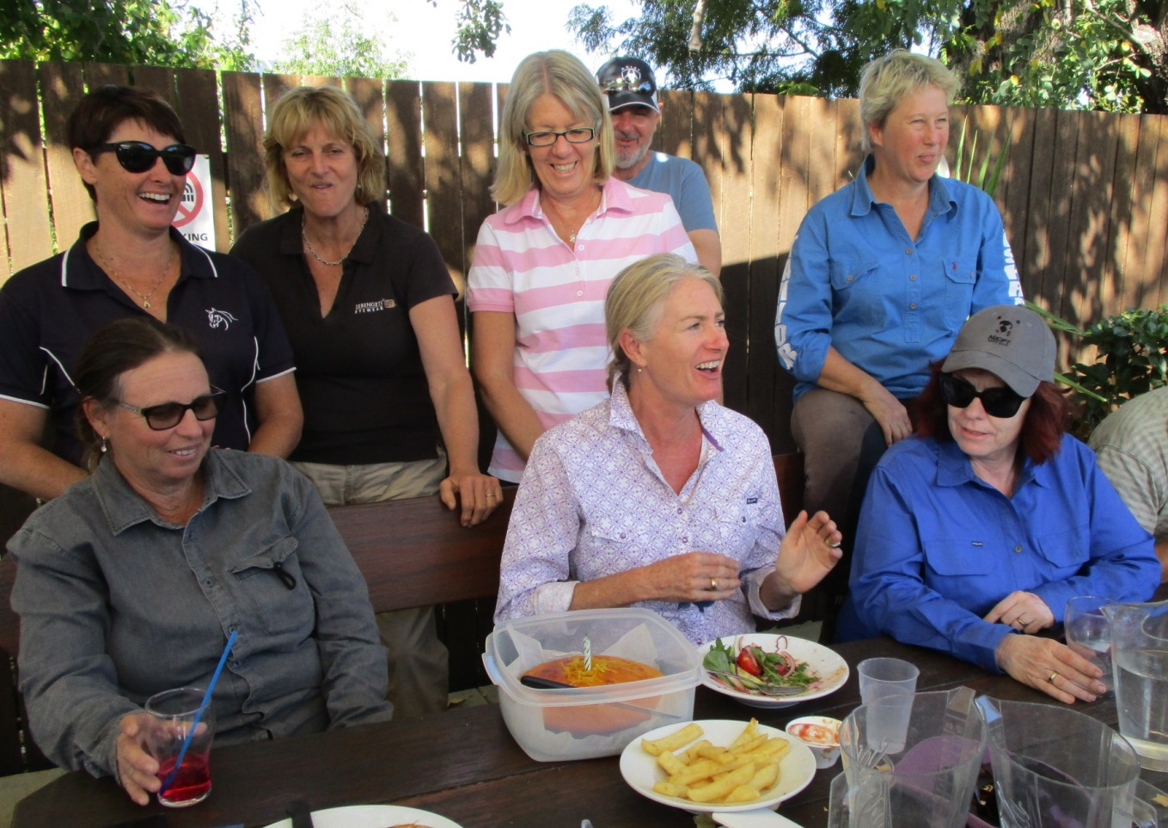
After lunch we all had a photo taken outside of the pub which is so cool that it is now on the athra websites cover page. The ride was fun and we had a couple of canters. When we got back to the show grounds a little girl in a cart with a pony came zooming up behind us scared the horses. It was good fun and I love my horse Fleetwood. (Report By Eloise Galvin 11 years old)
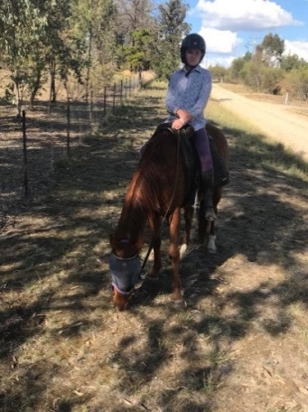

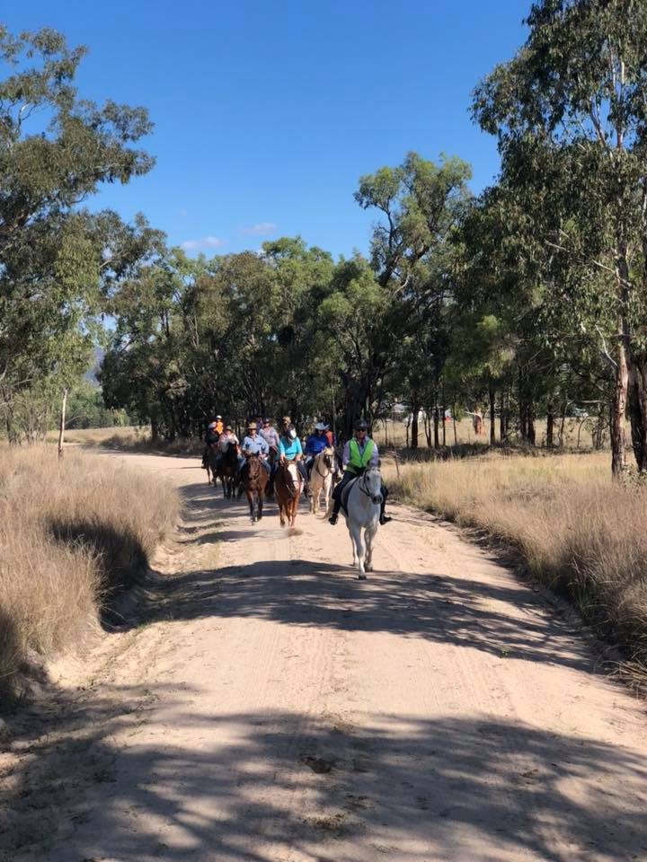 | 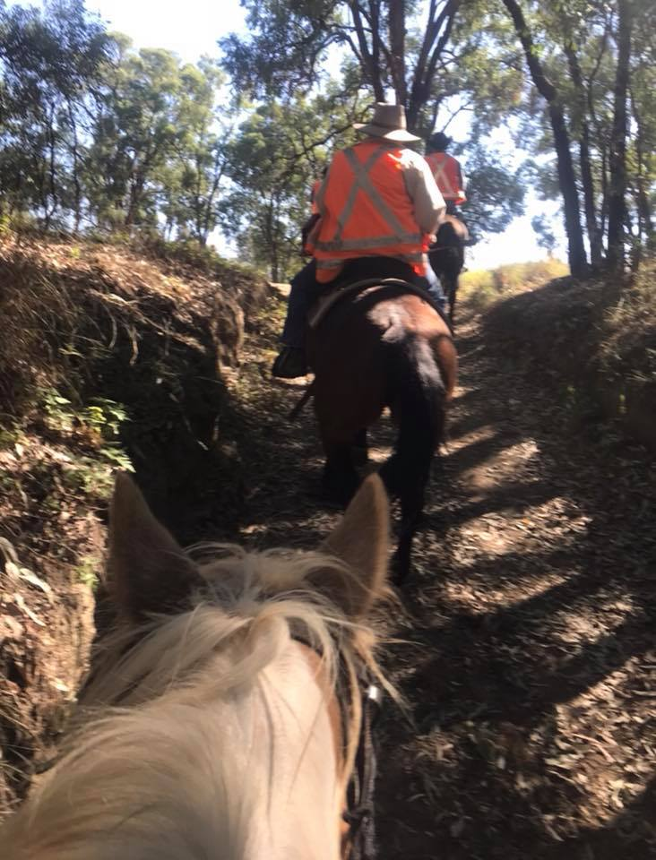 |  |  |  | 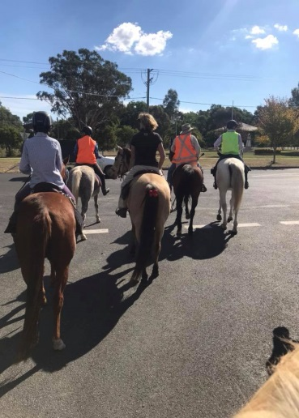
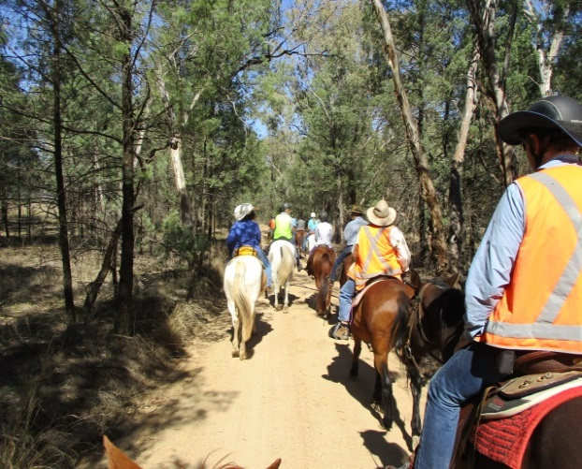 |  |  |  | 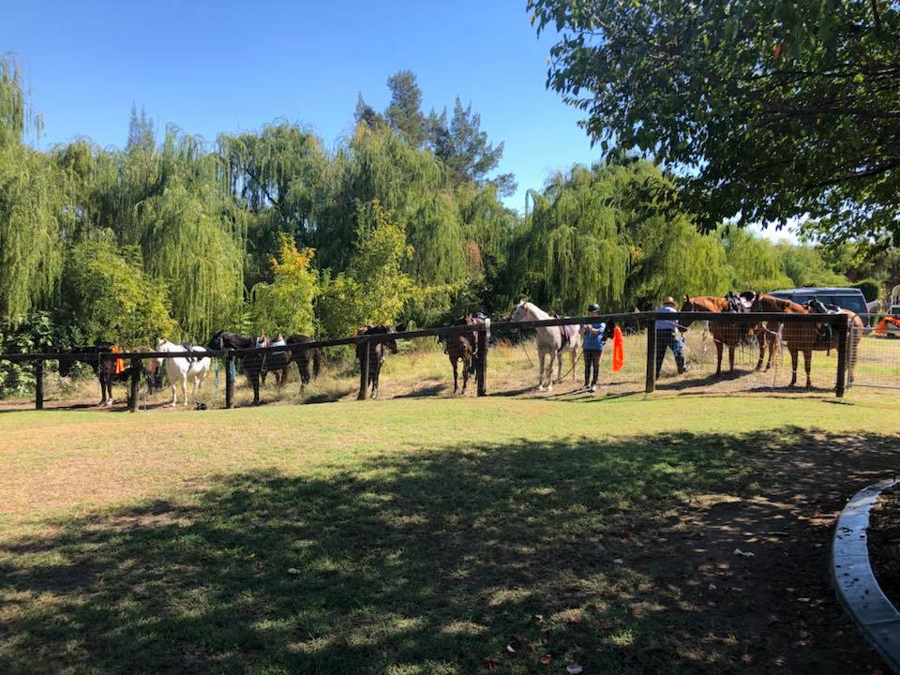
and joining us for lunch at the Kootingal Pub …….. past members and good friends
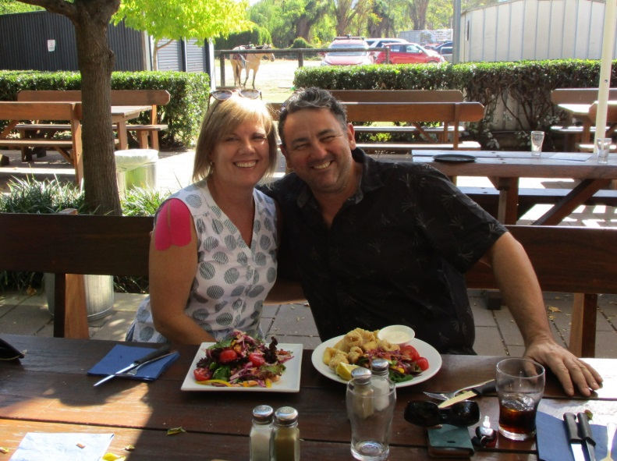 | 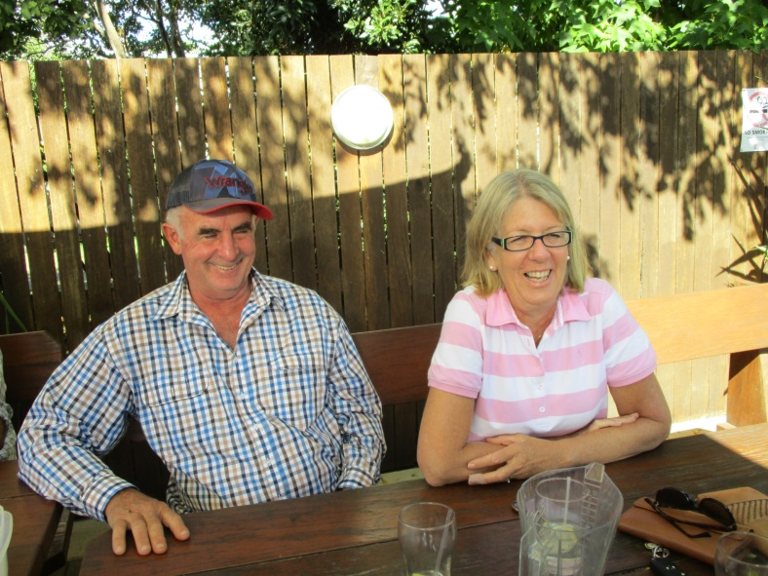

BUSHRANGERS OUT AND ABOUT …. by Megan (Megsie) Galvin
ANZAC DAY 2018
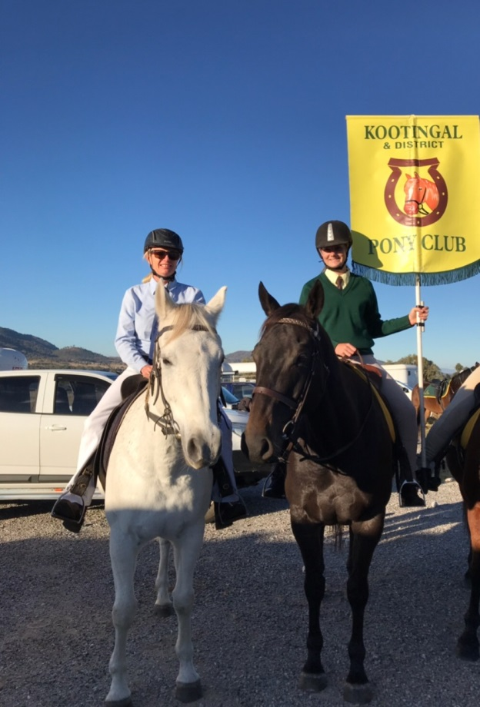 |  | As part of Kootingal Anzac Day March Kootingal and District Pony Club have a number of their members participate in the march on horseback to honour the memory of the Anzac’s.  This year 21 riders took part. This was made up of junior members and adult riding members. The flag of the KDPC is carried by a junior member as is the Australian flag.  Both Claudia and I took part in the march on our trusty steeds. I rode Smokey my grey quirky horse who has done the march twice before, and Claudia rode her big Thoroughbred Lenny. Both horses took it in their stride and I was particularly impressed by Lenny who at only 7 handled the crowd of approximately 1000 people, the band playing, the bag pipes and all associated fanfare. The horses are then required to stand in a troop line nice and quiet for the duration of the service.  A speech was read out by selected members of KDPC, that outlined the role of horses in the military. Claudia read a section of the speech to the crowd and I was very proud of her.
Claudia and I were both honoured to be able to show our respects to the Anzacs and be a part of this important day, and especially to be able to have our horses involved. The fact that our horses are able to tolerate the march and all it entails is a testament to how versatile good trail horses can be!
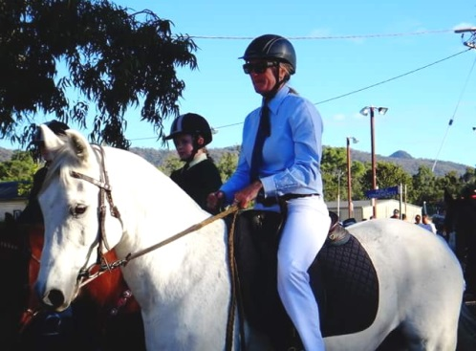 | 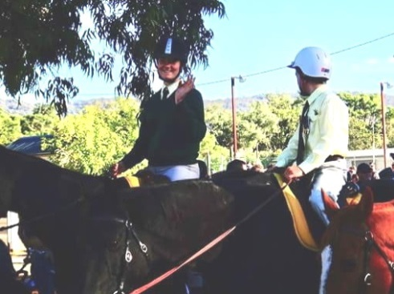 |  | 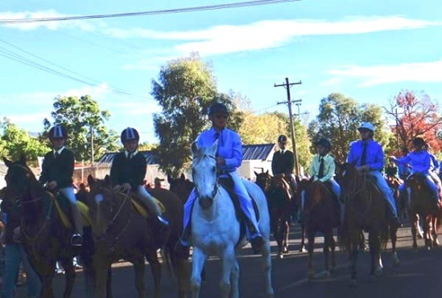
We are looking forward to it again next year.

For those that were not aware our Secretary Francie McLean had a bad accident several weeks ago and luckily is on the mend but apart from the broken bones and horrible bruises the drought for anyone on the land also emotionally takes its toll. A few of our members might by now be wondering ‘what happened’ so Francie has contributed the following Article in the hope that others might not join her in discovering how hard the ground can be. Thank you Francie ….

It is lovely to be appreciated, as a secretary and a friend.
The dry season we are all experiencing is taking its toll on everyone, with rising feed costs affecting the viability of many grazing operations both small and large scale. Well considered tough decisions must be made to select down to the animals you can afford to feed, it comes down to who stays and who must go. Turning a blind eye to the problem is not too effective for those standing outside in a cold empty dry paddock over winter.

Duncan and I have been hand feeding since the 5th January. I have kept a close eye on where we are going and how we would get there every fortnight. Our feed commitments have cost tens of thousands of dollars, with cattle eating because of the sale of others. We’ve sold 50 % of our herd. I have sold my entire beloved Belted Galloway herd that many of you have over the years ridden through at Oakview. I have bred Belted Galloways for 20 years and it has been a wrench, but a necessary one.

The herd has been broken up all over the place to 12 Belted Galloway studs, from Queensland, through NSW and down to Victoria, with my last old beauties leaving this Saturday to live out their last years in Yea in Victoria. I have made so many beautiful friendships through the breed over the years I’ve breed Galloways and I’ve sent them all over the Eastern seaboard even flying them to Asia for breeding, and as I leave the breed many of those friendships will remain with me. Just as my love for Belted Galloways, and cows in general will always stay with me.

Friendships start in many ways, and I have found new friendships and renewed old friendships riding with Tamworth Bushrangers, and after that fateful day 3 weeks ago I was reminded of the lovely, kind friendships I have made through this group of people from all different backgrounds who come together with a shared interest, horses.

Many of you will know that I had a terrible fall from my gelding ‘Pursuit’ 3 weeks ago. We all know that feeling of the near fall, the rapid scramble back into position, but on this day it was not to be.

My lovely big normally gentle gelding ‘Pursuit’ was a different animal in the blink of an eye as he choose to hammer me into the ground, to extract me from his back and gallop back to the comfort of his spot at the bottom of the yards to wait by the gate for the sound of the creak of the feed shed door.

As I lay on my own, a crumpled mess unable to breathe momentarily with the feeling my back was broken I could hear his galloping hooves go silent, he was gone, and I was still alive, but something changed that day between him and me. I can barely stand to have anything to do with him, and until writing this now I have not admitted that, in fact at the moment I barely have a thing to do with any of the horses. I think I just feel let down, sore and disappointed.

Where did it go wrong.....why did a kind gentle horse turn so mean?

The horses have been dull and unusually they have all been squabbling with each other over feed, over standing space, over nothing, it was as though they were experiencing deprivation, they weren’t, but they were just sick of things and probably bored, as are we with this relentless dry. They could go up the empty creek and pick about but choose to stay by the bottom gate waiting for the creak of the feed shed door, day after day.
We had them shod a few days earlier, we had made a decision to feed our two main riding horse’s 2 kgs of Calm Ride pellets and a couple of biscuits Lucerne hay as they were finding the conditions difficult as the dry days rolled by, and we felt sorry for them.

That morning I was distracted, I’d been finalising plans to move 3 loads of cattle to the coast and Victoria for the next few days, I had to move a few old cows up to the paddock and I didn’t want to ride, I actually just wanted to take them up on foot. Dunc said a ride would be good for me and to take Pip, neither Pip or Pursuit had been ridden for 2 weeks but that’s never been a problem, I chose Pursuit.

I felt lazy; a busy morning of our relentless feeding and tagging cattle had left me depleted. Anyway I jumped on without paying any attention to him at all, I probably didn’t even pat him, I certainly didn’t mindfully connect with him.

He notified me in a subtle way that he was not interested in going out, I ignored it and kicked him up, he did a slight rear of reluctance or rather resentment, I ignored it and pushed him forward, and still after all my years of riding I misread every single cue that he put to me, he didn’t and wasn’t going to do what I asked, and a short distance further up the creek he just bucked and bucked and tossed me aside.

This all happened for a number of reasons. Too much high protein feed for 2 weeks for horses that are standing around doing nothing, because, we felt sorry for them in this dry weather with not even a dry pick of green grass. I was disconnected from what I was doing and misread the moments until it was just too late. I should
have lunged him first, prepared him, and importantly listen to him. I also should have just walked those old cows up the creek and rode when I had more time. Make no mistake; what he did was a dreadful thing to do.  To impart what I learnt from that brief moment in time, don’t over feed your horses on high protein feed or pasture, and importantly listen to them and take your time. It’s true, the ground does hurt so much more when you’re older, and yes your life flashes before your eyes, and I could have been killed and I now have to trust Pursuit again and I don’t know if I can.  To everyone who has been in touch to offer support, I thank you so very much, to you all who I know will encourage me to continue riding once I am able, I thank you, and to the club for sending me the beautiful native arrangement of flowers, thank you, it is lovely to be appreciated, as a secretary and a friend.  Francie | 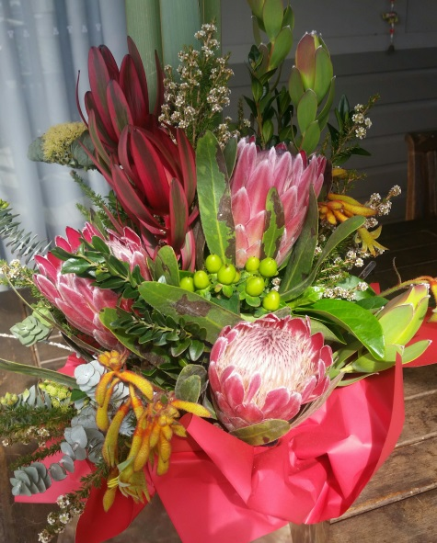

BUSHRANGER OUT AND ABOUT ……… Competing

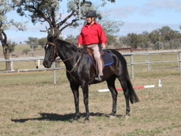  Championship preparation at Barraba | Angela (Ange) Witherdin is competing this coming  Saturday 12th May 2018 at the …..  2018 ANWE NSW State Working Equitation Championships – AELEC, Tamworth  Most recent competition was at Barraba in late April where Ange riding Roger, her beautiful young gelding won all 3 phases and was Champion in the class. (Notice he looks a little shinier than is usual appearance out on the trail)  Not sure if Ange would appreciate a cheer squad, probably not – but if you wanted to check out these Championships this weekend – Entry is Free
I asked Ange what was involved in Working Equitation and I quote …..

“Working Equitation consists of 4 phases Dressage; completion of Maneability (Editor’s Note – Yes, it is a real word – looked it up) which is an obstacle course in particular order, in dressage frame; Speed event [same course on time) and a cattle phase [I’m not doing this]. My aim is not to get eliminated, have a go at all the obstacles, bridge, garotcha [stick & ring & ball], gate, carry Drizabone and I get to ride on new arena at AELEC.”

and from the Web a little more information…………………

Working Equitation was founded in Portugal, Spain, France and Italy but quickly expanded to Sweden, Germany, the UK and Brazil. The discipline of Working Equitation was created to promote the different types of equitation techniques developed in countries that used the riding horse to work on farms, ranches and with livestock. Working Equitation came to Australia in 2007. It is now a fast-growing sport here in Australia! Riders of every breed of and discipline are trying their hand at the precision and unity of horse and rider needed to excel at Working Equitation.

OTHER BUSHRANGERS OUT AND ABOUT ……..

Background: Border County Trail Riders Club based in Tenterfield had booked a “camp over” Trail riding weekend for 13th-15th April, at our property Barlow Park located south west of Guyra. Much to do and pre-rides to be done, so Alison and myself spent a good part of our Easter break sorting out rides for Friday afternoon (approx.. 2 hours), longer ride on the Saturday involving Morning Tea stop on the Creek and lunch at the Hut with another ride for the Sunday morning allowing participants time to pack up and head home after lunch. Had also organised for a couple of Bushranger members who were familiar with our property to come the ride weekend to help out (and thanks for your offers to assist, really appreciated) and also an opportunity to meet members from another ATHRA club. However, it was not to be as they did not have sufficient numbers so they were forced to cancel the week before.

ALL DRESSED UP FOR THE PARTY AND NOWHERE TO GO!! What to do????
Of course, you Trail Ride for the weekend anyway – informally going wherever you please for as long as you want – Donna & Alison (still keen to have a weekend away) and myself made the most of the lovely weather. Alison bought both ‘Comet’ and ‘Luna’, Donna and ‘Little Jack’ hitched a ride with Alison and as I have ‘Lout’ started back in work as well as my normal mount ‘Scooter’ – 3 riders, 5 horses - fun swapping mounts. But Lunar not impressed (see below)
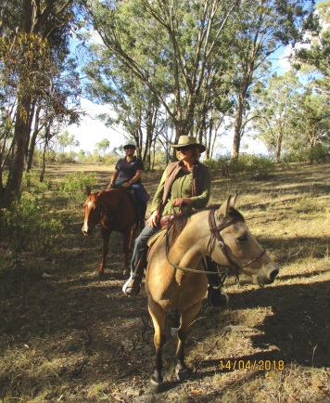 | 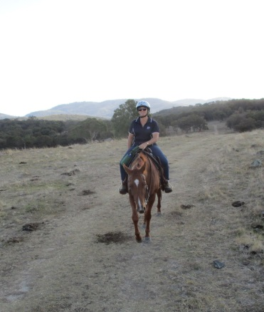 | 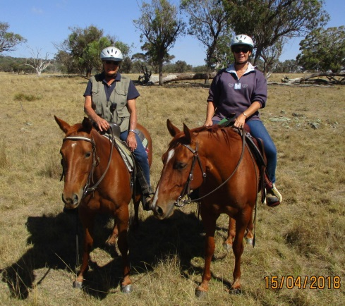 | 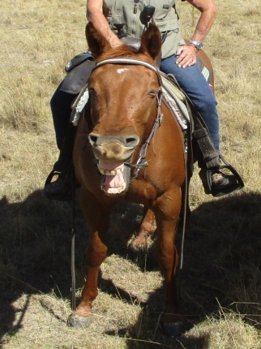
When Chris found out it was Donna’s birthday special lunch prepared complete with wine.
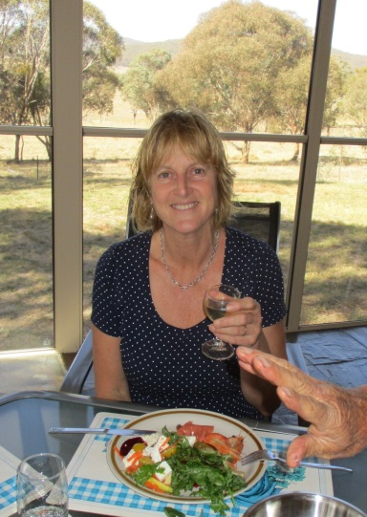 | We all know what the rules are about texting and driving, but what about riding Donna? | 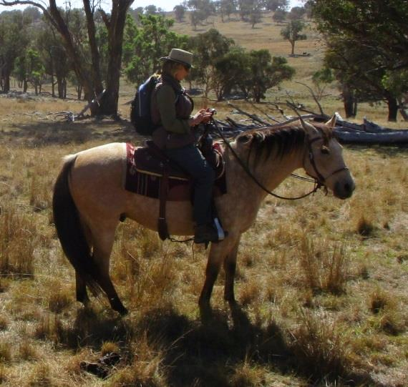
 | Disappointing that the weekend had to be cancelled, however, we now have some super rides set out at Barlow Park and the surrounding properties that the Bushrangers might like to take advantage of for a weekend ‘campover’ in the warmer weather later on in 2018

