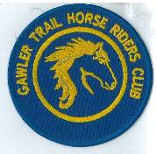
March 2019 Newsletter
Club Postal Address
P.O. Box 55
Gawler SA 5118
athra.com.au Email: Gawler.THRC@gmail.com
President - Julie Jackson 0419850793 Vice President -Tamara Godfrey 0417869695 Treasurer - Sandra East 0400884402 Secretary - Kath McCullagh 08 82807046
General Committee Maria Pearce & Lisa Rothe

GENERAL MEETING (1st Thursday of the month) 8pm Thursday 7 March 2019

All welcome Southern Hotel (next to Cafe Nova)
Come early for tea – 7pm

February Meeting
Ride Calendar almost complete for 2019
Come a Try Trail Rides to be introduced in 2019 ~ 3x/yr to encourage new members, details in progress

Members for 2019 Welcome
Welcome Back to Re-joining Members
Diane Scheafer of Cockatoo Valley, Kylie Kleeman of Lobethal
& Past Member Ruth Naismith of Williamstown
& hope you continue to enjoy may days of riding (& socialising) with the club

Coming Events
BEACH RIDE – Osborne Beach – Sunday 17 March 2019 - no need to RSVP
Host & Boss – Tamara Godfrey ph 0417869695 arrival ~ 6am ride/swim - off beach by 8am
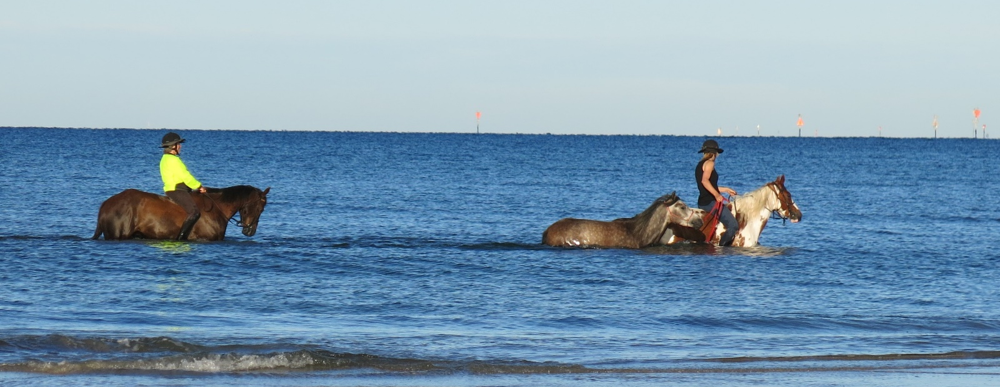
Ride description - We can ride south as far as Wigley St, Largs Bay. This is a short ride but those what are enthused can do it twice or just stop for a dip in the ocean back at Osborne.
Horses are only permitted on the foreshore between the hours of 4am and 8am. These times must be strictly adhered to as we would not want to jeopardize any future beach rides. The car park must be left spick & span:- All manure and hay MUST be removed prior to departing for home.
We will be cooking egg & bacon ‘sangers’ on the BBQ – so please BYO & join in.
Directions- Go down the Port River Express Way over the bridge onto Victoria Road. Turn left into Strathfield Tce or Gedville Rd; turn right into Lady Gowrie Drive (the Esplanade). Car park is opposite Moldivia Walk. There are toilets & a playground there and a walkway down onto the beach.
Cost:- Nil. A the beach is an unrestricted site there is “no ATHRA day membership” on this event & therefore all non ATHRA members ride at their own risk in this public area.

March RIDE OUT – Birdwood – Sunday 31 March 2018 - RSVP by 27/3/19
Host & Boss – Sandra Sampson phone 0417001158 Ride time – 9am > for an 10am start

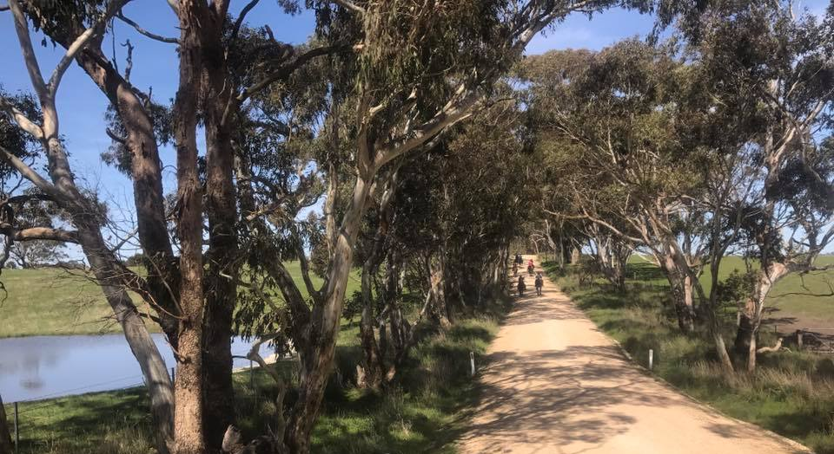
Ride Description:- The ride will be along shady roads and probably 2 - 3 hours long. BBQ after, BYO? – details to be confirmed in next newsletter

Directions: - provided to those that RSVP

Cost- ATHRA member $2 Ride fee. Non ATHRA member riding visitor fee $25/day (please be advised that if you are not a member of ATHRA you will need to be sponsored by an ATHRA member to ride & pre-register as a day member 3 days prior with ATHRA online - $15 direct to ATHRA & $10 to club on the day). Please bring the correct change & place in tin at sign on book.

RIDE CALENDAR FOR 2019 host MEETING DATES 2019
Rides are usually held on the 3rd weekend (Sunday calculated) & 5th Sunday of the month (if there is one).
Camps held ~1st or 5th weekend of the month (negotiable) Meeting dates are held on the 1st Thursday of the month

The following is a work in progress – dates, location & hosts to be continually confirmed
Please nominate a date if you have nominated to host rides
& MANY More rides needed to complete the calendar

March 17 | Beach Ride - Osborne | Tamara | 7 Mar
March 31 | Birdwood | Sandra S
April 14 | Trail Challenge Day Cockatoo Valley | Di S | 4 April
April 27 | Winery Ride | Lisa B
May 18/19 | Kapunda | Sandy | 2 May
June 16 | Mt Crawford - Cromer | Sandra S | 6 June
June 29 & 30 | Belvidere Camp | Richard
July 21 | Rosedale to Seppeltsfield (TBC) | Lisa C | 4 July
Aug 18 | Truro Gorge | Julie J | 1 Aug
Sept 14/15 | Leasingham | Sandy | 5 Sept
Sept 27-30 | Camp – Southern Flinders? | Kath
Oct 19 & 20 | Owen Camp & obstacle day | Julie J | 3 Oct
Nov | Forest Ride/Camp – Kuitpo (not 16-17/11) | Laine | 7 Nov
Dec 7 (Sat) | Christmas Dinner (TBC)
Dec 14/15 | Christmas ride (TBC)
? | Camp – Point Pass – (TBC) | Maria P

Past Events
BEACH RIDE – Pt Parham Beach – Sunday 10 February 2019 – by Di Scheafer
Following a few quite hot days during that week, the Sunday was predicted to be more on the mild side, however, the cooler forecast didn’t appear to dampen (hic) members’ enthusiasm, as there was a quite a lot of interest from members intending to attend the Pt. Parham beach ride.

Sandra East was the delegated Trail Co-ordinator for this rally and she invited me to come along again (as I had done so the year before…..??). As many of the Club Members are aware, I am not usually known for my early morning rides, however, I arrived at Sandra’s shortly before 6.00 a.m., transferred my gear into her vehicle, while Sandra caught and loaded the two horses, and we set off just after 6.00.a.m., arriving at Pt. Parham before 7.00 a.m., to put the club sign out directing any ‘new comers’ to our designated car and float parking area. Shortly after our arrival the first floats started to pull up and the Club members unloaded and got ready to go down onto the beach.

Pt. Parham is some distance away from most Club Members, and I overheard a few people comment on their unusually early Sunday morning wake-up call, with dear Sandy Jones saying her alarm clock doesn’t even have such an early hour alarm setting!!!! But she made it and said she had a great time!

It was actually a perfect morning, no wind, a little overcast, but very pleasant. The waves were just gently lapping the beach, so the horses could be ridden out some way and still be in relatively shallow water.

By 8.00 a.m., most members were ready and assembled for the ‘pre-ride’ briefing. The Pt. Parham rally is generally ‘informal’, with no actual ‘Trail Boss’, whereby riders can ride along the beach, or in the water for however long they wish, as long as they abide by the Club protocol, ride safely, be aware of the other horses and ride to your ability in such unfamiliar surroundings.

Everyone seemed to be having a wonderful time with some riders becoming a tad more adventurous than others, in relatively safe, shallow, clear, calm waters. Perhaps next year we could take a beach-ball and have a game of beach volley ball on horseback? Just to spice things up a bit…ha..ha..just kidding…. After a couple of hours of splashing about, the riders reassembled at the car-park where two b.b.q’s had been set up ready to cook breakfast. Many of the members then set up chairs and tables and had a social catch-up and brunch together.

It was fantastic to see so many riding members, non-riding members and visitors attend the beach rally. Including Kelly, Marjoleine, Tamara, Teena, Maria, Lisa & Gayle B, Kath, Sandy, Kylie & Kaice K, Teri, Julie, Lisa J, Sandra S, Lisa R, Di and Sandra E.

Thank you to Darren and John for bringing along the B.B.Q’s, and Chris for overseeing the cooking.
Thank you also to all of the participating members for making this Rally so enjoyable and fun, and also for cleaning up around their floats etc.. As many horse riders would be aware, some of the Pt. Parham locals (one in particular) look for any reason to complain about horse-floats being parked in the area designated, and horses being ridden on the beach, so it is in all of our best interest to be diligent with picking up manure and not to leave any hay or any signs whatsoever that horses have been there, so as not to fuel any controversy on the subject. Our Club Members would be well versed in this procedure at any venue, but at Pt. Parham one needs to be extra vigilant.

Horse Health & Wellbeing
Identifying Behavioral Pain Indicators in Ridden Horses – extract from “thehorse.com”

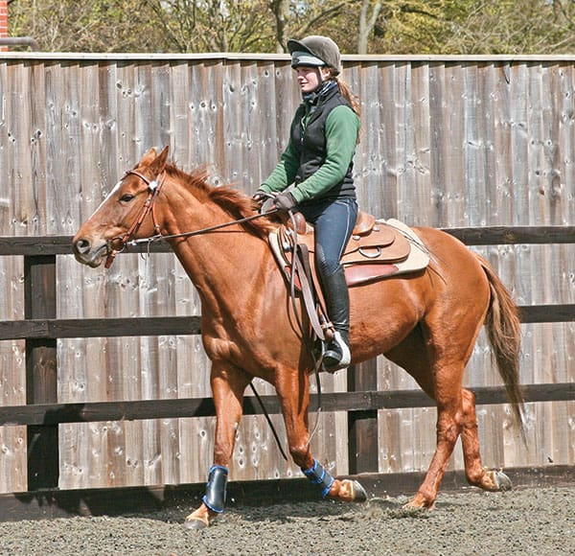
Researchers found that both trained and untrained individuals can use a ridden horse ethogram to identify behaviors likely indicative of musculoskeletal pain, but being educated about the ethogram produces the best results.

Your horse might buck if a bug bites, swish his tail if you give a whip-tap on his haunches, or show the whites of his eyes if he spots a very scary object. But one researcher recently reported that if these behaviors become regular occurrences, especially without provocation, your horse is probably trying to tell you he’s in pain.
In a series of studies over the past few years, Sue Dyson, MA, Vet MB, PhD, DEO, Dipl. ECVSMR, FRCVS, head of Clinical Orthopaedics at the Animal Health Trust Centre for Equine Studies, in Newmarket, U.K., and colleagues developed and validated an ethogram for ridden horses—a catalog of behaviors a horse might display under saddle and what they mean. She designed the ethogram to help identify low-grade lameness or pain in ridden horses.

In her most recent study Dyson compared horse behavior and pain scores before and after diagnostic analgesia (nerve blocks given during a lameness exam) to see if individuals with no specific training on the ethogram could use it to reliably recognize pain in horses working under saddle. She shared the results at the 2018 American Association of Equine Practitioners Convention, held Dec. 1-5 in San Francisco, California. “Owners and trainers are often poor at recognizing lameness,” especially if it’s subtle, Dyson said. “Performance problems are often labeled as training-related, behavioral, or ‘just how he’s always gone.’ “Horses are trying to communicate with us,” she added. “We need to learn to listen.”

Dyson said the original ridden horse ethogram contained 117 behaviors. In the current study she and colleagues focused on 24 behaviors they identified as most closely associated with pain (see sidebar). She said the presence of eight or more of these markers likely reflects musculoskeletal pain.

24 Pain-Associated Behaviors
Face
- Ears rotated back behind vertical or flat
- Eyelids closed or semiclosed
- Sclera (whites of the eye) exposed
- Intense stare
- Opening mouth repeatedly
- Tongue exposed and/or moving in and out of the mouth
- Bit pulling through the mouth, to the left or right
Body
- Repeated head position changes
- Head tilt
- Head in front of the vertical
- Head behind the vertical
- Head moving constantly from side to side and/or head tossing
- Tail clamped or held to one side or large tail swishing movements

Gait
- Rushed gait/irregular rhythm
- Sluggish gait/irregular rhythm
- Hind limbs not following in the front limbs’ tracks
- Repeated wrong lead and/or change of lead in front or behind in canter
- Spontaneous gait changes
- Stumbling and/or repeated toe-dragging
- Sudden change in direction of movement
- Spooking
- Reluctance to move freely/stopping spontaneously
- Rearing
- Bucking with or without kicking out backward

In the study Dyson had one assessor trained in how to apply the ethogram and 10 untrained assessors (two veterinarian interns, one junior clinician, five vet techs, and two veterinary nurses) assessors each watch videos of 21 horses ridden in working trot and canter in both directions by professional riders, before and after diagnostic analgesia (42 videos total). The videos were presented in a random order, she said. “The ethogram was applied in a binary fashion for each behavior: yes or no for the presence of the behavior,” she added.

The study horses had various diagnoses of unilateral or bilateral lameness in the front and/or hind limbs, kissing spines, or sacroiliac pain. Before veterinarians administered the diagnostic analgesia, the trained assessor identified three to 12 (with an average of 10) behavioral indicators of pain in ridden horses, Dyson said. After analgesia, the trained assessor pinpointed zero to six (an average of three) behavioral indicators of pain—a significant decrease in behavior scores, she said. “The untrained assessors also had significant reductions in behavior scores for all the horses after resolution of pain,” she said.
Additionally, “the reduction in behavior scores verifies a likely causal relationship between pain and behavior,” she said.

Dyson and her colleagues also analyzed agreement among assessors—how often they independently came to the same conclusions about a horse’s behavioral indicators:
- Agreement was “fair” among the untrained assessors for lame horses;
- Agreement between the trained assessor and the untrained assessors for lame horses was moderate; and
- After diagnostic analgesia, there was fair agreement among the untrained assessors and slight to no agreement between the untrained assessors and the trained assessor.
Based on these findings, Dyson concluded that both trained and untrained assessors can use the ridden horse ethogram to identify the likely presence of musculoskeletal pain. However, veterinarians, owners, trainers, and others using it require education on the ethogram for best results, she said.

Previous Member update
Hi friends of GTHRC,
I thought I would post this quick update of what and where I am at the moment!

(For those that don’t know me I was a past member of GTHRC for about 12 years and left in 2009 to relocate back to Victoria). I receive the newsletters that Kath kindly sends to me, they are very much appreciated and I often get the drools of envy when I see the pics of your rides and functions, especially the beach rides. We are nowhere near the beach up here. Ah well, at least I have the memories and made some wonderful friends too.

So - Paul and I have moved again! What? You say!
We were at our 5 acre property at Woori Yallock (55 klms east of Melb) for 9 years, (where we moved to from Gawler Belt), we got a price on the place we couldn’t refuse, paid off the mortgage, semi-retired and moved to 60 acres NE of Victoria in a little township called Boho. There’s not a lot at Boho except a really nice fire station and lots of big farms. It’s 20 klms west of Benalla and 10 klms east of Violet Town, just off the Hume Freeway so quite accessible from Melbourne city. In the scheme of things around here our 60 acres is miniscule! That’s OK, it’s certainly big enough for us especially in the spring!

We moved here on 1st September last year and we just love it. If anyone has ever watched the TV show called ‘Escape to the Country’, they have 2 houses then the 3rd is the mystery house? Well we bought the mystery house. We weren’t going to look at it, not right location, too much money, etc. etc. but it’s perfect for us, we live at one end and Pauls 90yo mum lives in the other end. Lots of shedding, 5 big paddocks, cattle yards, a big dam, room for the arena, you get the drift? We are also lucky enough to bring over cattle from across the road when required, then send them back when feed and/ or water gets too low.

I’m still working at Woolworths and managed to get a transfer to the Benalla store, still in the Meat Dept (which I really like) and only contracted to 16 hrs pw though more often than not there are more hours than that worked each week! Paul is ‘between jobs’, is ‘looking’ but I don’t think it’s very hard! Some part time work may be coming his way which will be just perfect. He’s done 40 years interstate truck driving so deserves some time off the road. He has joined the local CFA Fire brigade (been a 20 year past member elsewhere) and has already been an active member, 2 days after he was signed up and ‘official’.

I still have Sunny (25 and retired) and Dale is 16 ½ and still my main riding horse. I do however have another waiting in the wings once she is old enough. Her name is Tootsie; she’s an Appaloosa (of course!) and is only 13.2hh and 3yo so lots of growing still to do yet though she’ll be lucky to hit 14h I’d reckon. Very perfect for me, less to fall and less to get back on, lol. Her mother was an underweight pregnant rescue from the sale yards (not by me) and 2 months later out popped Toots. She needed to be rehomed back before Xmas last year due to drought conditions so she came to live with us. She has fitted in wonderfully and is a really smart cookie.

My main riding pursuits up here at the moment are mountain trail courses and trail riding. This is a great area locally for quiet roads. Some of the roads are just formed tracks, dirt or gravel and no traffic except for the odd escapee cow or sheep! I’m still a member of the Working Equitation club back in Melb and will re-join something up here once my friend Brenda and I find a suitable club. At least if I’m not a member of a local club then I can’t put my hand up for the Committee, ha ha ha. I’m seriously having a rest from all that as somehow I ended up Madam President and newsletter editor of the last club, for 6 years!

I’m doing lots of clinic organising for Steve Halfpenny who is based in Blanchetown but visits us regularly over here. There is a venue called Banyandah Naturally, just over an hours drive from here, up on the Murray border in a town called Howlong. It’s 400 acres of horse heaven for riders and is very popular for clinics so I arrange for Steve to visit there regularly, as well as in the local area. That keeps me very busy so no time for Committees!

I have just recently decided to become a stockist for Inside Out Equine Nutrition. Erika Gough has a mineral pellet on the market that is fabulous and there’s no-one selling it up here so I’ve put my hand up for that. Hopefully it’ll give me new leads of horse folks around the area. I’ve arranged for Erika and Steve Halfpenny to speak at a ‘chat night’ next Monday at the local CFA station, to introduce themselves to the area so I’m looking forward to that. I have about 20 coming so far so it should be a good night with lots of good info being distributed.

Anyway, all the best to you all, happy riding and stay cool and safe. Regards Helen Sharp

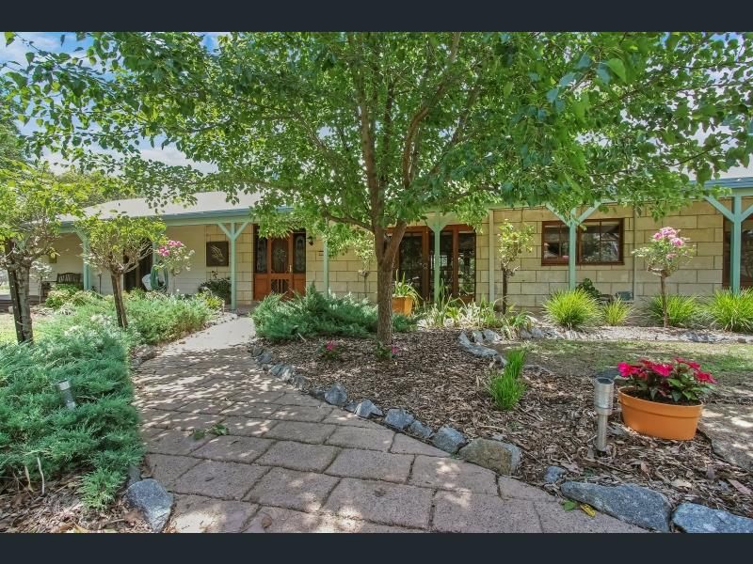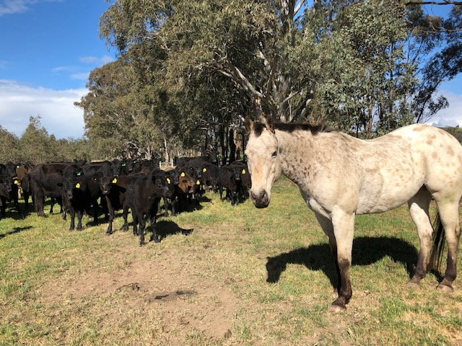
Front of new house Dale with neighbours cows, front paddock
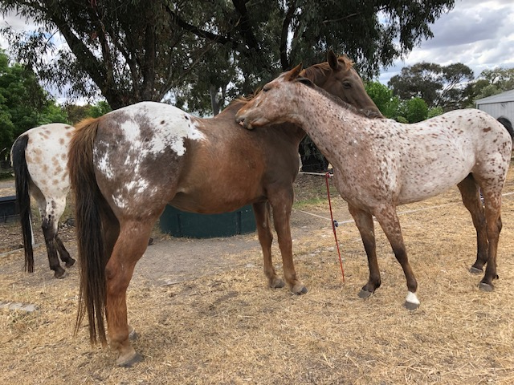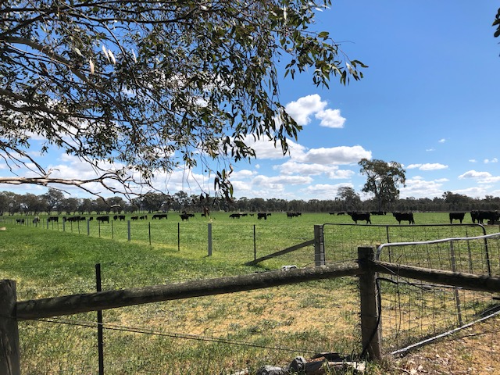
Sunny and Tootsie Back paddocks, back in the spring!
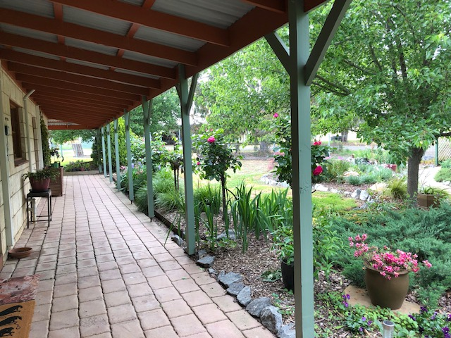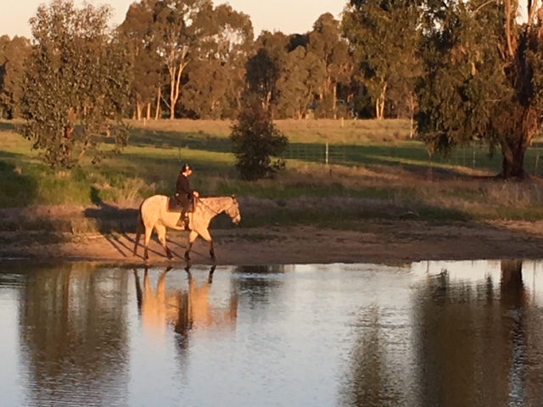
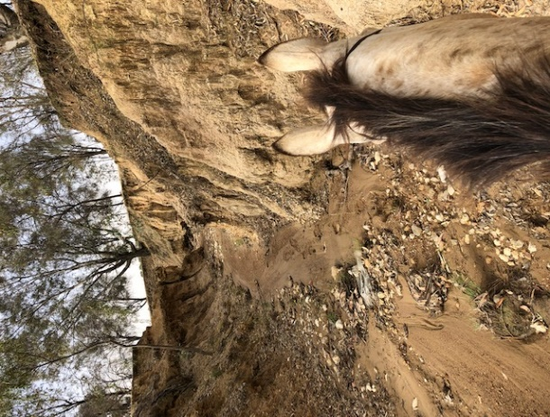
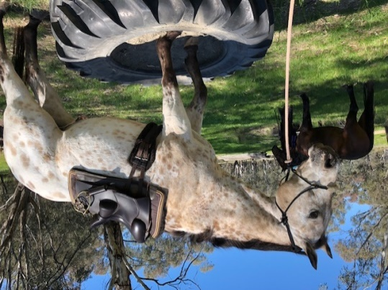
Front garden Riding around the dam
Riding in the dry creek across the road

Dale doing what he does best – just hanging about!

NEWSLETTER DEADLINE
The deadline for any items that members want printed in the April 2019 newsletter will be Wednesday 17 April so please ensure that your emails reach Kath kathryn.mccullagh@hotmail.com before that date to avoid disappointment.

Policies
A reminder to all members that our club has some policies that we endorse. These include a NON SMOKING, SAFETY & HOT WEATHER policy. These can all be viewed on the ATHRA web site, via the state page - www.athra.com.au.
Previous Newsletters, photos & club information can also be viewed at any time on the ATHRA web site.
WEATHER
The ride host/leader for the day will have the final say regarding weather (including inclement weather).
The hot weather policy states, if the weather forecast in ELIZABETH for the next day is to be over 32 deg (as per the news the night before) the club rally/ride will be cancelled (unless the ride is scheduled to commence prior to 9am or after 6pm). This is for the safety of all riders and horses. Also, any club rides in FOREST areas on TOTAL FIRE BAN days will be cancelled.
Please check with the Trail Boss if in any doubt. They have the final word!
CLUB UNIFORM
Our club uniform currently comprises of a lime yellow high-vis shirt (long or short sleeve), club badges available for $12. Gawler Club Members & their visitors are required to wear Safety Helmets whilst mounted - helmet must be no more than five years old from Date of Manufacture.
RIDE FEE & DAY MEMBERS
ATHRA members - a ride fee of $2 per ride is applicable.
Non ATHRA Members (Day Members) – a ride fee of $25/person/day is applicable ($10 to club on the day & $15 to ATHRA with pre-registration) (Non-refundable fee, maximum 2 days as a day member).
The important things to note: 1. Day Members must be sponsored and accompanied at all times by an ATHRA member during the ride or event.
2. The Sponsoring member must make the Day Member aware of ATHRA rules and requirements of the Code of Conduct.
3. They may only sponsor 1 Day Member per ride.
4. By participating as a sponsor, the sponsoring member acknowledges responsibility for the conduct and behaviour of the Day Member
5. Day Members must contact the trail boss to discuss attendance & then pre-register with ATHRA Online at least 3 days prior to ride.
RIDE HOST CHECKLIST
A ride host’s checklist is in the green bag, in which is kept the sign in book, ride fee tin, saddle bags, first aid kits, safety vests, etc. Trail Bosses are to check the list to make sure all is in order prior to your ride. It is also the Hosts responsibility to ensure a ride report is arranged to be submitted to Newsletter Editor prior to next publication date.

DISCLAIMER
The material in this newsletter is for the benefit and information of our members. The items are in the nature of general comments only and are not to be used, relied or acted upon without written permission of GTHRC. The club accepts no responsibility for any errors or omissions or for any damage suffered as a result of any person acting without written advice. All opinions and views in the newsletter are not necessarily the view of the club, but are personal opinions only.

