TAMWORTH BUSHRANGERS TRAIL RIDING CLUB
Newsletter: November/December 2018
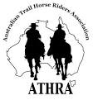 | President: Angela Witherdin  0418234854  awitherd@bigpond.net.au  Vice President: Bev Fletcher  Secretary: Francie MacLean  0407660334  Treasurer: Anthony Read  0409362434  Newsletter: barlowpark2@gmail.com
Commiserations to those members who were unable to attend the infamous Tamworth Bushrangers Christmas party on Saturday 24th November 2018. You unfortunately missed a wonderful evening of laughter, light hearted conversation, fun entertainment from some of our members with questionable talent and the choir with no talent at all.
However, first things first ………… 14 Riders gathered at the fray for the last official Bushrangers ride for 2018 and here is the ride report prepared by Helen Woods.
Nundle Pony Club Grounds Taylors Lane, Nundle

Saturday 24th November 2018

Season’s Greetings Bushrangers and all other peeps.
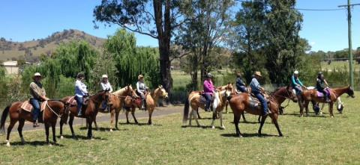
With plans “A, B and C” all a no go, decisions were made that our final ride for 2018 would be plan “D”, a relaxing ride around historic and scenic Nundle.

Nundle for those who may not know, started life as a gold mining community. This township is positioned between the Peel River and slopes of the Great Dividing Range. Nundle is located 392 kilometres north of Sydney via the New England Highway and 59 kilometres south east of Tamworth.

The name Nundle is probably a corruption of a Kamilaroi Aboriginal word meaning “mouth” and probably refers to the mouth of the Nundle River as it flows into the Peel.
I googled all of that!!
So on with the ride report.
Following what had been some awful weather leading up to this weekend, the weather in Nundle on Saturday 24 November 2018, presented as a perfect, trail riding day. Our ride would take us from Nundle Pony Club grounds then on to a scenic tour around Nundle and return from whence we begun.
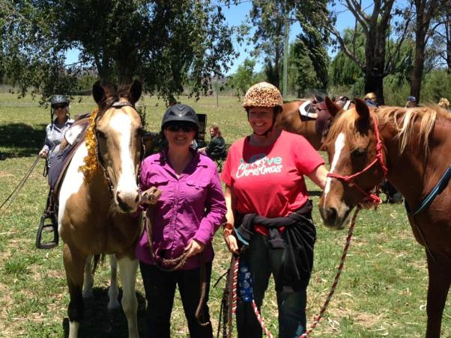
Fourteen horses and riders, some in festive dress fronted at 9.45 am for our usual pre-ride brief and leisurely depart at 10.00 am
As it happened, by 10.15 am “Little Jack Smith” had discarded his festive attire, dropping it on the trail for others to step on.
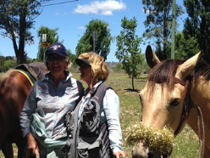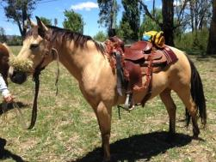

From Nundle Pony Club Grounds our ride covered approximately 10 kilometres through the back streets of Nundle and along some of the quieter roads. Through 'suburbia' we briefly encountered traffic, dogs, children, bikes and several oddly placed washing machines left on roadside. I can proudly say every one of our wonderful trail horses took these in their stride. We rode a couple of short hills, navigated brief rocky patches, not drawing breath as friends discussed the year ahead and behind.
Just prior to reaching our morning tea and rest stop, Capable Clayton with his clever steed demonstrated some fine cutting horse moves when a local dairy cow got down low and worked a fence line. Well done Clayton for keeping that fearsome milker under control!!
Next it was morning tea on the Peel under some shady trees. A big thank you goes to our Chuck Wagon Mike who, whilst we were out and about, had kindly delivered and set up our tea spot. Here we watered the horses then chowed down to the most amazing and tasty spread.
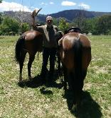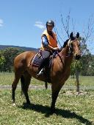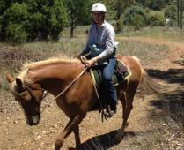
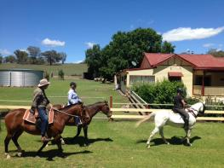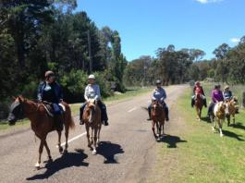
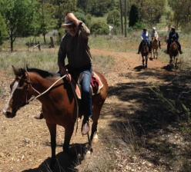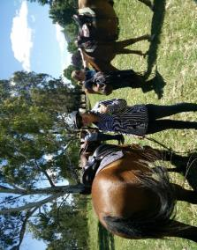

Following a good break, we then made our way home, halting on the way just long enough to pick up festive decorations previously discarded by “Little Jack Smith”.
Riders on the day were Ange, Judy, Donna, Clayton, Megan, Claudia, Eloise, Francie, Duncan, Kylie, Carmel, Rebecca, Sally and Helen. Our non-rider was blind camera man Mike, who travelled in 4WD Black Betty. A special mentioned goes to Bec. This was Bec’s last ride with the club as she moves away to take up a new position down south in snow country. We will miss riding with you Bec and wish you all the best in the future.
Thoughts were also with Ken and Lynda who had intended to ride but had to pull out due to an unfortunate horse injury. We hope he is healing well and look forward to many more rides with you next year.

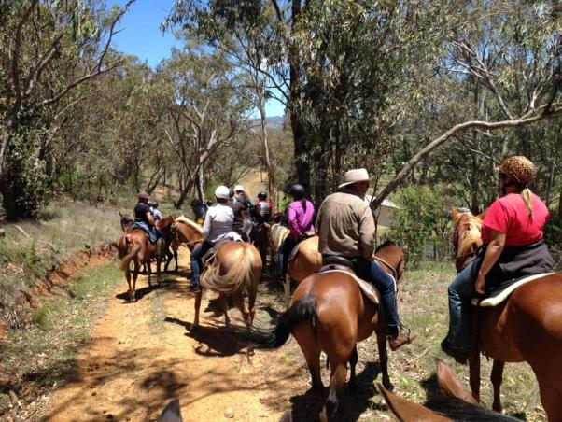
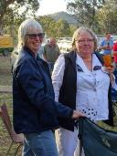 | 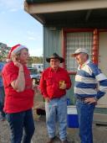 | The evening commenced late afternoon with current and past members and visitors from neighbouring ATHRA Clubs gathering in the quadrangle outside the cabins enjoying nibbles and drinks while laughing and chatting and catching up with friends new and old.
 | 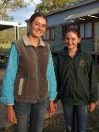 | 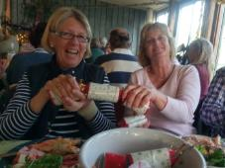

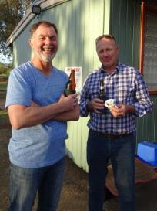  Reason to Smile | Our treasurer was so keen not to miss this event his effort to get to Nundle can’t pass without a mention. Anthony is currently on assignment in Melbourne until September 2019 and despite travel arrangements planned in advance to allow him a relaxing weekend visiting Tamworth (catching up with friends and horse “Play Station” who is agisting at Donna and Collins) – it wasn’t to be. Horrendous winds in Sydney with all but one runway closed to air traffic meant delayed flight from Melbourne and cancelled flights to Tamworth. So having finally arrived in Sydney with no prospect of flying to Tamworth before Sunday our intrepid traveller caught a train to family, borrowed a car and drove himself arriving just in time for the party. Early start Sunday to drive back to Sydney to return the car and meet his flight to Melbourne. Thank you for the effort Anthony, we all loved being able to catch up with you again.
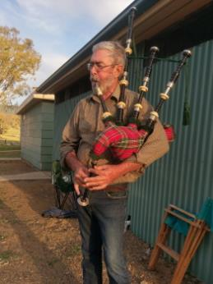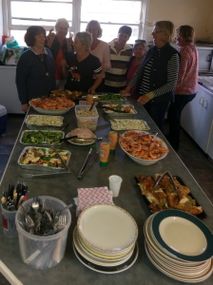
Duncan on the Bagpipes heralded the clan to Dinner of Prawns, lovely selection of cold meats, salads and sweets.
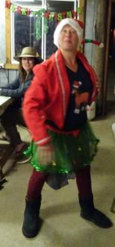 | Many, many thanks to Helen for her effort in organising the evening ……. Who else would be game enough to not only gather together a group of women late in the evening after many drinks had been consumed; arm them with cheap tin whistles from Bon Bons decorating the tables and expect a recognisable tune to be the result. Eternal optimist Helen!! |  | 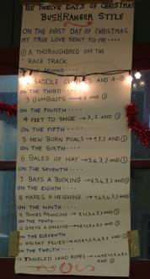
 | 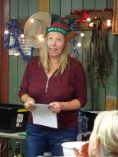 | 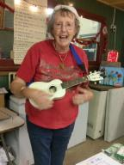

Just a reminder to renew your ATHRA Membership for 2019 particularly if you are out and about pre riding for future club rides. Renewal can be done on line by logging in to the ATHRA Website www.athra.com.au Click on the Membership Tab on the Right hand side of the Home Page, then go to Member Login & Renewal. You will need your Membership no. and email address. Also on the same tab is a link to New Membership Registration.

BUSHRANGERS OUT AND ABOUT …. Adventures on Horseback
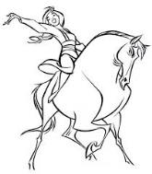
Now What Could Possibly go Wrong …..
- No Helmet
- No Stirrups
- Unfamiliar Saddle
- Unknown Horse
- New Environment

Who might this be???

Reminder from the Editor: This Newsletter is put together for the information and enjoyment of our members, however, articles can only be published if you provide them. As horse loving Trail Riders it is not just about the monthly ride and the Ride Report even though this is perhaps the most anticipated article (hope they didn’t mention ….. or use that photo!) Would love to receive news of other ‘horsey’ happenings – eg. How did you go at Pony Club?: Something funny happen on the pre-ride?: See something amazing at ALEC?: Ride with another club? In another country? Your horse trashed his new rug?: ……. If it is ‘horsey’ it will probably be interesting. With the summer break members will still no doubt be riding occasionally so submit a few words with pictures to: barlowpark2@gmail.com
Also the photos in this newsletter have been dramatically reduced in size and some will not be on Facebook, so if you see a photo you would like in a larger format just let me know as I have them all saved to file and can email to you.

