TAMWORTH BUSHRANGERS TRAIL RIDING CLUB
Newsletter – JULY 2018
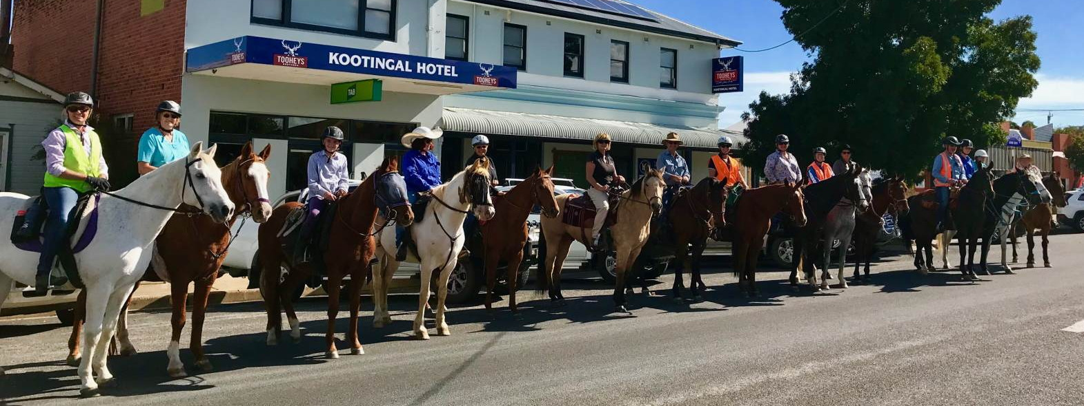
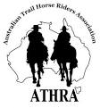 | President: Angela Witherdin  0418234854  awitherd@bigpond.net.au  Vice President: Bev Fletcher  Secretary: Francie MacLean  0407660334  Treasurer: Anthony Reid  0409362434/67665448

NO RIDE REPORT THIS MONTH

What sounded like a lovely ride was cancelled at the last minute because of RAIN …
which was rather ironic as it was the only day in the whole month that received any
precipitation at all – and we do need the rain (what an understatement that is) but any
other day would have been ok.

In last month’s newsletter Megan noted a quieter lunchbreak with a few of our regular members absent - in particular Eloise’s favourite story teller and general club “entertainer” Helen ……..

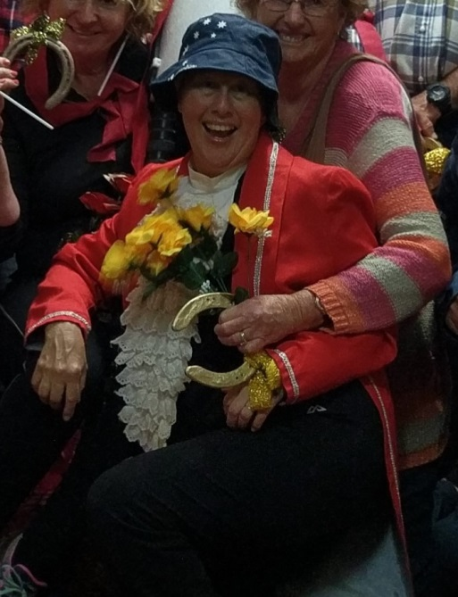 | 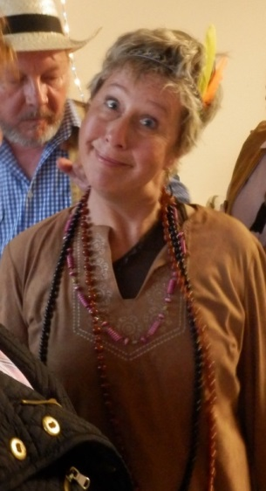 | 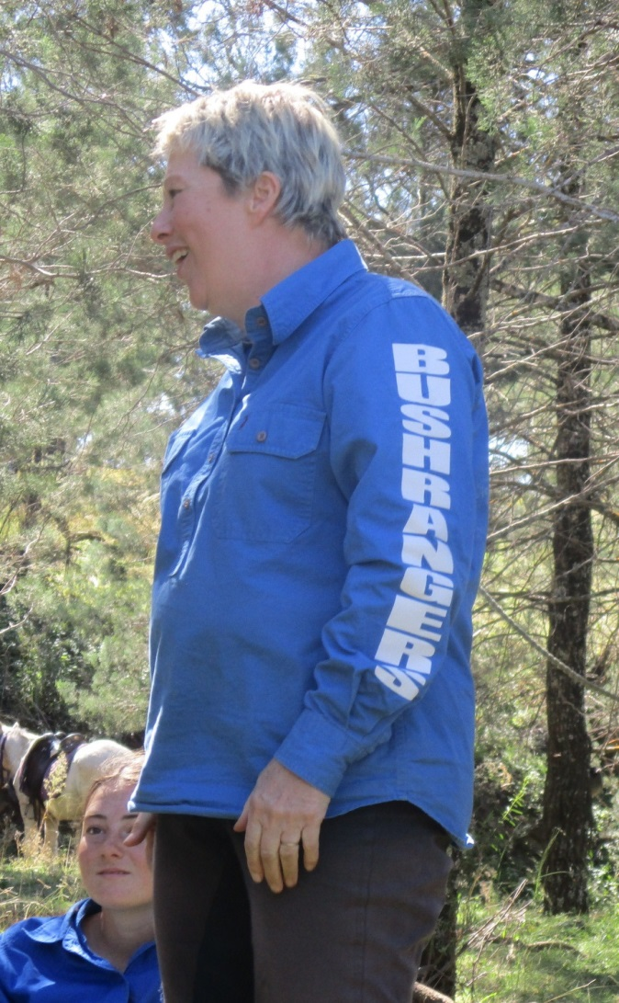 | But there is a good reason for Helen’s absence for the past couple of months, so  in her own words .....

Tales of Tilly and Tinkerbell

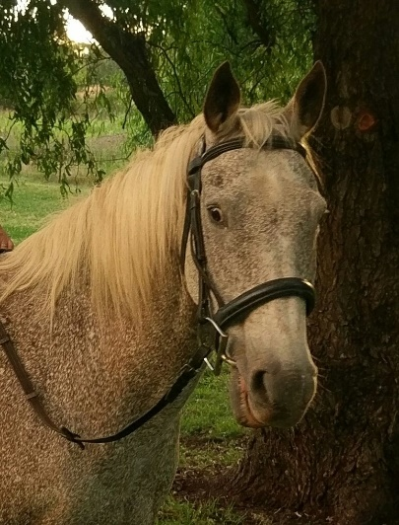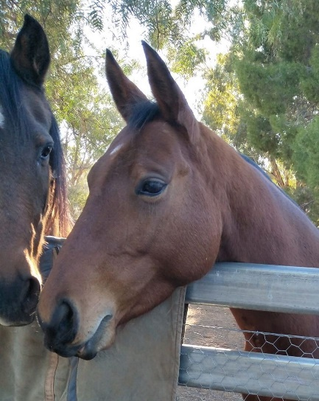

Sometimes decisions on what to do are not easy.

As many will know, I have, for some time been searching for a new trail riding horse and then if one become available, debating on what to do with my long-time companion Tilly.

Well a month ago amongst winter, the drought and some tough family times an opportunity arose where a new pony was found and a kind home for Tilly also became available.

So, it is with both joy and sadness I announce Miss Princess Matilda Woods has left our bare and dusty paddock and moved to Wauchope. Here she now lives with a gentle palomino called Magic and a family who will love her. She lives on 100 acres of grassy grazing land, a forest and a dam and reports and photos on Facebook tell she has settled well and that they love her.

Now for my new pony.

Her name is Tinkerbell and she is a 5-year-old red dun quarter horse. It is still early days but so far, she is proving to be a gem. For me buying Tinkerbell was a huge and scary decision. Any way I took the plunge and so far, so good.

Whilst on this adventure, I have been humbled again and again and am truly grateful to the support that has come from my bushranger friends. Thank you firstly to Ange who found the horse and came along with me when I test rode. Following this she has also spent hours and hours generously giving me ground work pointers and the confidence to just get on and do it. Thanks also to my Mike who has not only provided morale support in this venture but has also given his time to drive me all over the country side. Then came Alison, who took me out on Tinkerbell’s very first trail ride followed by another where we were joined by Francie. What a frill it was when together we cantered, all on loose rein up the long drive way and along a quiet rode. Then today out came Megsie, Claudia and Eloise who took me around the streets on our first ever ride through suburbia. Thank you everyone, I am so appreciative of what you have done for me. got a cracker!!

And as for Tinkerbell, it is still early days but if I may borrow our Megsie’s words…I think I’ve got a cracker!!

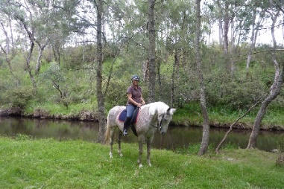

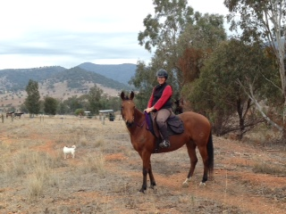

Helen Woods

BUSHRANGERS OUT AND ABOUT …..

One fine sunny Monday a very impromptu ride managed to come together for some of my fellow Bushranger Buddies. An unusual event in itself as we all lead crazy busy lives, like most people! So Ange and Zac, Helen and Tinker bell, myself on Smokey headed to Alison’s place to explore the countryside with Alison on board Comet.

We had a lovely time and managed to find a few lovely tracks for a canter. Following the ride we all had a cuppa and a nice chunk of cake and a few laughs. And vowed we must catch up again soon. It’s a lovely break to catch up with good buddies and do what we love.

If only ‘life and its busyness would stop getting in the way!!

Thx Al for your hospitality.
Megsy

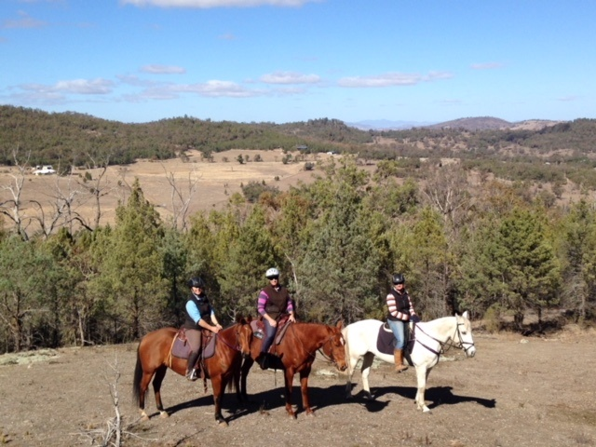

Happy Birthday

Cheers to all our wonderful partners and hope they had a wonderful Birthday on August 1st and partied hard with lots of carrots.

