TINDERRY TRAIL HORSE RIDERS | 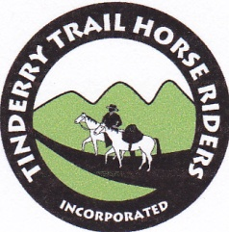
APRIL RIDE – BOOROOMBA STATION
2016 has been a year of perfect weather for trail riding. The first Saturday in April saw the Tinderry club at the top of a high hill on Booroomba Station with spectacular views over the southern ACT. Thanks Don for your hard work to plan such a good ride.
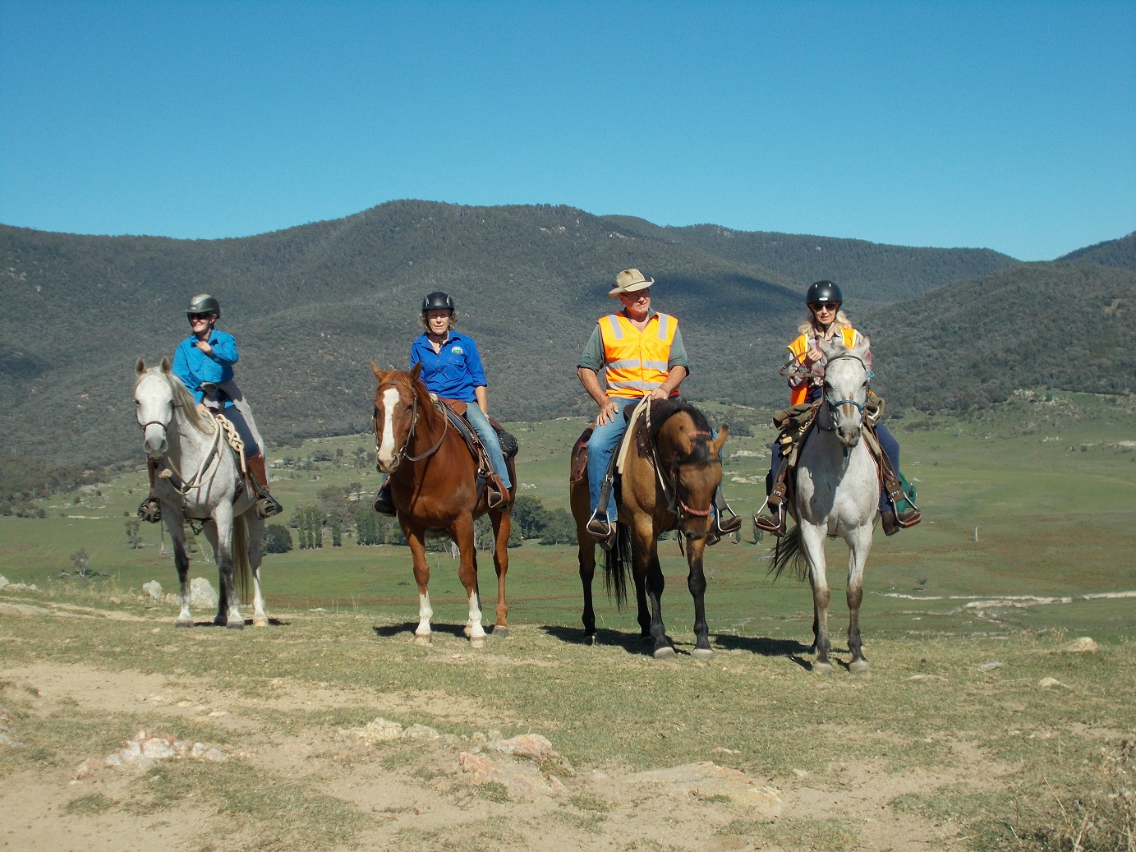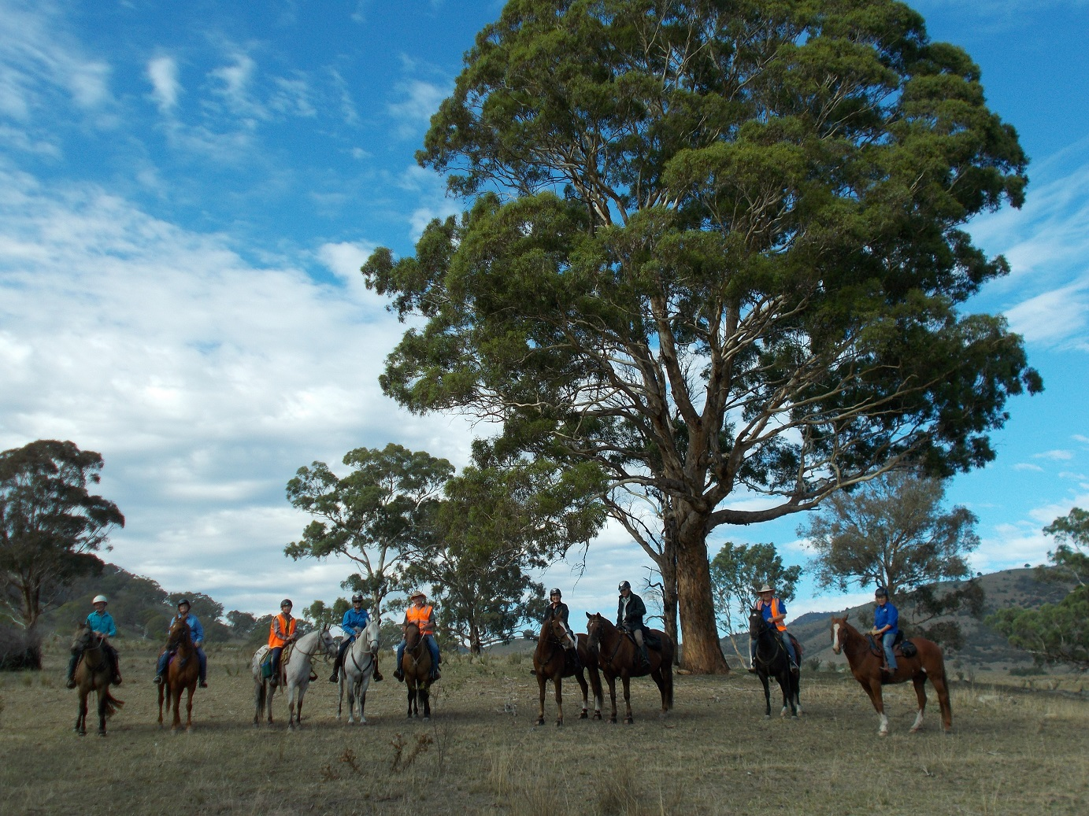
UPCOMING RIDES
4 June: Tinderry club ride to Arboretum ACT. Contact: Nic Webb 0439 490 127
2 July: Tinderry club ride around Red Hill ACT. Contact: Judie Conolly
6-7 August: Tinderry Weekend at the Coast (location TBA)
MAY RIDE - BREDBO
Welcome to our new members! What a good turn up we had for this ride, with 2 new members, and 2 potential members, joining Tinderry and Monaro Trekker members for a ride to the Goatshooters Hut on a beautiful autumn day. Billy accepted the challenge of driving the support vehicle through the Murrumbidgee River (low after a long dry spell) and over some steep hills to deliver a welcome BBQ lunch at the Hut.
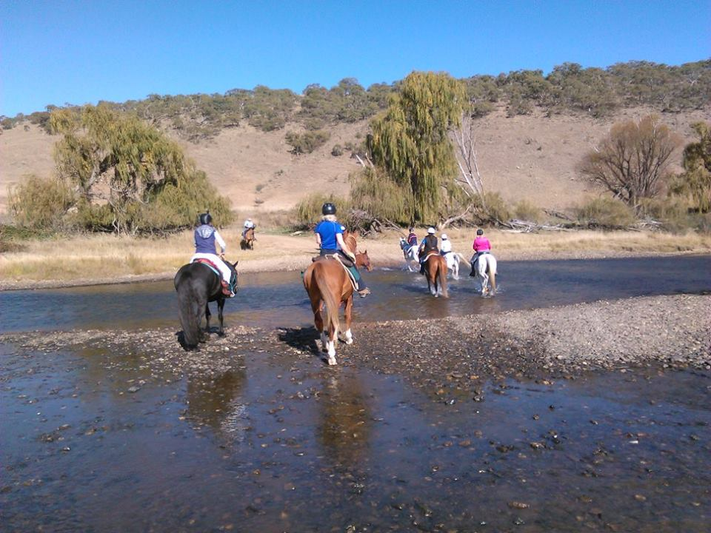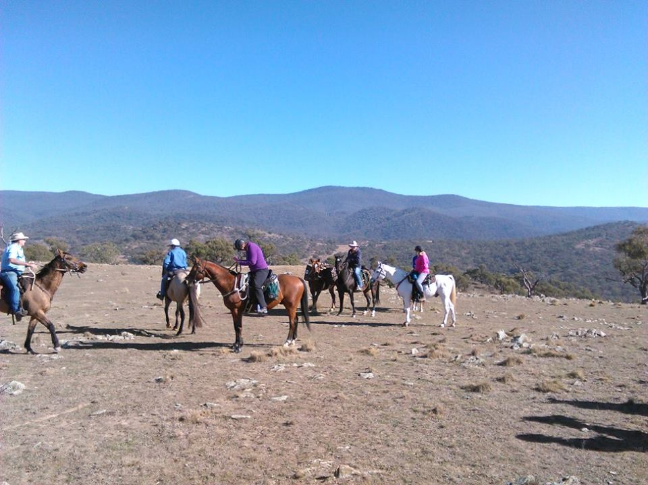
Thank you Helen Palma and Lesley Rose for the photos.
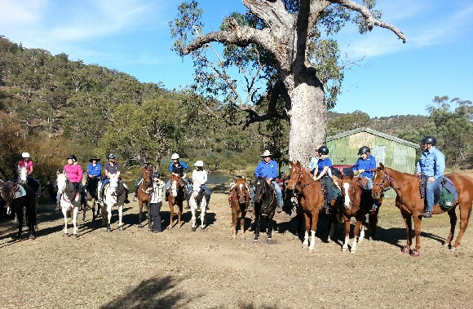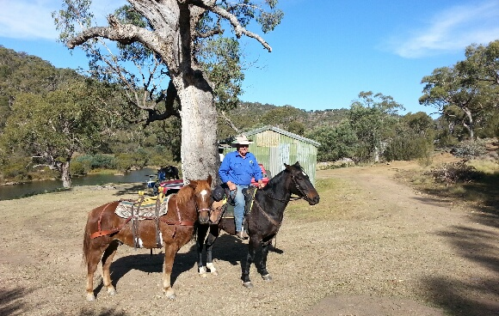
RIDE ETIQUETTE AROUND WATERING POINTS
Watering points are potential sources of accidents. To keep everyone safe, please consider others when at watering points, that is, dams, puddles or creeks. It is likely to be crowded at watering points as thirsty horses will want to drink, while others may just want to play. Horses or riders can be kicked if a bottleneck occurs. Please follow these basic rules.
- Spread out around dams to give horses room to drink.
- A thirsty horse will drink straight away. If your horse isn’t thirsty, move it well away from the water to let others behind you come through.
- Some horses like to play and paw the water. Please don’t let them as it muddies the water for other horses wanting to drink. As soon as your horse has finished drinking, move it away the water to give others space to come through.
- If your horse is at the end of the queue, don’t let it crowd horses still drinking.
- If your horse doesn’t drink, remember there is always another watering point further up the trail.
Happy trails, Hilary Gunn TTHRI Secretary 2016

