January 2019 Newsletter
Club Postal Address
P.O. Box 55
Gawler SA 5118
athra.com.au Email: Gawler.THRC@gmail.com
President - Julie Jackson 0419850793 Vice President -Tamara Godfrey 0417869695 Treasurer - Sandra East 0400884402 Secretary - Kath McCullagh 08 82807046
General Committee Maria Pearce & Lisa Rothe

GENERAL MEETING (1st Thursday of the month) 8pm Thursday 3 January 2018

All welcome Southern Hotel (next to Cafe Nova)
Come early for tea – 7pm

Members for 2019 Welcome
Welcome Back to Re-joining Members
Julie Jackson of Gawler River, Jeannine Skene of Point Pass,
Marjoleine Lloyd of Two Wells & Kylie Bryant of Tanunda
& hope you continue to enjoy many days of riding (& socialising) with the club
Coming Events
January Moonlight Ride: Gawler River – Saturday 19 January 2019
RSVP to Gawler.THRC@gmail.com by 16 January
Host & Boss – Julie Jackson 0419850793 5pm arrival for 6pm ride

Ride description: Riding out on various properties and quiet gravel/sandy roads in the district with slight undulation. Ride will be duration of about 3 hrs, walk & some trot. It will be a 6pm start with an unmounted briefing at 5.45pm. Moonrise is at 5.31pm (meridian ~10.45p) and sunset is at 8.31pm (expecting 90% moon if no clouds) so we should have good light for an enjoyable ride.

Any riders wishing to come at 4pm for a BBQ are more than welcome. If you don’t want the BBQ you can arrive at 5pm.

To participate - Rider must wear reflective clothing (hi-vis with reflective strips), and it is advisable to take a torch or head light (worn on helmet). (Some spare vests should be available for those who do not have hi-vis reflective gear). For your information/safety here is the link for road rules for riding horses on roads from DPTI: http://www.dpti.sa.gov.au/towardszerotogether/safe_road_users/horses

N.B. Hot Weather Policy may apply – as always the trail boss (Julie) has the last word!

Ride Grade: Hazards will be Kangaroos and rubbish dumped on the sides of the very quiet back roads. Terrain mainly flat out our way but a bit of undulation. Walk & Trot. Roads and tracks are of limestone and dirt which are ok for seasoned bare foot horses. We do have to cross the bitumen Two Wells Road twice but William will control the traffic as he has done in the past.

Directions Gawler River area
– Full Directions to be sent to those that RSVP to Gawler.THRC@gmail.com
Club sign will be posted at entrance. Clean up of manure and hay afterwards as usual.

Cost- ATHRA member $2 Ride fee. Non ATHRA member riding visitor fee $25/day (please be advised that if you are not a member of ATHRA you will need to be sponsored by an ATHRA member to ride & pre-register as a day member 3 days prior with ATHRA online - $15 direct to ATHRA & $10 to club on the day). Please bring the correct change & place in tin at sign on book.

RIDE CALENDAR FOR 2019
We will be continually discussing our monthly ride calendar for the next couple of months, PLEASE get those ideas & dates to the committee …Please make suggestions of rides that you would like the club to do & maybe some new rides, pretty rides, bush, forest, country or just a favourite ride you would like to share. Remember it does not need to be from your home, but the start of the ride need to have parking of floats. So give it some thought & let us know. Or even just let us know which of the rides the club has done that you would like to do again. (Ring or Email Julie Jackson 0419850793 connellvale@bigpond.com)

Remember it’s your club, so vote for a ride you want to do & we will find a volunteer to host….
Ride Nominations (Saturday or Sunday) –Mintaro (Sandy), Truro Gorge (Julie), Seppeltsfield Winery Tour (Maria), Tungkillo (Sallyanne), Birdwood (Sandra S), Mt Crawford Forest (Lainie),
we also try to schedule road rides in winter (forest rides have to be when ground not too wet or fire bans in place)
Camp Nominations – Robe, St Kits (Maria), Owen & tail course (Julie), Waterloo (Sandy?)
As not all members can travel/camp the camp nominations will be mostly been scheduled as additional weekends (~5th weekend of the month or 1st if we have nominations) - camp weekend dates are negotiable

Woo Hoo – Looking forward to another great year of riding in our great state

DRAFT - RIDE CALENDAR FOR 2019 host MEETING DATES 2019
Rides are usually held on the 3rd weekend (Sunday calculated) & 5th Sunday of the month (if there is one).
Camps held ~1st or 5th weekend of the month (negotiable) Meeting dates are held on the 1st Thursday of the month

The following is a work in progress – dates, location & hosts to be continually confirmed
Please nominate a date if you have nominated to host rides
& MANY More rides needed to complete the calendar

Jan 19 | Moonlight Ride - Gawler River | Julie | 3 Jan
Feb 10 | Pt Parham | Sandra E | 7 Feb
March 17 | Beach Ride - Osborne | Tamara | 7 Mar
March 31 | Humbug Scrub | Kath
April 14 | TBC Trail Challenge Day Cockatoo Valley | Di S | 4 April
May 18/19 | Kapunda | Sandy | 2 May
June 16/17 |  |  | 6 June
June 29 & 30 | Belvidere Camp | Richard
July 20/21 |  |  | 4 July
Aug 17/18 |  |  | 1 Aug
Sept 14/15 | Leasingham | Sandy | 5 Sept
Sept 27-30 | Camp – Southern Flinders? | Kath
Oct 19/20 |  |  | 3 Oct
Nov | Forest Ride/Camp – Kuitpo (not 16-17/11) | Laine | 7 Nov
Dec 7 (Sat) | Christmas Dinner (TBC)
Dec 14/15 | Christmas ride (TBC)

Past Events
Club Christmas Dinner Gathering: Seppeltsfield – Saturday 1st December 2018 By Maria

On December 1st the Gawler Trail Riding Club members came together to enjoy an evening of fun, laughter and plenty of eating and drinking at Seppeltsfield for the Club’s Christmas dinner. On reflection I remember taking a moment to listen from within the home and there was plenty of noise from the crowd outside….. it was clear to me that there was a happy group of people out there mulling around that night.

We had 34 people enjoying the Christmas cheer with each other and the weather was not so bad for the night – its changing patterns did not worry us a bit …. One minute we were sitting out in the garden patio enjoying drinks and platters and then the next the heavens opened and we were gathering ourselves undercover. We enjoyed wonderful salads and vegetables brought by members that accompanied the most succulent and tasty roast meats of turkey, pork, lamb and beef – we were spoilt for sure with the quality and quantity of our foods.

Sincere gratitude to Craig Crinion for purchasing, cooking and serving our meats for the night. A huge job – he was helped by Chris as well who was very happy to hand this major job over to someone super capable of getting it sorted and out to the servery. We also enjoyed lots of beautiful desserts that were supplied by members – a great selection of treats. The group partied on until late and the atmosphere seemed very enjoyable for everyone.

I wish to thank all the members and partners who helped put our Christmas dinner on for the night. Julie and William, Sandra East and Di Schaefer who came to help during the day to ensure all was ready for the evening – you all made such a difference – thank you. Our partners continually come along and join in helping a great deal for our events, and I do thank husband Chris for his constant work on this occasion also. Special thanks to Julie and William for the extra visits they paid to our place to help out before and after the event.

All in all it was a lovely night together .

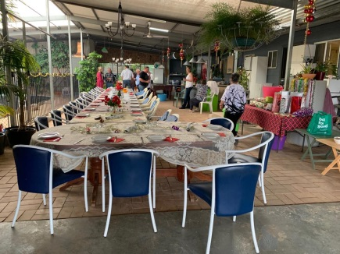 | Happy  Christmas  Everyone  2018
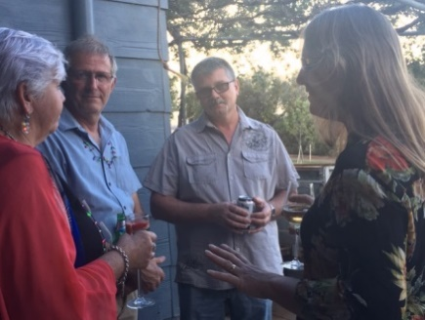 | 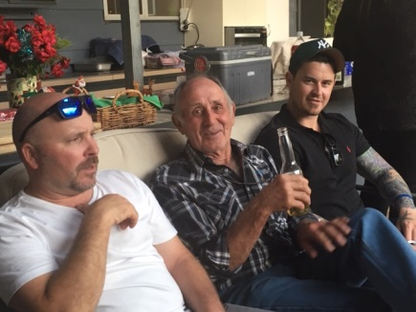
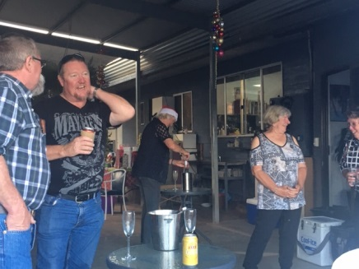 | 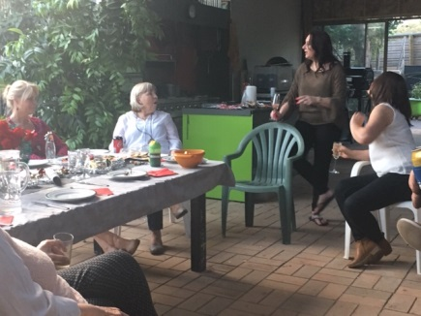
 |  | 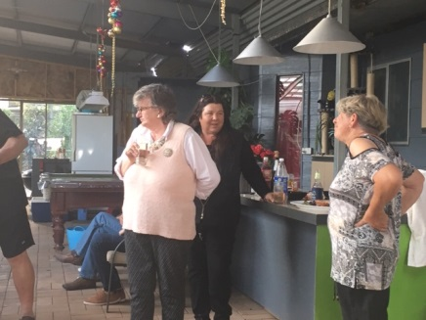

December RIDE OUT: Rosedale Christmas Ride - by Kylie B

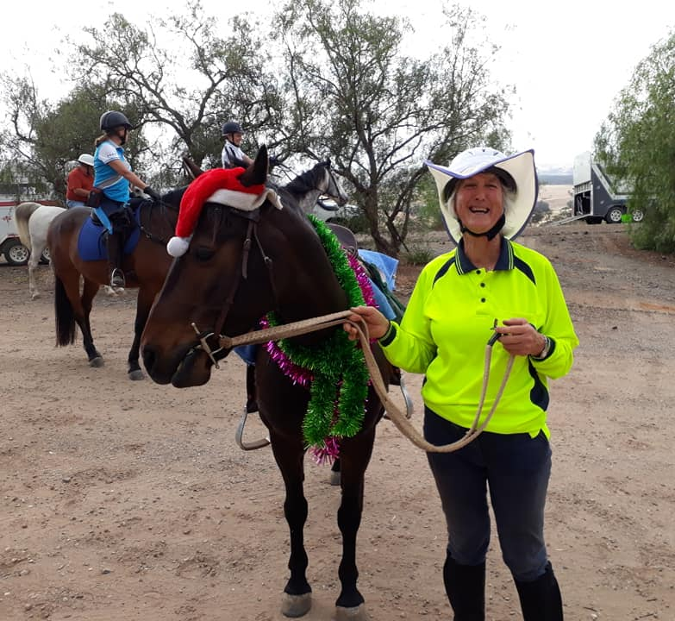
The day started out muggy and a little uncomfortable but as everyone arrived they were all in great spirits there were 11 riders some with some horses dressed up in excellent Christmas costumes.

Everyone was ready to ride out a little later at 9:30am. We set off along Adrian & Chris’s driveway, and then headed out on the dirt road past vineyards and beautiful scenery. We picked Virginia and Winston up on the way. We enjoyed a short trot before making our way past a turkey farm and a cheeky Maremma sheepdog protecting his property.

We made a quick pit-stop on the side of the road for Lisa Bate’s (sorry Lisa – hehe) and continued up the dirt hill with a nice long trot and canter for some

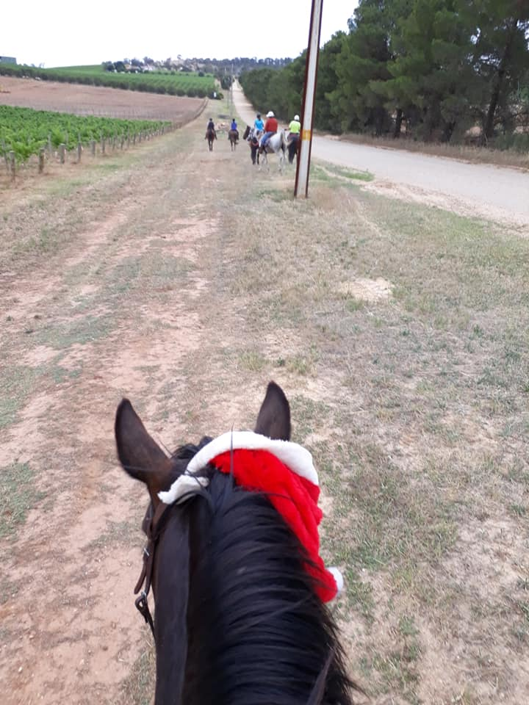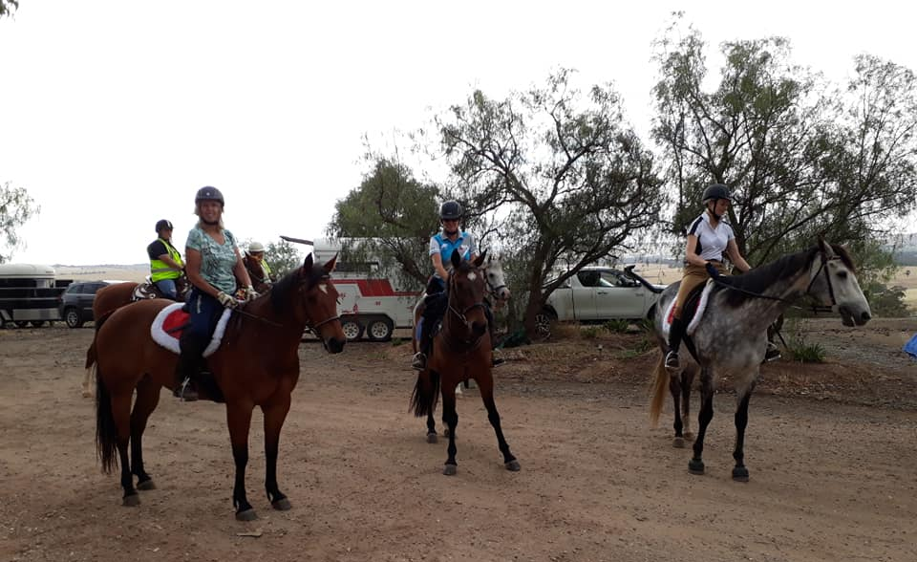

Back down the dirt road we continued single file to meet up with “sneaky” a gorgeous mini that said hello and gave us a buck or two. Everyone ventured through the vineyards and back up the dirt road and back to the Dahlenberg’s farm.

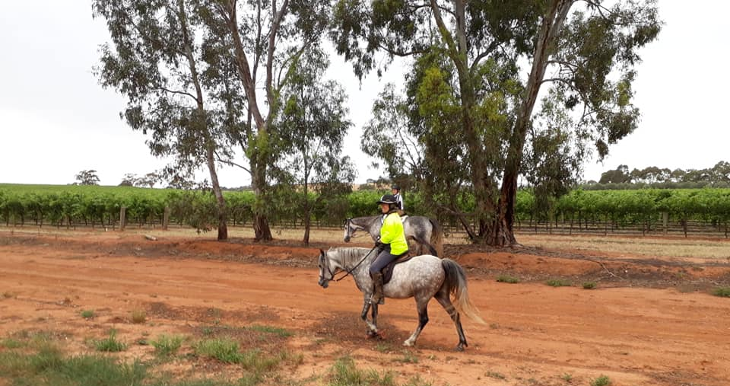
Adrian (Lisa’s Dad) and Craig (Lisa’s Husband) had a beautiful BBQ ready for us when we returned. We had extra’s come for lunch which was a great effort for everyone at this busy time of year. Thank you to everyone that brought food to share at the BBQ

BIG thankyou to Adrian & Chris for having the club at such a beautiful venue.

Merry Christmas everyone and a safe and happy new year

Happy trails

2019 MEMBERSHIP APPLICATIONS & FEES
Membership for 2019 is due = Adult/Family $110, Junior (under 18) $50, Social (non riding) $40.

Please join online via ATHRA.com.au
- Membership of Gawler THRC can only be made online with PayPal
- When re-joining have your current member number to hand & select Member Login and Renewal (the committee can assist if your unable to find your member number).
- ATHRA no longer mails membership cards, so keep a copy (screen shot) of your renewal to show membership if needed (i.e. riding with another club).
- New, renewing and day member notification emails are sent to Club contacts, so that each Club is aware of membership transactions.
- Family Membership for 2019 is now available ONLINE. A Family in this regard is one adult riding member who is the parent or legal guardian of one riding child. ATHRA has waived the junior/child member fee to lower the overall cost for families and encourage more members to join.
- When completed can you please help us by letting us know the PIC # of where your horses are kept - we need this information when completing forms but this is not available from the ATHRA web site.
N.B – you can change your member details at any time by updating via your membership profile on ATHRA online.

CLUB UNIFORM
Just a reminder to all Members – Our club uniform currently comprises of a lime yellow high-vis shirt (long or short sleeve). This is to help promote the safety of our riders especially whilst riding in shared zones such as on roads.

Club Badges are available for purchase by members $12 each (& yes you can have more than 1). They are available with the sign in book – take your badge from the bag & place your money in the badge bag. You can put your badge on your high vis top or even on your Saddle blanket – it’s up to you.

Can members please look to wear the club uniform at all club rides (on & off road), & whilst it is not mandatory it is preferred & is a good promotion for the club. A lime yellow high-vis safety vest is also suitable to be worn in place of a shirt or over the top of other gear (& visible in all weather).

Club members & their visitors are required to wear Safety Helmets whilst mounted - helmet must comply with S/NZS 3838:2006 safety standard and be no more than five years old. When buying a helmet always check the date of manufacture as this determines the age of the helmet.
Horse Health & Wellbeing

NEWSLETTER DEADLINE
The deadline for any items that members want printed in the February 2018 newsletter will be Tuesday 22 January so please ensure that your emails reach Kath kathryn.mccullagh@hotmail.com before that date to avoid disappointment.

Policies
A reminder to all members that our club has some policies that we endorse. These include a NON SMOKING, SAFETY & HOT WEATHER policy. These can all be viewed on the ATHRA web site, via the state page - www.athra.com.au.
Previous Newsletters, photos & club information can also be viewed at any time on the ATHRA web site.
WEATHER
The ride host/leader for the day will have the final say regarding weather (including inclement weather).
The hot weather policy states, if the weather forecast in ELIZABETH for the next day is to be over 32 deg (as per the news the night before) the club rally/ride will be cancelled (unless the ride is scheduled to commence prior to 9am or after 6pm). This is for the safety of all riders and horses. Also, any club rides in FOREST areas on TOTAL FIRE BAN days will be cancelled.
Please check with the Trail Boss if in any doubt. They have the final word!
CLUB UNIFORM
Our club uniform currently comprises of a lime yellow high-vis shirt (long or short sleeve), club badges available for $12. Gawler Club Members & their visitors are required to wear Safety Helmets whilst mounted - helmet must be no more than five years old from Date of Manufacture.
RIDE FEE & DAY MEMBERS
ATHRA members - a ride fee of $2 per ride is applicable.
Non ATHRA Members (Day Members) – a ride fee of $25/person/day is applicable ($10 to club on the day & $15 to ATHRA with pre-registration) (Non-refundable fee, maximum 2 days as a day member).
The important things to note: 1. Day Members must be sponsored and accompanied at all times by an ATHRA member during the ride or event.
2. The Sponsoring member must make the Day Member aware of ATHRA rules and requirements of the Code of Conduct.
3. They may only sponsor 1 Day Member per ride.
4. By participating as a sponsor, the sponsoring member acknowledges responsibility for the conduct and behaviour of the Day Member
5. Day Members must contact the trail boss to discuss attendance & then pre-register with ATHRA Online at least 3 days prior to ride.
RIDE HOST CHECKLIST
A ride host’s checklist is in the green bag, in which is kept the sign in book, ride fee tin, saddle bags, first aid kits, safety vests, etc. Trail Bosses are to check the list to make sure all is in order prior to your ride. It is also the Hosts responsibility to ensure a ride report is arranged to be submitted to Newsletter Editor prior to next publication date.

DISCLAIMER
The material in this newsletter is for the benefit and information of our members. The items are in the nature of general comments only and are not to be used, relied or acted upon without written permission of GTHRC. The club accepts no responsibility for any errors or omissions or for any damage suffered as a result of any person acting without written advice. All opinions and views in the newsletter are not necessarily the view of the club, but are personal opinions only.

