September 2018 Newsletter
Club Postal Address
P.O. Box 55
Gawler SA 5118
athra.com.au Email: Gawler.THRC@gmail.com
President - Julie Jackson 0419850793 Vice President -Tamara Godfrey 0417869695 Treasurer - Sandra East 0400884402 Secretary - Kath McCullagh 08 82807046

NEXT MEETING (1st Thursday of the month) 8pm Thursday 6 September 2018

General Meeting All welcome
Southern Hotel (next to Cafe Nova)
Come early for tea – 7pm

August Meeting
Planning for 2019 ride calendar to start. Trail Boss training to be arranged for 2019.

Coming Events
September Ride out: Mintaro – Sunday 16 Sept 2018 RSVP to Gawler.THRC@gmail.com by 13 August
Host & Boss – Sandy Jones Ph 0401672241 9am arrival for 10 am start

Ride description: Pre Ride talk 9.45am (no horses), then 10am ride out. Riding from Mintaro, through the outskirts of the town and along mainly dirt roads with a short section of bitumen. The ride will either be 15k or 25k approx (~3-5hr) depending on the weather and a vote on the day by riders attending. Both are suitable for being ridden or driven. Lunch to be taken if the longer ride is decided on.
Ride Grade: Walk/trot. Barefoot. No known obstacles. Hazards – stock, Horse Carts.

Directions- Mintaro area ( kms north of Gawler)
– Full Directions to be sent to those that RSVP to Gawler.THRC@gmail.com
Club sign will be posted at entrance. Clean up of manure and hay afterwards as usual.

Cost- ATHRA member $2 Ride fee. Non ATHRA member riding visitor fee $25/day (please be advised that if you are not a member of ATHRA you will need to be sponsored by an ATHRA member to ride & pre-register as a day member 3 days prior with ATHRA online - $15 direct to ATHRA & $10 to club on the day). Please bring the correct change & place in tin at sign on book.

September CAMP: Bendleby Ranges (via Orroroo) – Friday 21 – Sunday 23 September 2018
Host & Boss – Kath McCullagh & Tamara Godfrey
Further info – Kath 0476937707 or Tamara 0417869695
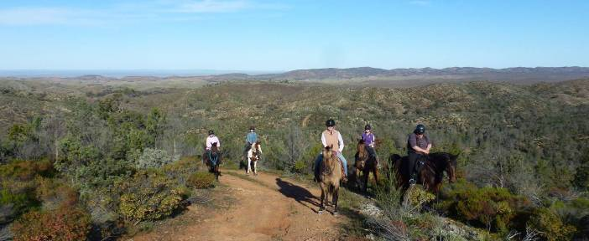
RSVP to Gawler.THRC@gmail.com ASAP but before 17/9. Would like to send final confirmation of numbers Wednesday prior to departure.

Arrival: Friday – before 1pm
Friday – 2 pm start – ride ~ 2 ½ hours
Saturday - 9 am start - ride ~ 5 hours – lunch to be carried.
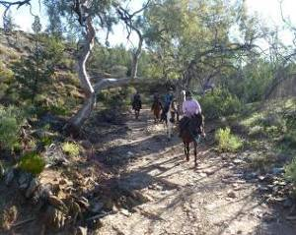
Sunday - 9 am start - ride ~ 3 hours.
You can stay longer if you wish – many more rides available.

Riding is easy to moderate (It's all pretty easy going but hilly), riding is rocky, hills with lots of rocks but only a few steep sections with spectacular scenery to enjoy - all tracks through a working sheep & cattle property. Well seasoned barefoot horses should cope but boots highly recommend. If we do decide on the Hungry Range shoe or boots will be required. Ride duration & route to be finalised closer to the date.
*Your horse should have some conditioning as it is hilly*

Horses –BYO everything. Drinking water for horses is available. Various sheep & cattle yards (large & small) are available but it is suggested that you bring electric fencing to keep spaces between yards or split up yards as necessary.
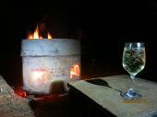
People - BYO everything you need for you and your horse. Unpowered camping, close to the yards $22 / night / person & $11 per horse per stay. Wood for campfire included in camp fees & toilet & showers close by.
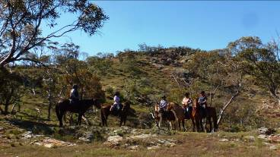
Cost- ATHRA members only - $2 Ride fee/day or $4 ride fee for the weekend. Please bring the correct change & place in tin at sign on book.

Hope to see you there for a great weekend of riding & socialising!!!

EVERYBODY WELCOME....... including non riders.....

A few testimonials from our last visits
Amazingly tough, rugged and beautiful country – views were spectacular…..….. the ride was delightfully viewtastic with native conifers and flowers dotting the hills as we climbed and meandered our horses along tracks……. The weekend was fabulous lots of flowers, great laughs, lots bubbles, beautiful sunrises and sunsets and fun riding…..…..ride was an eye opener to the environment and the natural rockiness of the tracks and creeks that criss crossed the trail many times. ………….The rides were the most challenging I have ever done and I loved it.... Very steep tracks up hills to views that went for miles to meet more hills in the distance…….The views on all 3 rides were spectacular and the countryside just breath taking, sharing it with others on horseback was a wonderful experience……..

RIDE CALENDAR FOR 2018 HOST MEETING DATES 2018
Rides are usually held on the 3rd weekend (Sunday calculated) & 5th Sunday of the month (if there is one).
Camps held ~1st or 5th weekend of the month. Meeting dates are held on the 1st Thursday of the month
Sept 16 | Mintaro | Sandy J | 6 Sept
Sept 21-23 | Camp – Bendleby Ranges | Kath Mc
Oct 20 | Moonlight Ride: Gawler River | Julie J | 4 Oct
Nov 17/18 | (TBC) |  | 1 Nov
Dec 1 (Sat) | Christmas Dinner (TBC)
Dec 8 | Christmas ride - Rosedale | Lisa C

Past Events
July Camp Ride: Mt Belvidere Camp - 28-29th July – By Richard Grimson
It’s the Monday before the camp and on checking weather forecast it did not look good. Possibility of up to 25mm rain before the camp started. As the track into the camp site is clay, the forecast was putting the camp in doubt. By Thursday it was apparent there may not be all that much rain so the camp was declared ON.

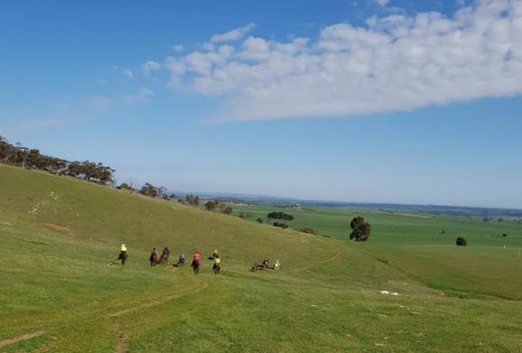
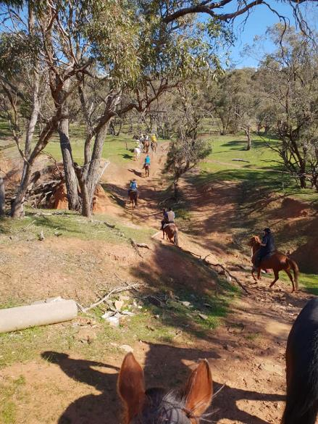
I managed to arrive by 09:30 at the camp and set up. Slowly at first then a large group arrived and camps set up and lunch consumed. Before long it was time to saddle up and start the ride. Part of the pre ride talk included not getting too far in front of me as I have a tendency to change direction when that happens.

First challenge was a dry, steep creek crossing which turned out to be a non-event as everyone went through with no problems. Up and through the gap with Mt Belvidere on our left and a grand vista opened in front of us. In the distance we could see Freeling. Here we had our first rider leave due to a bad headache, ably escorted back by Kath and Tamara. The two way radios proved their value for the improved communications provided. On their return another two riders decided it was safer for one of them to go back to camp. Again Kath and Tamara escorted them back.

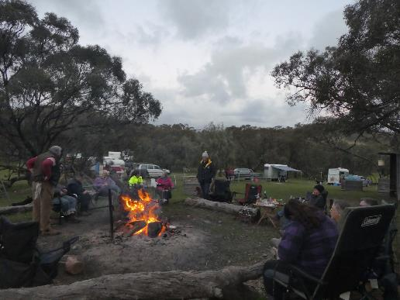
The rest of use continued on dirt roads and even got a wave from the owner of Mt Belvidere as we started to head back to camp. Here the group split with Julie taking those riders who wanted to have a trot on a slightly longer track and we met at the cross roads. One rider who stayed mostly on the verge of the road managed to help defray the cost of his attendance at the camp – he found a $20 note in the grass. Finally back at camp.
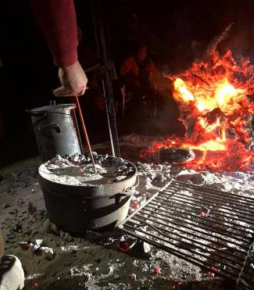
Fire lit and then an impromptu Happy Hour followed by evening meals around the campfire. Then the entertainment started by Chris and everyone joining in. Chris even managed to provide a chocolate pudding cake which everyone enjoyed. Thank you Chris.

As rain started to fall it was time to retire to bed.

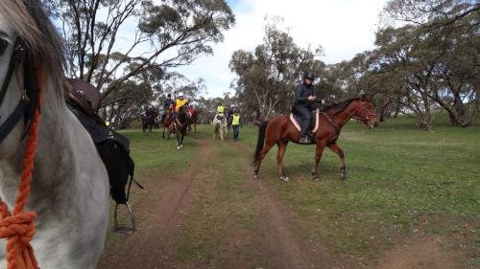
Sunday looked bad and a cold wind was blowing but the ride started, although a bit late, but off we went, leaving in the direction we returned on Saturday. Kath took the trotting group on the longer track and met us at the next cross roads. It was planned to shorten the ride here but when the time came to turn back, a unanimous vote put forward that we continue, even if we are doing yesterday’s ride in reverse.

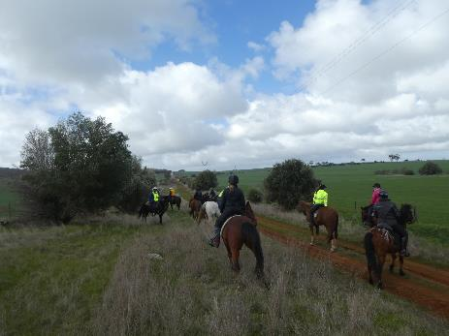
Back past Mt Belvidere and heading to camp where some riders too far in front of the Trail Boss took the wrong turn at a gate. Riders were warned as to what happens if too far in front. As they watched the rest of the riders go by they realised their error. Through the steep, dry creek crossing and back to camp. Pack up and slowly everyone left and the camp was silent again, that is except for the birds hiding from the rain.

On returning home I find through Facebook and thankyous at camp, how much the camp was enjoyed by those attending, riding or not. Glad that the camp was so well enjoyed.

Note from the Editor - We would like to pass on a BIG THANKYOU to Darren Graetz for allowing us to camp at Mt Belvidere. I can confidently say that allowing us to access your place was greatly appreciated & very much enjoyed. We are all hoping to come back again one day soon

August RIDE OUT – Moppa District - Sunday 19 August 2018 - by Michelle Day
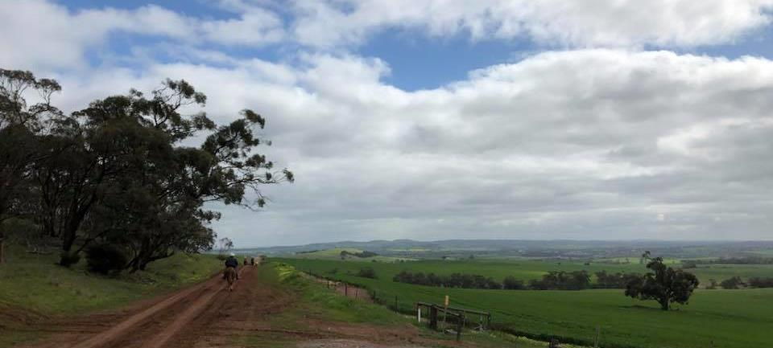A brisk chilly morning with dobs of sunshine greeted riders at the start of The Moppa trail ride as club members arrived to get ready. Riders for the day were Lisa and Adrian, Mar, Evonne, Tamara, Julie, Richard, Sandra E, Sandy, Teena, and myself with volunteer Joy Day.

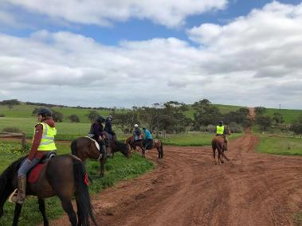
As we gathered for the ride out up easement clay tracks and white gravel roads we spread out nicely to soak in the chilly temperature that fluctuated through the ride depending on which road we took. A few cars only and one motorbike went passed conscientiously as we waved our thanks (found out later that it was Mic from my work on the motorbike) and told him that it was appreciated how careful he was. So good on Mic.

Most clay roads were passable as they were drying out from previous rain. A mainly walking trail with one trot/canter 1km, just to catch up and break up the ride, was a fun way to head to the next junction as we crossed to the other side of bitumen which was done with quick finesse helped by all and Julie, Sandra stopping traffic (worked a treat). Passed olive groves and gum trees and again to cross smartly near the airplane museum we made our way back to be surprised by Amanda and hubby Ryan plus Joy waiting at the gate(our cheer squad hehe).

As we tied up horses we found Chris Pearce popped in as well to catch up. We all sauntered inside for a warm cuppa with delightful sweet potato cake and pineapple cake with cream YUMMY! Supplied by Joy Day (tx mum xx) We all squeezed into the kitchen and warmed up soon by the buzz of hearty conversation and food.

What can I say but thanks all for coming out again or for the first time to the Moppa ride and c u next time gang :)

Horse Health
Best Practice in Environmental Strongyle Worm Management
A Seasonal Guide for Horse Managers
Relevant for healthy, adult horses from the age of 3 years
Gear up for SPRING
With an increase in temperature and good moisture, pasture grass will grow quickly. These are the best conditions for Strongyles to begin laying eggs. So, about a month into Spring…
• undertake a faecal egg count (FEC) for each horse and record these measurements for your future reference
- LOW (0 – 100 EPG) – No treatment necessary.
- MODERATE (> 100 <200 EPG) – No treatment, FEC monitor in 4-6 weeks or after warm, moist weather.
- MODERATE-HIGH (>200 <500 EPG) – treatment advisable, monitor with additional FEC at end of efficacy
period (according to manufacturer’s statement).
- HIGH (>500 EPG) – High-egg shedder. Treatment necessary. Continue to monitor these horses.
always treat HIGH egg-shedding horses with a targeted treatment (read the label) and monitor with FECs.

Extract from - © evidencebasedworming.com.au

NEWSLETTER DEADLINE
The deadline for any items that members want printed in the October 2018 newsletter will be Tuesday 25 September so please ensure that your emails reach Kath kathryn.mccullagh@hotmail.com before that date to avoid disappointment.

Policies
A reminder to all members that our club has some policies that we endorse. These include a NON SMOKING, SAFETY & HOT WEATHER policy. These can all be viewed on the ATHRA web site, via the state page - www.athra.com.au.
Previous Newsletters, photos & club information can also be viewed at any time on the ATHRA web site.
WEATHER
The ride host/leader for the day will have the final say regarding weather (including inclement weather).
The hot weather policy states, if the weather forecast in ELIZABETH for the next day is to be over 32 deg (as per the news the night before) the club rally/ride will be cancelled (unless the ride is scheduled to commence prior to 9am or after 6pm). This is for the safety of all riders and horses. Also, any club rides in FOREST areas on TOTAL FIRE BAN days will be cancelled.
Please check with the Trail Boss if in any doubt. They have the final word!
CLUB UNIFORM
Our club uniform currently comprises of a lime yellow high-vis shirt (long or short sleeve), club badges available for $12. Gawler Club Members & their visitors are required to wear Safety Helmets whilst mounted - helmet must be no more than five years old from Date of Manufacture.
RIDE FEE & DAY MEMBERS
ATHRA members - a ride fee of $2 per ride is applicable.
Non ATHRA Members (Day Members) – a ride fee of $25/person/day is applicable {$25 1/3-30/9/18 normally $45} ($10 to club on the day & $15 to ATHRA with pre-registration) (Non-refundable fee, maximum 2 rides as a day member).
The important things to note: 1. Day Members must be sponsored and accompanied at all times by an ATHRA member during the ride or event.
2. The Sponsoring member must make the Day Member aware of ATHRA rules and requirements of the Code of Conduct.
3. They may only sponsor 1 Day Member per ride.
4. By participating as a sponsor, the sponsoring member acknowledges responsibility for the conduct and behaviour of the Day Member
5. Day Members must contact the trail boss to discuss attendance & then pre-register with ATHRA Online at least 3 days prior to ride.
RIDE HOST CHECKLIST
A ride host’s checklist is in the green bag, in which is kept the sign in book, ride fee tin, saddle bags, first aid kits, safety vests, etc. Trail Bosses are to check the list to make sure all is in order prior to your ride. It is also the Hosts responsibility to ensure a ride report is arranged to be submitted to Newsletter Editor prior to next publication date.

DISCLAIMER
The material in this newsletter is for the benefit and information of our members. The items are in the nature of general comments only and are not to be used, relied or acted upon without written permission of GTHRC. The club accepts no responsibility for any errors or omissions or for any damage suffered as a result of any person acting without written advice. All opinions and views in the newsletter are not necessarily the view of the club, but are personal opinions only.

