December 2018 Newsletter
Club Postal Address
P.O. Box 55
Gawler SA 5118
athra.com.au Email: Gawler.THRC@gmail.com
President - Julie Jackson 0419850793 Vice President -Tamara Godfrey 0417869695 Treasurer - Sandra East 0400884402 Secretary - Kath McCullagh 08 82807046
General Committee Maria Pearce & Lisa Rothe

GENERAL MEETING (1st Thursday of the month) 8pm Thursday 3 January 2018

All welcome Southern Hotel (next to Cafe Nova)
Come early for tea – 7pm

November Meeting
- 2019 Ride Calendar planning continues – please nominate some rides/dates for us all to enjoy
- New Members only Facebook page up & running – full ride directions/details posted on this page.
- ATHRA Affiliation 2018 paid & a couple of Trail Boss accreditation extended.
- Motion passed at meeting to continue Executive Committees’ 50% subsidy of ATHRA fees in 2019.
- Christmas Dinner 2018 – Don’t forget to RSVP by 26/11/18.
A happy and safe Christmas to all

Coming Events
Club Christmas Dinner Gathering: Seppeltsfield – Saturday 1st December 2018
Host: Maria & Chris from 5pm – until Late RSVP to Maria 0412195531 & Gawler.THRC@gmail.com by 26th Nov

Welcome everyone to come together and celebrate the end of year Christmas Dinner with club members/partners at Seppeltsfield. Same as previous years – sit about/sprawl out and relax on the lawn area before the evening dinner.
Covered in area if the weather is bad / indoor pool for a swim if the weather is hot.
- From 5pm onwards just chilling on the lawn together, enjoy cheese platters/nibbles provided before the main meal at around 7.30pm.
- As in the past, a contribution is requested: salad/veg dish or dessert for the main meal (please advise me what you wish to bring along so that we do not double up.)
- BYO cold drinks of your choice.
- Selection of teas and coffee will be provided.
- Let me know if you are vegetarian.
- All drinking glasses, cutlery and plates are provided.
- We should have enough chairs for the night but I will contact you if we need more.
- Kris Kringle – Committee members agreed we should continue with the gift giving for a good laugh – Bring on….‘Thieving Kris Kringle’ at some point during the night – Thieves were out of control last year !!!!! So each person please bring a wrapped gift to share suitable for male or female (Value $5 - $10).
NOTE – if anyone prefers not to take part in this concept just feel free to opt out for this.
- Any other ideas from anyone for a fun night will be appreciated thanks – let me or others know your thoughts.
- RSVP to Maria ASAP. All RSVP’s & payment are needed by 26th Nov. so that I have funds available to shop for the night!

Directions: Seppeltsfield area – full directions to those that RSVP.

Cost: $15 per person to cover costs of pre-dinner platters, dinner foods & items needed for the evening.

December RIDE OUT: Rosedale Christmas Ride – Saturday 8 December 2018
Host: Lisa & Adrian Mobile Lisa 0418806213 Trail Boss: Julie Jackson 0419850793
Arrive 8am> for 9am ride out RSVP to Gawler.THRC@gmail.com by 4 December

Ride Description: This ride is ~ 2.5 to 3hrs,. We will be heading out on mainly gravel roads, crossing the bitumen twice and going through some vineyards. This is a lovely ride to do . For those that are keen there is an opportunity for a trot and a canter too!! For any who have not been here before – when floating up to the carpark DO NOT STOP on the hill until you are up the top!

The club will have a shared BBQ lunch after the ride (all bring a plate to share) I will be supplying the meat, so only salad or deserts needed.
Please let Lisa know what you will bring so no double up's.
Just come for lunch if unable to come to ride ~12n

NB: Lunch will go ahead regardless of weather. Due to the season the Hot Weather Policy may apply – BUT the Trail Boss has the final word! So if in doubt ring the Trail Boss.

Ride Grade: easy to moderate.
Traffic - Mostly gravel road.
Slightly undulating, no steep hills (other than the driveway) ☺ 
Ok for season barefoot.
There more than likely will be a few kangaroo & stock in paddocks
Group trot & canter
Cart Friendly

Directions: Rosedale area – full directions to those that RSVP.

Cost- ATHRA member $2 Ride fee. Non ATHRA member riding visitor fee $25/day (please be advised that if you are not a member of ATHRA you will need to be sponsored by an ATHRA member to ride & pre-register as a day member 3 days prior with ATHRA online - $15 direct to ATHRA & $10 to club on the day). Please bring the correct change & place in tin at sign on book.

RIDE CALENDAR FOR 2018 HOST MEETING DATES 2018
Rides are usually held on the 3rd weekend (Sunday calculated) & 5th Sunday of the month (if there is one).
Camps held ~1st or 5th weekend of the month. Meeting dates are held on the 1st Thursday of the month
Dec 1 (Sat) | Christmas Dinner - Seppeltsfield | Maria & Chris
Dec 8 | Christmas ride - Rosedale | Lisa C

RIDE CALENDAR FOR 2019
We will be continually discussing our monthly ride calendar for the next couple of months so get those ideas & dates to the committee …Please make suggestions of rides that you would like the club to do & maybe some new rides, pretty rides, bush, forest, country or just a favourite ride you would like to share. Remember it does not need to be from your home, but the start of the ride need to have parking of floats. So give it some thought & let us know. Or even just let us know which of the rides the club has done that you would like to do again. (Ring or Email Julie Jackson 0419850793 connellvale@bigpond.com)

Remember it’s your club, so vote for a ride you want to do & we will find a volunteer to host….
Ride Nominations (Saturday or Sunday) –Leisingham &/or Mintaro (Sandy), Truro Gorge (Julie), Seppeltsfield Winery Tour (Maria), Tungkillo (Sallyanne), Birdwood (Sandra S), Mt Crawford Forest (Lainie),
we also try to schedule road rides in winter (forest rides have to be when ground not too wet or fire bans in place)
Camp Nominations – Robe, St Kits (Maria), Owen & tail course (Julie), Waterloo (Sandy?)
As not all members can travel/camp the camp nominations will be mostly been scheduled as additional weekends (~5th weekend of the month or 1st if we have nominations) - camp weekend dates are negotiable

Woo Hoo – Looking forward to another great year of riding in our great state

DRAFT - RIDE CALENDAR FOR 2019 host MEETING DATES 2019
Rides are usually held on the 3rd weekend (Sunday calculated) & 5th Sunday of the month (if there is one).
Camps held ~1st or 5th weekend of the month (negotiable) Meeting dates are held on the 1st Thursday of the month

The following is a work in progress – dates, location & hosts to be continually confirmed
Please nominate a date if you have nominated to host rides
& MANY More rides needed to complete the calendar

Jan 19 | Moonlight Ride - (TBC) |  | 3 Jan
Feb 10 | Pt Parham | Sandra E | 7 Feb
March 17 | Beach Ride - Osborne | Tamara | 7 Mar
March 30/31 | Kapunda | Sandy
April 14 | TBC Trail Challenge Day Cockatoo Valley | Di S | 4 April
May 18/19 |  |  | 2 May
June 16/17 |  |  | 6 June
June 29 & 30 | Belvidere Camp | Richard
July 20/21 |  |  | 4 July
Aug 17/18 |  |  | 1 Aug
Sept 14/15 |  |  | 5 Sept
Sept 27-30 | Camp – Southern Flinders? | Kath
Oct 19/20 |  |  | 3 Oct
Nov 16/17 | Forest Ride/Camp – Kuitpo | Laine | 7 Nov
Dec 7 (Sat) | Christmas Dinner (TBC)
Dec 14/15 | Christmas ride (TBC)

Past Events
November Camp: Burbrook – Saturday 17 & Sunday 18 November 2018 by Lainie
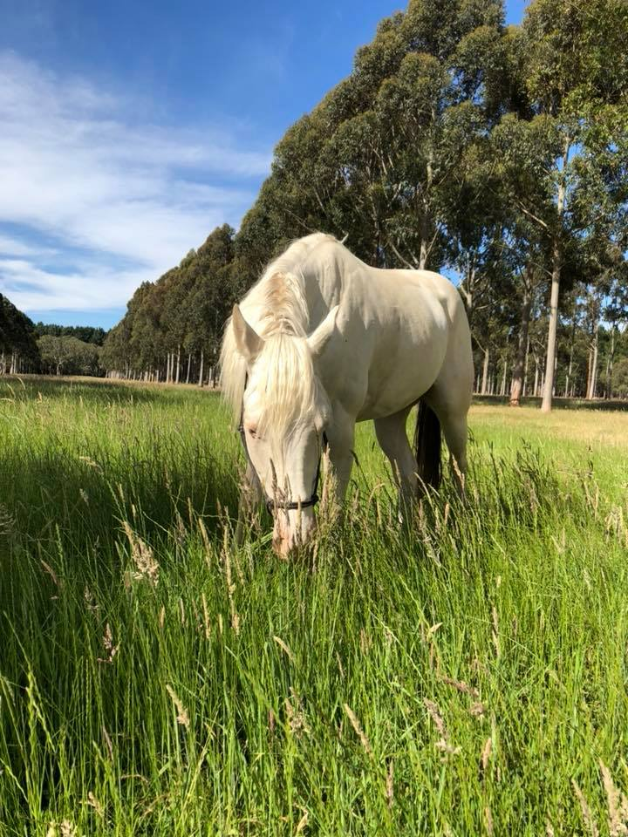
Burbrook was the meeting/ camp ground for the Kuitpo Camp A lovely green paddock for the horses to stay in overnight. Tamara’s Barry thought all of his Christmas’s has come at once, so did Kath’s Joey but he was banished to the native grass spot between the gums. Roo and Turbo had lush green yards also.

Saturday @ 2pm, 5 of us (Me, Lisa, Sandy, Kath and Tamara) set off with our steeds into the beautiful green forest. Only a short ride for Saturday saw us riding for a couple of hours and 12kms through the narrow fire tracks, up and down a few small hills. Turbo had a bit of trouble working out he was a trail horse this weekend not an endurance horse with a couple of handstands he eventually settled and got on with his job.

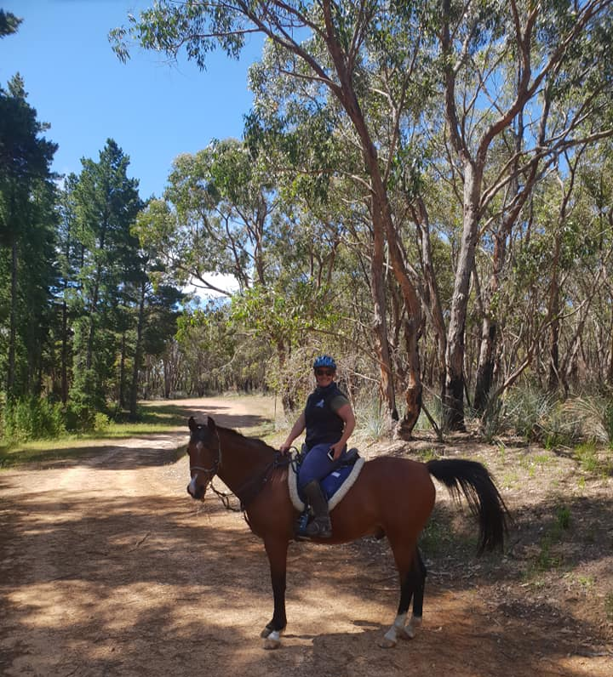
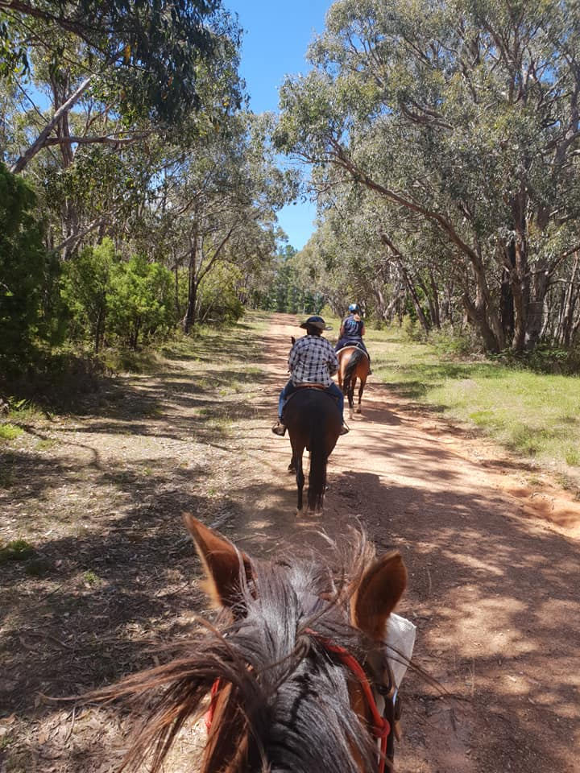
Lisa said goodbye after the ride & so we settled down with pre dinner nibbles & then chatted the evening away. Saturday night was a cold with none of us prepared so we had to have a tipple to keep us warm.

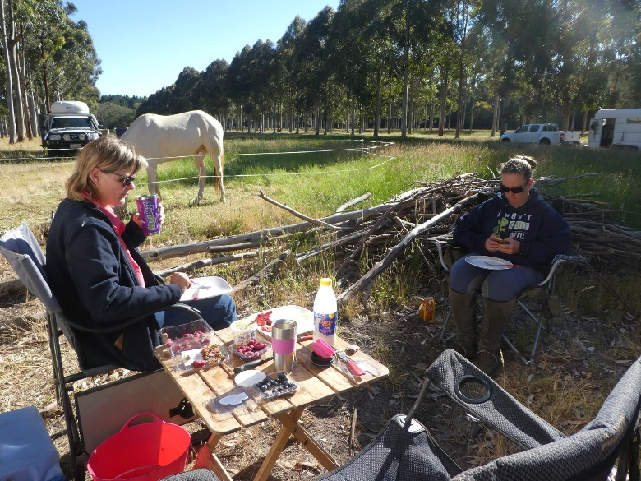
Sunday morning saw some yummy pancakes and fresh fruit care of Tamara and Kath and we were all saddled and on by 9.30am. This was the warmer day of the 2 so I tried to keep us in the shade as much as possible. Lots of hills on day 2 with 22.5kms. The horses, yet again were awesome. We did tour the dams in the forest. Going up to the Airstrip saw all of us cantering along. Much fun was had.

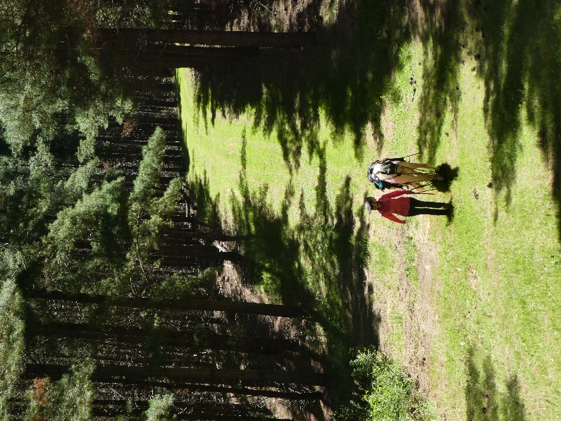
Thanks to the ladies that made the time to come up to my neck of the woods.

Turbo and I look forward to seeing you all at the next ride.

Happy Trails.

Lainie and Turbo.

2019 MEMBERSHIP APPLICATIONS & FEES
Membership for 2019 is now due - fees = Adults $110, Junior (under 18) $50, Social (non riding) $40.

Join online via ATHRA.com.au – have your current member number to hand to enter when re-joining.
When completed can you please help us by letting us know the PIC # of where your horses are kept - we need this information when completing forms but this is not available from the ATHRA web site.

CLUB UNIFORM
Just a reminder to all Members – Our club uniform currently comprises of a lime yellow high-vis shirt (long or short sleeve). This is to help promote the safety of our riders especially whilst riding in shared zones such as on roads.

Club Badges are available for purchase by members $12 each (& yes you can have more than 1). They are available with the sign in book – take your badge from the bag & place your money in the badge bag. You can put your badge on your high vis top or even on your Saddle blanket – it’s up to you.

Can members please look to wear the club uniform at all club rides (on & off road), & whilst it is not mandatory it is preferred & is a good promotion for the club. A lime yellow high-vis safety vest is also suitable to be worn in place of a shirt or over the top of other gear (& visible in all weather).

Club members & their visitors are required to wear Safety Helmets whilst mounted - helmet must comply with S/NZS 3838:2006 safety standard and be no more than five years old. When buying a helmet always check the date of manufacture as this determines the age of the helmet.

Horse Health & Wellbeing
FIRE PLAN FOR YOUR HORSES
Friendly reminder to not just plan for yourselves but also for your horses during the Fire Danger Season – don’t get caught out with no plan. Arrange you bushfire buddy early, write it down & practice your plan so it all comes easily to you under pressing circumstances.

See HoseSA & CFS websites for many helpful hints & Links

My Horse Disaster Plan https://www.myhorsedisasterplan.org.au/
Looking after horses in bushfires - Guide https://www.cfs.sa.gov.au/public/download.jsp?id=104503

NEWSLETTER DEADLINE
The deadline for any items that members want printed in the January 2018 newsletter will be Monday 17 December so please ensure that your emails reach Kath kathryn.mccullagh@hotmail.com before that date to avoid disappointment.

Policies
A reminder to all members that our club has some policies that we endorse. These include a NON SMOKING, SAFETY & HOT WEATHER policy. These can all be viewed on the ATHRA web site, via the state page - www.athra.com.au.
Previous Newsletters, photos & club information can also be viewed at any time on the ATHRA web site.
WEATHER
The ride host/leader for the day will have the final say regarding weather (including inclement weather).
The hot weather policy states, if the weather forecast in ELIZABETH for the next day is to be over 32 deg (as per the news the night before) the club rally/ride will be cancelled (unless the ride is scheduled to commence prior to 9am or after 6pm). This is for the safety of all riders and horses. Also, any club rides in FOREST areas on TOTAL FIRE BAN days will be cancelled.
Please check with the Trail Boss if in any doubt. They have the final word!
CLUB UNIFORM
Our club uniform currently comprises of a lime yellow high-vis shirt (long or short sleeve), club badges available for $12. Gawler Club Members & their visitors are required to wear Safety Helmets whilst mounted - helmet must be no more than five years old from Date of Manufacture.
RIDE FEE & DAY MEMBERS
ATHRA members - a ride fee of $2 per ride is applicable.
Non ATHRA Members (Day Members) – a ride fee of $25/person/day is applicable ($10 to club on the day & $15 to ATHRA with pre-registration) (Non-refundable fee, maximum 2 days as a day member).
The important things to note: 1. Day Members must be sponsored and accompanied at all times by an ATHRA member during the ride or event.
2. The Sponsoring member must make the Day Member aware of ATHRA rules and requirements of the Code of Conduct.
3. They may only sponsor 1 Day Member per ride.
4. By participating as a sponsor, the sponsoring member acknowledges responsibility for the conduct and behaviour of the Day Member
5. Day Members must contact the trail boss to discuss attendance & then pre-register with ATHRA Online at least 3 days prior to ride.
RIDE HOST CHECKLIST
A ride host’s checklist is in the green bag, in which is kept the sign in book, ride fee tin, saddle bags, first aid kits, safety vests, etc. Trail Bosses are to check the list to make sure all is in order prior to your ride. It is also the Hosts responsibility to ensure a ride report is arranged to be submitted to Newsletter Editor prior to next publication date.

DISCLAIMER
The material in this newsletter is for the benefit and information of our members. The items are in the nature of general comments only and are not to be used, relied or acted upon without written permission of GTHRC. The club accepts no responsibility for any errors or omissions or for any damage suffered as a result of any person acting without written advice. All opinions and views in the newsletter are not necessarily the view of the club, but are personal opinions only.

