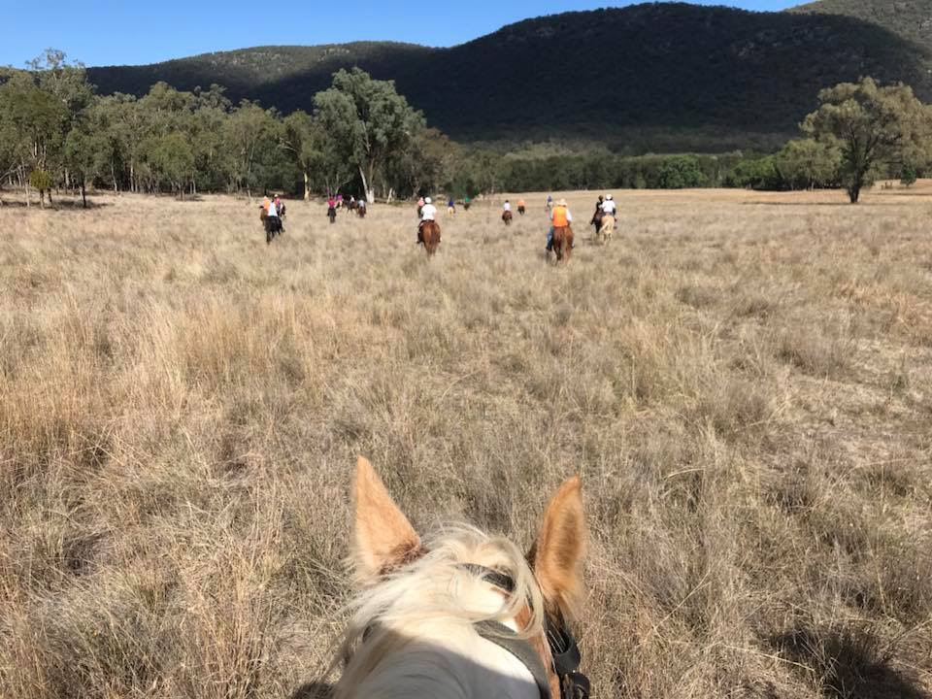 | 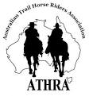
President: Angela Witherdin
0418234854
awitherd@bigpond.net.au
Vice President: Bev Fletcher
Secretary: Francie Maclean
0407660334
Treasurer: Anthony Read
0409362434/67665448

TAMWORTH BUSHRANGERS TRAIL RIDING CLUB
Newsletter – MARCH 2018

It is really exciting that we seem to have either a visitor or new member at each ride. Good to make new friendships and add more diversity to the strength of our club. Welcome.
Shortly our President Angela Witherdin will be emailing a survey to all members, old and new, asking for information about First Aid and Trail Boss Accreditation Training.
Both of these are needed to allow our club to run effectively and maintain our high standard of safe and enjoyable rides. Some of our current Trail bosses will shortly be required to undertake the Accreditation Course to maintain their Trail Boss status and newer members would be encouraged to undertake this training to assist with the smooth running of our rides and make sure that no rides are left without enough accredited people. Actually, all members should be encouraged to take part in these weekends because even if you do not see yourself taking on a leadership role on a ride, the information gained is invaluable. Organising these weekends takes time and forward planning and a minimum number of participants. The first aid course is naturally something that everyone should do particularly if your ‘hobby’ is horses. We need more trained First Aid members. 100% response would be great.

You might remember this from last Month!

BUSHRANGERS OUT AND ABOUT ….
Note from the Editor: This Newsletter is put together for the information and enjoyment of our members, however, articles can only be published if you provide them. As horse loving Trail Riders it is not just about the monthly ride and the Ride Report even though this is perhaps the most anticipated article (hope they didn’t mention ….. or use that photo!) Would love to receive news of other ‘horsey’ happenings – eg. How did you go at Pony Club?: Something funny happen on the pre-ride?: See something amazing at ALEC?: Ride with another club? In another country? Your horse trashed his new rug?: ……. If it is ‘horsey’ it will probably be interesting.
Please submit stuff by the end of the month to: barlowpark2@gmail.com

Well nothing arrived in my Inbox so presume nothing much happened - no horse rides other than on the Monthly ride, no photographs apart from Monthly ride, no funny anecdotes even on the Monthly ride … so for those that attended the Monthly ride and those that didn’t here is the Ride Report …….

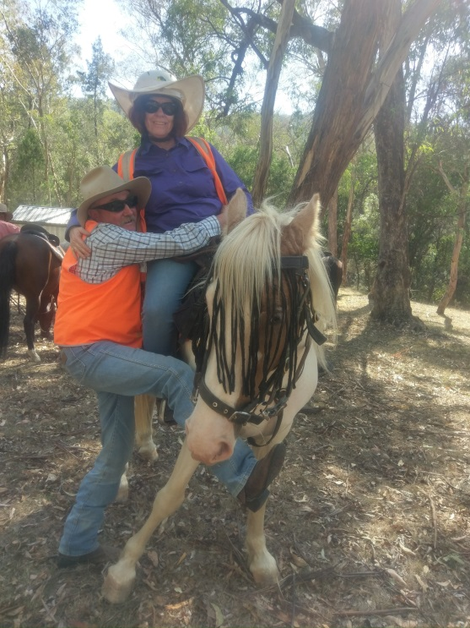 | 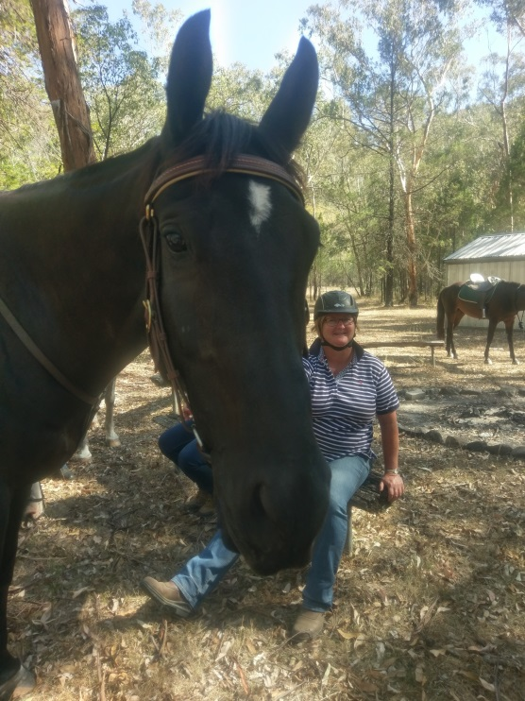 | 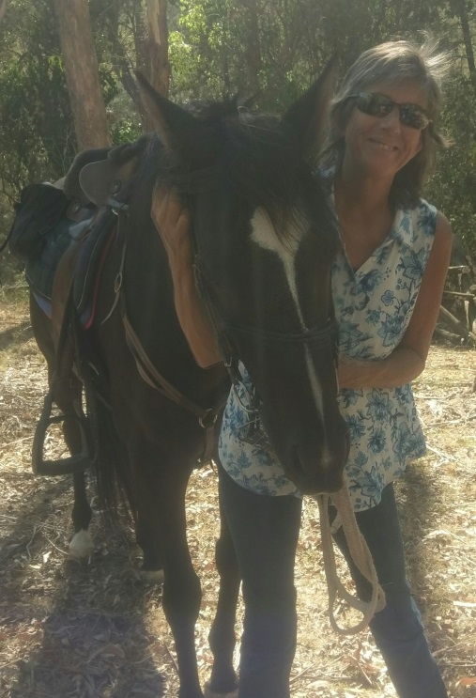

UPPER MOORE CREEK
25TH March 2018

Upper Moore Creek was the destination for our March ride. The day started off with glorious autumn weather.

There were 23 riders with wonderful horses of various sizes, colour and temperaments. We welcomed our usual crew Helen, Francie, Meggsy, Claudia, Eloise, Rick, Ange, Kylie, Gail, Kevin, Alison and Clayton, some visitors Lana, Justine, Rachael and her mum Belinda, a new member Sally. We also enjoyed the company of Lynda, Ken & Bernie and Michelle, Emma & Carmel from our neighbouring ATHRA clubs. After our thorough ride brief we headed up the hill through some lovely Australian bush. Someone commented that we could have been out in the middle of the bush anywhere (not on a farm).

We continued through the bushland heading towards the impressive hills of the Moonbi range. After a drink stop for the horses, those who wanted to have a canter were able to, following a track at the base of the range which wound its way up the mountain. Today’s ride did not include the steep climb, so we all headed back down to follow the creek bed. Unfortunately, the creek did not have any water in it, but some of the horses found the soft sand a change to what they were normally used to.

We stopped for a bit of a rest at the old archery camp spot. Some of us went and checked out the Scout Camp set in a magic spot in the bush. Then it was time to head back, winding our way back across the creek through some open paddocks and one last meander in the bush on our way back to the floats.

A great ride. Thanks to the organisers, coordinators and all the riders.

Ride Report by Kylie Watson

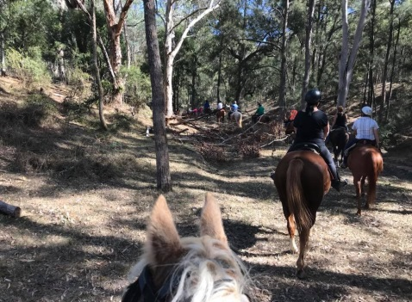 | 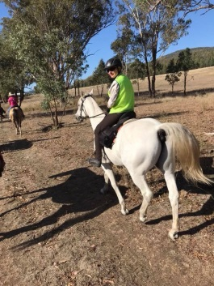 | 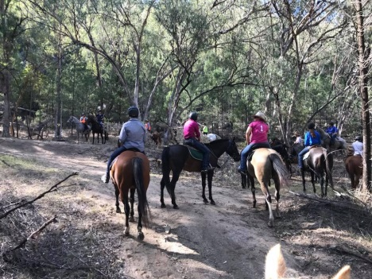 | 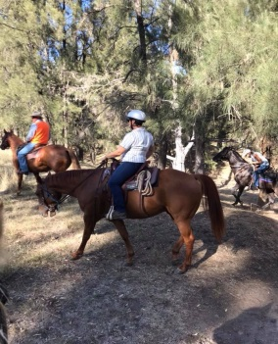

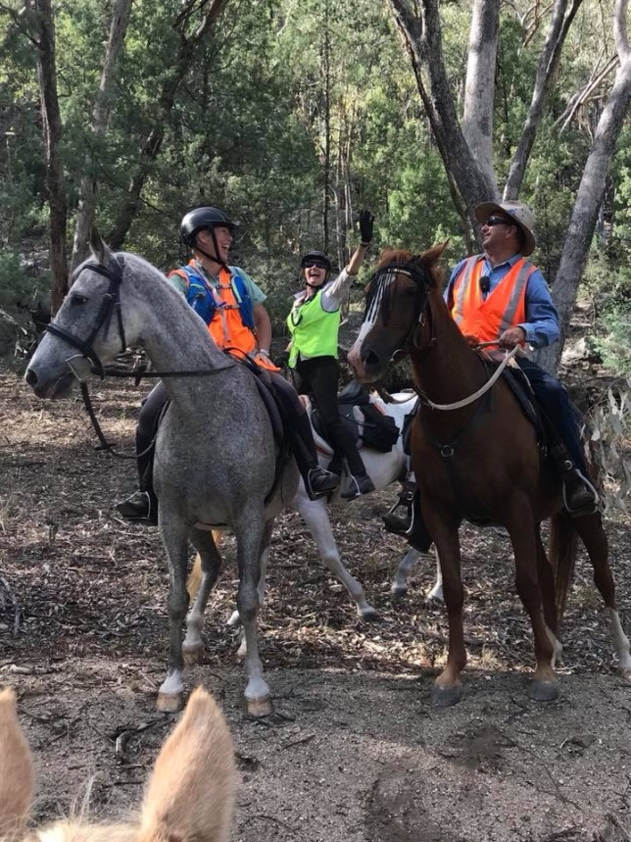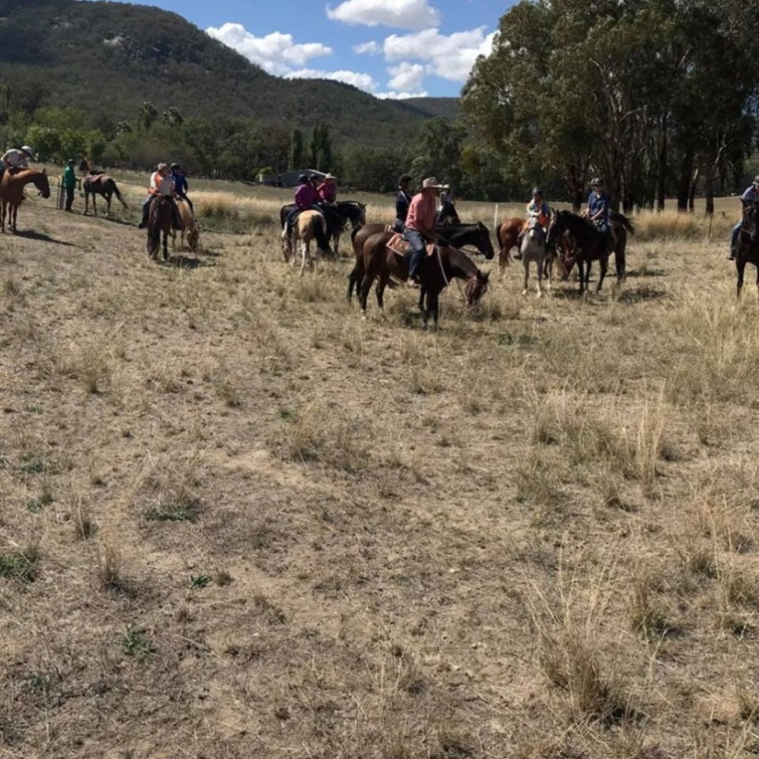

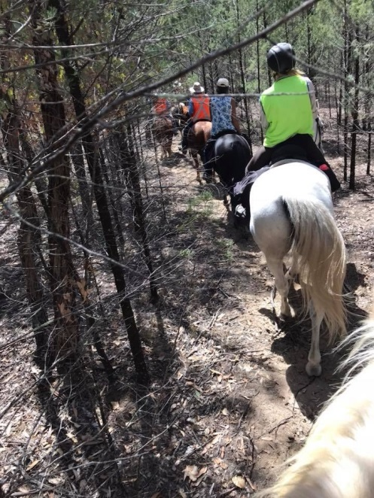 | 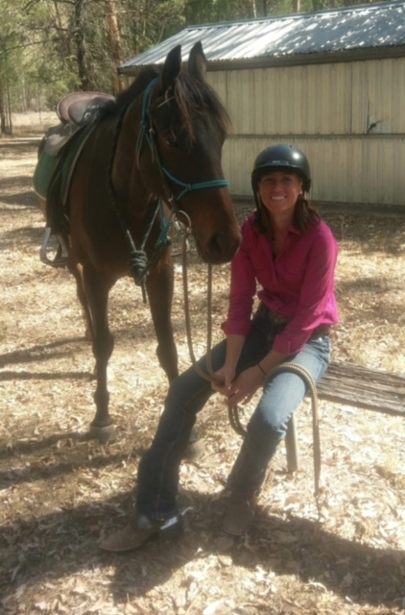 | 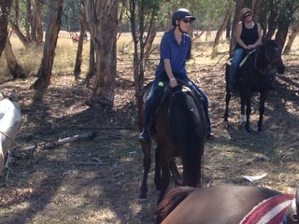  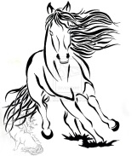
** For a limited time MARCH until SEPTEMBER **
Know someone who would like to Trail Ride and possibly join an ATHRA Club but not sure what it is all about …. Bring them along on a ride and take advantage of the ATHRA reduced Day Membership fee, usually $40 per day but
ATHRA Day Membership Fee $15 (Must be paid online prior to the ride and Receipt presented on the day) plus Club Fee of $5 paid to Club on day of the ride

AND JUST AROUND THE CORNER IS OUR NEXT CLUB RIDE ………. CHECK YOUR INBOX!!
Due to unforeseen circumstances the ride for this month is not at Bendemeer as advertised -info available in next few days.

Start getting ready now ……….. As we have had quite a few new members - here is some information and a reminder for others of things to do to make sure we all have a fun day.

- Check the start time – whatever the time that is the time to Ride out not to be looking for a spot to park your float. New policy – bit like the Airlines check-in, if you ain’t there, gunna go without you.

- Sign the Ride Attendance Register BEFORE you get on your horse and prior to the pre-ride briefing and be on time for the briefing WITHOUT your horse who is tied to your float saddled and ready to leave. (See note following on Pre-ride Briefing)

- No. 1 & 2 above. Show respect to the people who have given up a lot of their own time to pre-ride and organise the ride for all members.

- If your horse kicks and you have forgotten your RED ribbon, ask, someone else is bound to have one or grab a sticker.

- Sometimes particular ride rules and etiquette may be mentioned at the Pre-ride Briefing, but everyone should already be familiar with these. But if not here is a reminder ……….

PRE-RIDE BRIEFING

For visitors and members, the Pre-ride Briefing serves 2 purposes:
- An opportunity for the ride organisers who are familiar with the ride to outline how the ride will be conducted; obstacles that may be encountered (eg. Watch for drop bears); watering points; any aspects of the terrain riders should be aware of: introduce the jacketed riders and the role they have been assigned and to enquire if any of the participants have any health issues or concerns regarding themselves or their horses, and any other information relevant to the ride. Also an opportunity to welcome Visitors or New Members
- An opportunity for Ride participants to let the ride organisers know of any particular concerns they may have about themselves or their horse eg. young horse, settles better at the front etc.
If a new Member this gives the Ride crew a chance to buddy you up with another rider with a more settled horse, or position you where you horse will settle better. But it is important that you speak up at the briefing so a plan can be put in place “just in case”.

GENERAL HOUSEKEEPING ……… Rules and Regulations and the not so boring Stuff

All members should inform themselves of the ATHRA “Code of Conduct “ …. This can be found on the ATHRA Website at www.athra.com.au and while you are there check out the ATHRA guide to “Sharing the Bush” as well as the “Answers to Frequently Asked Questions -Insurance”.

Reprinted here are a couple of the Ride Rules as an example that would apply on all of our Rides and apply to all members and visitors alike.

3.12 At all times horses remain the responsibility of their riders. To avoid potential danger, riders should always be aware of others in their vicinity, including horses, riders, and others who are not ride participants such as cyclists, hikers and vehicles.

3.13 It is the responsibility of all riders to maintain control of their horse and to keep them out of kicking distance of other horses and people at all times. It is a rider’s responsibility to check behind and to the sides before moving laterally, to ensure it is safe to do so.

3.15 Riders must not pass or overtake another rider at a speed or in a manner which is likely to excite their horse.

3.18 No rider shall pass the Lead Rider without the Lead Rider’s permission, and no rider shall ride behind the Drag Rider without the Drag Rider’s permission.

3.19 Riders must maintain sight of the horse in front and the horse behind at all times during a ride

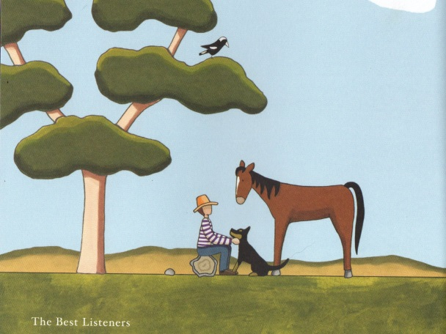 | 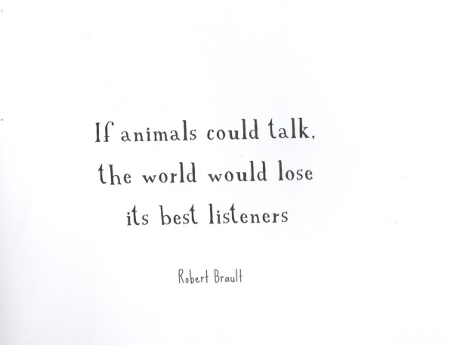
red tractor designs

