KYNETON & DISTRICT TRAIL RIDERS CLUB

President – Jo Garner – 54272257- 0419 935 402
Vice President – Garry Fischer – 53681439 - 0400640433
Secretary – Amy G – 0408342990
Treasurer – Julie Samson – 54248545 – 0427859586
Publicity Officer – Julie & Amy on above details

April 2015 NEWSLETTER

Update from the Secretary:
Hi all! It’s officially Autumn with cool nights and beautiful sunny days, god I love this time of the year. Our new President Jo Garner will be hosting our next ride up Mt Macedon, leaving from Woodend. We look forward to seeing you all there.

Next KDTRC Committee Meeting:
The next KDTRC Committee Meeting will be held on Sunday 19th April at approx 12.30pm during our next ride up Mt Macedon. Non riding members can meet us up at the Mount Macedon Pub and join us for our 4th meeting for the year.
Please join the committee in discussing the goings on of the club and come and contribute your ideas and feedback.

Pre-nominations are required for all KDTRC rides in 2015 either by calling, texting the ride leader. This is to insure that ride leaders are aware of the number of riders attending their ride and if these rides are catered for, then how much food is needed to be bought.

In addition, if you are unsure of any of the KDTRC rides that you want to attend then you also need to contact the ride leader to discuss this with them so that you are certain you and your horse will manage the ride on the day.

Ride Calendar for 2015

DATE |  | LEADER/PHONE | WHERE | TYPE OF RIDE
22nd FEB |  | ROB FEATONBY 0402980675 | BULLARTO | Bushy tracks some road trails. Saddle bag lunch.
22ND MARCH |  | AMY G  0408342990 | Hepburn Springs | Bushy tracks with lovely cool hills & gullys. BBQ lunch
19th APRIL |  | JO GARNER | MT MACEDON PUB | Pub lunch!
31ST MAY |  | GARRY FISCHER | GREENDALE | Hilly bush track.  Saddle bag lunch.
7TH 8TH 9TH JUNE |  | TBA | ENFIELD | More details to come!
26TH JULY |  | ROB STEVENS TBC | Firth Park | Forest tracks
30TH AUGUST |  | ALISON STONE | TARADALE | Hilly bush tracks  Saddle bag lunch
20TH SEPTEMBER |  | GREG FALKINER | BLACKWOOD PUB | TBA
25TH OCTOBER |  | WALLY PRONK | PIG AND WHISTLE EAST TRENTHAM | TBA
28TH 29TH NOVEMBER |  | GREG FALKINER | NEWBURY | 2 day ride bushy tracks & lovely trails creek crossings, hills & gully’s. bbq tea & brekky

There is also an ATHRA ride weekend coming up this year.
It is to be held at Strath Creek, on the 23rd & 24th May. See the ATHRA website for details.

FOR SALE

We have bargain basement prices on our lovely KDTRC jumpers for only $10 each! We have size M and L available. These can be purchased at the April ride or ordered through Amy G. We also have available, blue KDTRC ‘trucker’ style caps for $5!

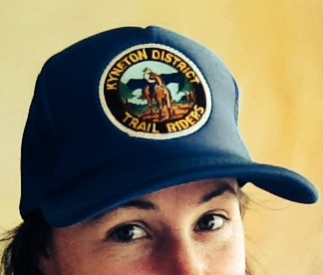

Important notice about rides in the fire session:
Just a reminder that during our summer rides this year – members must remember if the day of the ride is classified as a “Code Red Total Fire Ban” then the ride will be cancelled.
Also, it is at the ride leader’s discretion if they feel it is unsafe to ride on “Total Fire Ban”, Day the ride will also be cancelled – lead riders will be available to be contacted if any persons are unsure. During the clubs summer rides it would be appreciated if all riders could refrain from smoking whilst out in the bush as an added safety measure.

KDTRC 2015 MEMBERSHIPS

If you haven’t already completed a KDTRC 2015 Membership Form and new waiver Forms to become a member please, contact me & I will forward these forms to you ASAP.
All memberships commence from the 1st January 2015.
ATHRA $80.00
KDTRC $25.00
TOTAL $105.00

To ride out on a club ride the fees are:-
ATHRA members pay $5 and non-ATHRA day – visitors pay $25.
Contact Julie or Amy via phone details on the first page of this newsletter for membership queries. Membership forms and waivers are on the KDTRC facebook page for printing or grab a copy off Amy or Julie on the next ride. Completed forms and payment can be mailed or handed to KDTRC Treasurer Julie Samson 525 Springhill Rd Springhill 3444 or simply pay directly into KDTRC account: WESTPAC - BSB 033234, ACCT NO: 561506 & then let Julie know either by writing what amounts have been paid on the forms posted to her or by emailing her at juliesamson@westnet.com.au

KDTRC Ride report - March 2015 – Hepburn Springs
The weather was a lovely sunny 25 degrees as we headed out from Mount Franklin for our March ride. We had 10 riders including a KDTRC first timer, local girl Mel Sutton and her lovely Standy – Prince (it was great to meet you Mel!) and visiting from Baringhup Trail Riders was Deb from just down the road in Newstead (love that float Deb!). We headed a short distance up the road before crossing over into the Hepburn Regional Forest, following old miners’ tracks and then heading into the bush for some cross country following a kangaroo trail. All horses managed the at times, steep descends and negotiated the terrain very well. We crossed Mannings Rd, looking at the views to the North across Elevated Plains, before returning onto a mountain bike track through the forest. We passed old mullock heaps and rode along gullies before reaching Hepburn Springs.
We rode through the Spa House car park and up to the reserve were our lovely non riders (sorry Julian for stealing your horse for the day!), had cooked up a fabulous BBQ lunch for us. After lunch we headed along a long uphill ridge east and some of us had a little trot and canter to let the horses stretch their legs. We then did some more cross country heading through a steep gully with some tricky stairs (which all horses and riders handled very well), rode past an old mine (much to the delight of Garry who checked it out for us), and then came out of the bush at the Chocolate Mill for some tasty treats!
We covered a total of 21km.
Thank you to Jo for being drag, Julie for doing the paperwork and for our fantastic non riders for cooking up a storm for lunch – Julian, Meredith & James. The pressure was on for me, hosting my first ride but it all went well in the end. Thanks all for coming and making it such a great day!
Amy G

Update from Hilary and her adventures across the great southern land!
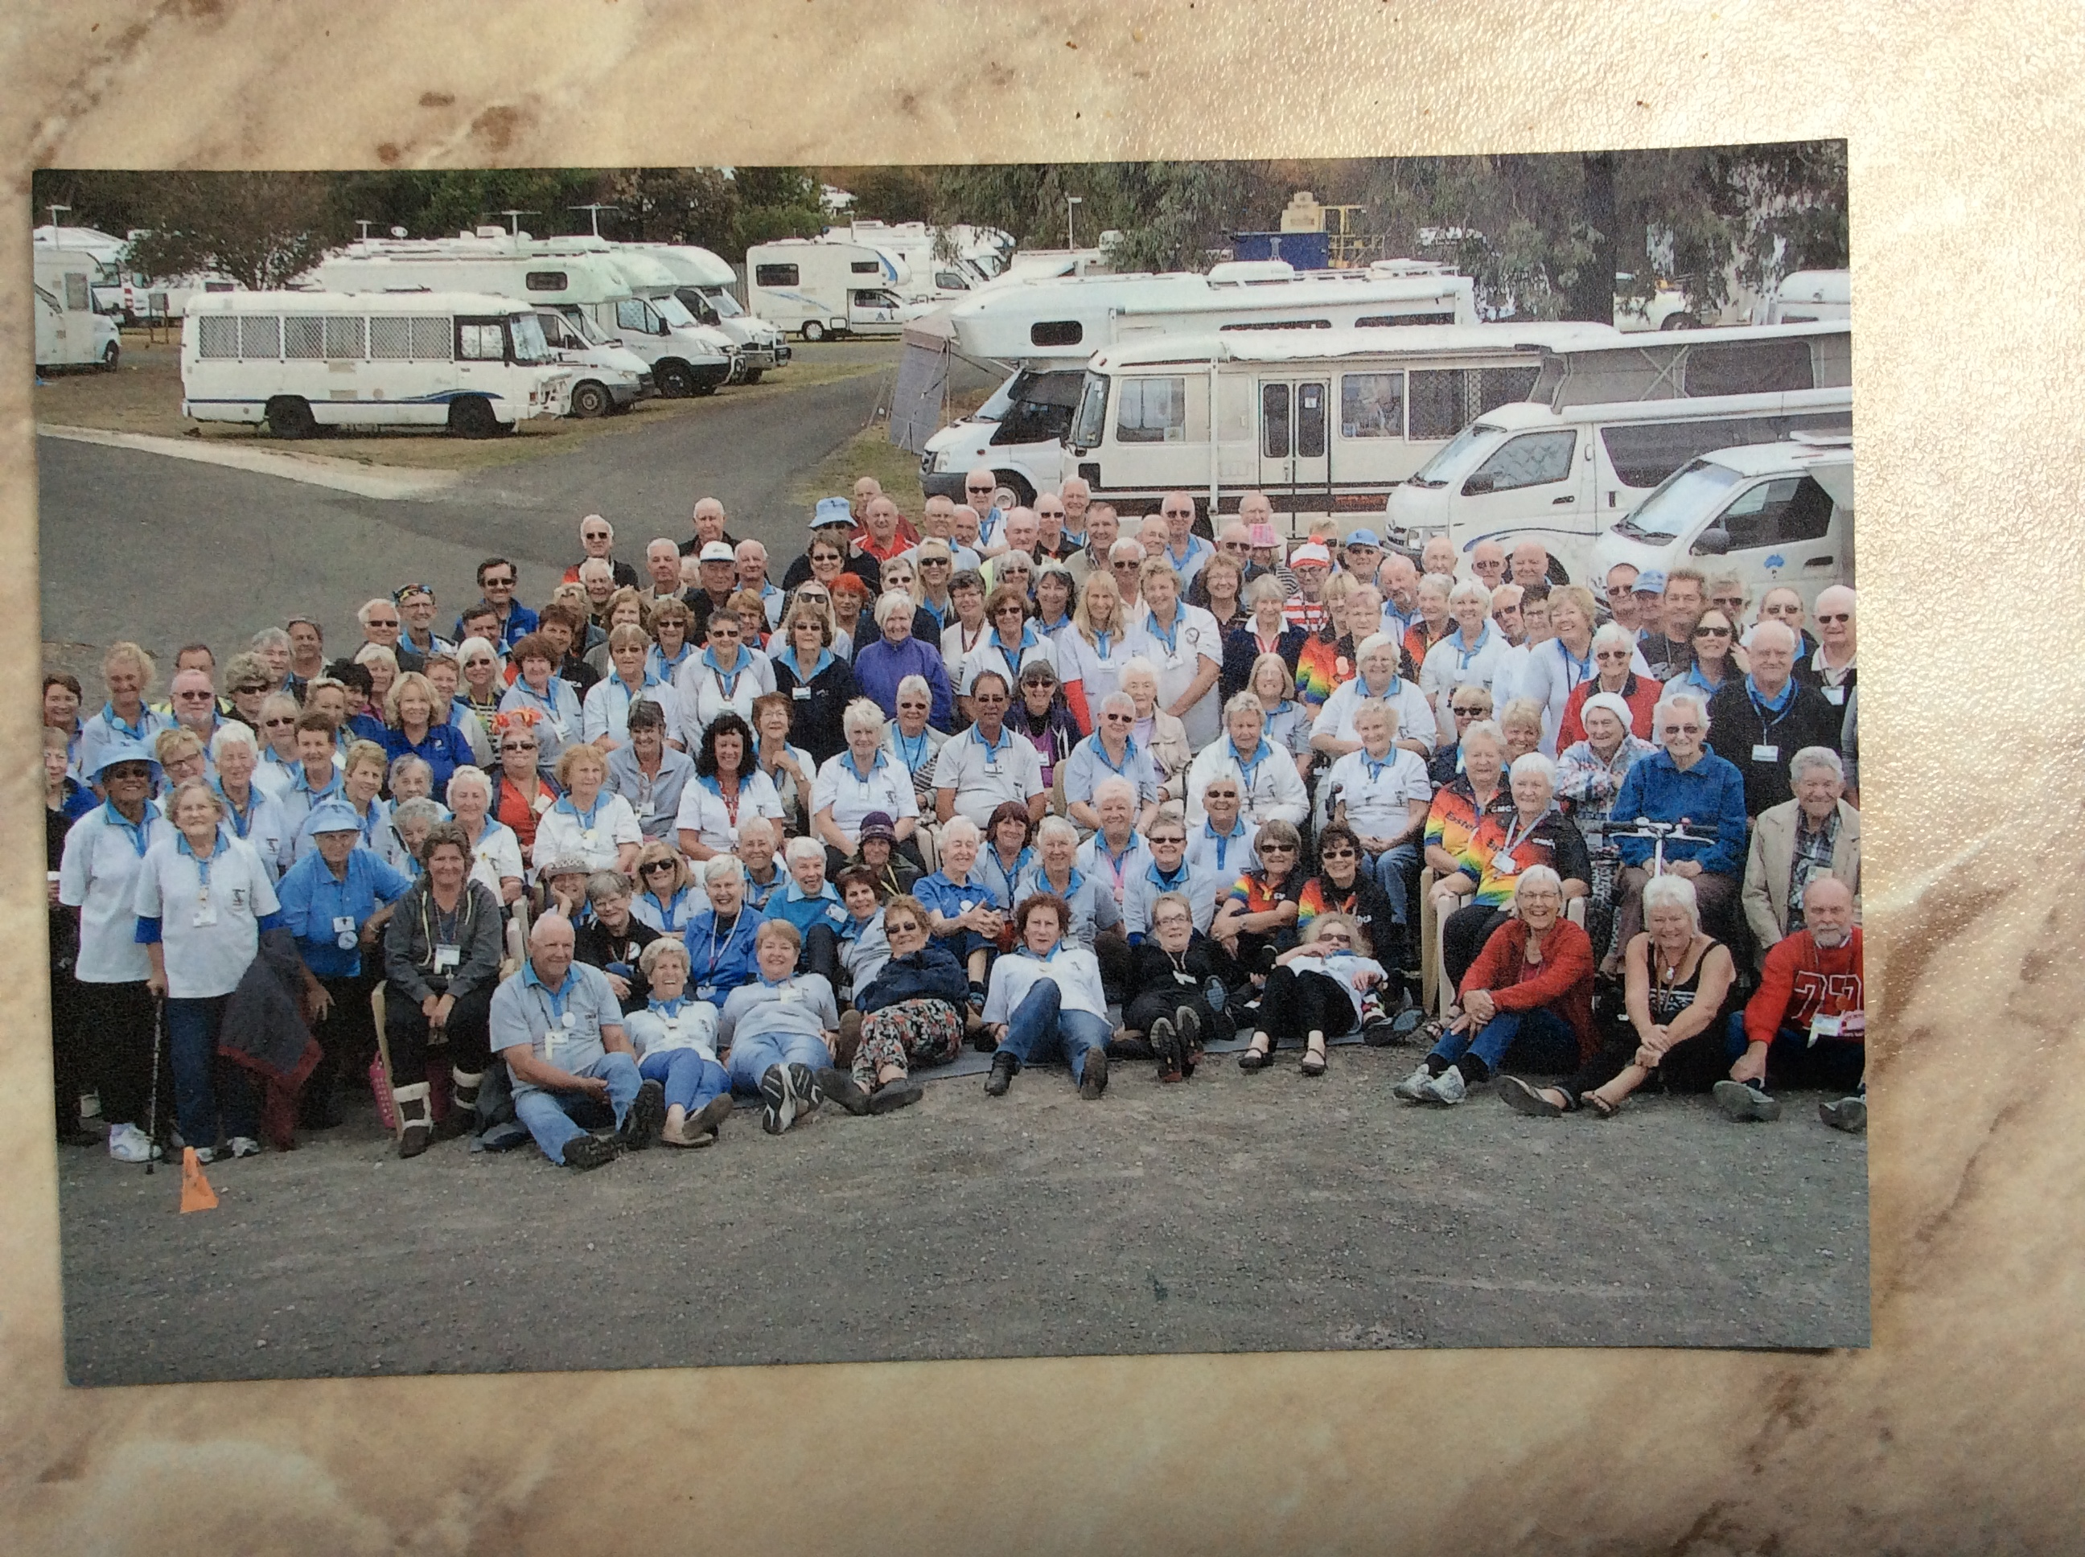
This is what Hilary Brimley is up to.... after passing her horse onto a new home, selling her float etc. , Hilary is embarking on a 8 month campervan tour around Australia; she's currently working her way through South Australia and will visit NT and WA before returning to Victoria by the end of this year. We wish her all the best! (She is the one sitting on chair third row 7th on right).

NEXT RIDE: KDTRC Macedon Ride – lead by Jo Garner

Where - Shannon Court, Woodend.

When - 10am sharp ride out time.

Directions – Starting from Shannon Court, Woodend. Shannon Court is 3 km south of Woodend on Black Forest Drive. If you are coming from Woodend, it's after the OLD Black Forest Sawmill on the LHS. Coming from Gisborne/Macedon, take the first Woodend exit off the Calder Hwy and its 3km along on the RHS, just after you pass the Spencer Rd sign on the LHS.

Sign in – COME & SEE JULIE TO SIGN IN.

Ride – We will go along quiet bush-roads, under the railway bridge and then on fire-tracks to the top of Mount Macedon where we will have a lunch at the Mount Macedon Pub. (You may invite your non-riding family/friends to join us there about 12.30.) Ride back through the pine-forest; should get back to Shannon court about 3.30 - 4 o'clock.

Conditions – Suitable for all riders who can manage 20 km and horses with suitably conditioned feet (there are some rocky bits).

Bring - Bring a drink for yourself for the ride, money for lunch (meals vary from $10 - $30), halter and lead rope. (There are plenty of tying up areas and a disused fenced tennis court).

Please let Jo know if you will be coming by texting her or RSVP to the Macedon Ride event on the KDTRC page on Facebook. Any queries about the ride, please call Jo on 5427 2257 .

For any advertisements, etc... Which you would like to have published in the KDTRC newsletter – please contact Amy G on 0408 342 990.

______________________________

