February 2019 Newsletter
Club Postal Address
P.O. Box 55
Gawler SA 5118
athra.com.au Email: Gawler.THRC@gmail.com
President - Julie Jackson 0419850793 Vice President -Tamara Godfrey 0417869695 Treasurer - Sandra East 0400884402 Secretary - Kath McCullagh 08 82807046
General Committee Maria Pearce & Lisa Rothe

GENERAL MEETING (1st Thursday of the month) 8pm Thursday 7 February 2019

All welcome Southern Hotel (next to Cafe Nova)
Come early for tea – 7pm

Members for 2019 Welcome
Welcome Back to Re-joining Members
Richard Grimson of Rosedale, Sandra East of Gawler Belt, Sandra Jones of Leisingham,
Tamara Godfrey of Hillbank, Teena Goodson of Cockatoo Valley, Maria Pearce of Sepeltsfield,
Yvonne Bryant of Gawler River, Gayle Bates of Gawler, Melissa Simmons of Waterloo Corner,
Kelly Phillips of Williamstown, Karen Suhrcke of Eudunda, Rebecca Laight of Willaston,
Lisa Rothe of MacDonald Park, Lynette Richter of Gawler South
& Lisa Bates of Williston
& hope you continue to enjoy many days of riding (& socialising) with the club

Coming Events
BEACH RIDE – Pt Parham Beach – Sunday 10 February 2019
Host & Boss– Sandra East phone 0400884402 RSVP to Gawler.THRC@gmail.com by 7 February
Ride time > 7a for 8a start

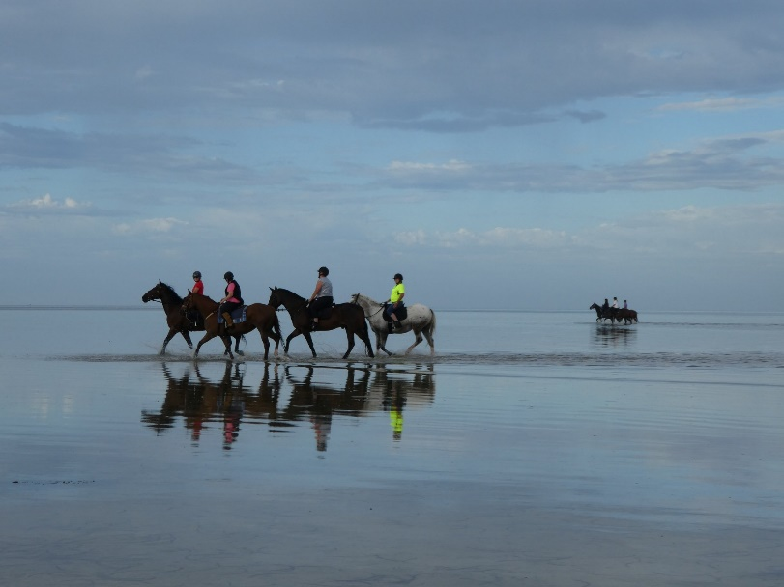
Ride Description: - This ride will give an opportunity to ride along the beach & in the water also as the water at high tide is shallow for a long way out & the high tide is at 8a (2.32m) & low tide 2.16pm (0.27m) so we should have plenty of time in the water (at low tide the water is out a long, long way)

CAUTION - Do not pass the causeway on the Northern end of the Beach – this is a restricted area.
Horses are permitted elsewhere on the beach all day so you can stay for as long as you like.

A BBQ breakfast again after – so please BYO & join in.
As usual - All manure and hay MUST be removed prior to departing for home.

Ride Grade: Hazards may include crabs, seaweed & some mud. Terrain is flat & wet (lol). All paces are possible. It is a really good introduction to water & the beach for the horses before you attempt the waves at Osborne Beach .

Directions Port Parham
– Full Directions to be sent to those that RSVP to Gawler.THRC@gmail.com

Cost- ATHRA member $2 Ride fee. Non ATHRA member riding visitor fee $25/day (please be advised that if you are not a member of ATHRA you will need to be sponsored by an ATHRA member to ride & pre-register as a day member 3 days prior with ATHRA online - $15 direct to ATHRA & $10 to club on the day). Please bring the correct change & place in tin at sign on book.

DRAFT - RIDE CALENDAR FOR 2019 host MEETING DATES 2019
Rides are usually held on the 3rd weekend (Sunday calculated) & 5th Sunday of the month (if there is one).
Camps held ~1st or 5th weekend of the month (negotiable) Meeting dates are held on the 1st Thursday of the month

The following is a work in progress – dates, location & hosts to be continually confirmed
Please nominate a date if you have nominated to host rides
& MANY More rides needed to complete the calendar

Jan 19 | Moonlight Ride - Gawler River | Julie | 3 Jan
Feb 10 | Pt Parham | Sandra E | 7 Feb
March 17 | Beach Ride - Osborne | Tamara | 7 Mar
March 31
April 14 | Trail Challenge Day Cockatoo Valley | Di S | 4 April
May 18/19 | Kapunda | Sandy | 2 May
June 16/17 |  |  | 6 June
June 29 & 30 | Belvidere Camp | Richard
July 20/21 |  |  | 4 July
Aug 17/18 |  |  | 1 Aug
Sept 14/15 | Leasingham | Sandy | 5 Sept
Sept 27-30 | Camp – Southern Flinders? | Kath
Oct 19 & 20 | Owen Camp & obstacle day | Julie J | 3 Oct
Nov | Forest Ride/Camp – Kuitpo (not 16-17/11) | Laine | 7 Nov
Dec 7 (Sat) | Christmas Dinner (TBC)
Dec 14/15 | Christmas ride (TBC)

Past Events
January Moonlight Ride: Gawler River – Saturday 19 January 2019 - by Julie Jackson
We could not have chosen a more perfect date for our most recent moonlight ride on the 19 of January.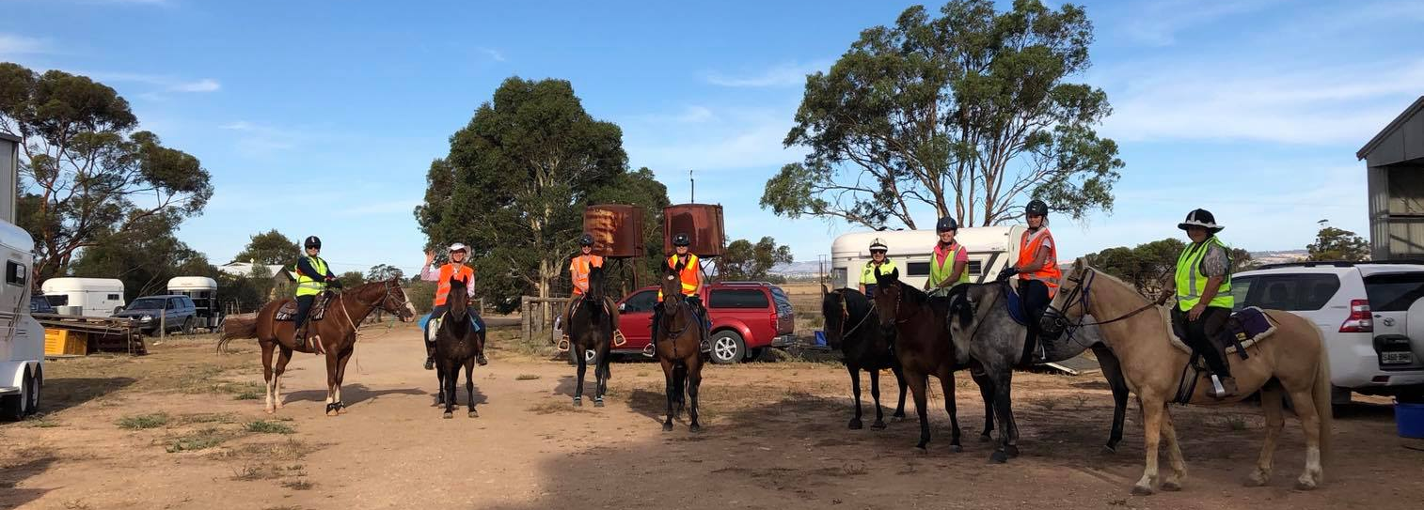
Riders were Melissa, Yvonne, Rebecca, Lynette, Teena in the cart, Mar, Lisa L, Sandra East, Gayle, Lisa B, Lisa R, Sandy and myself.
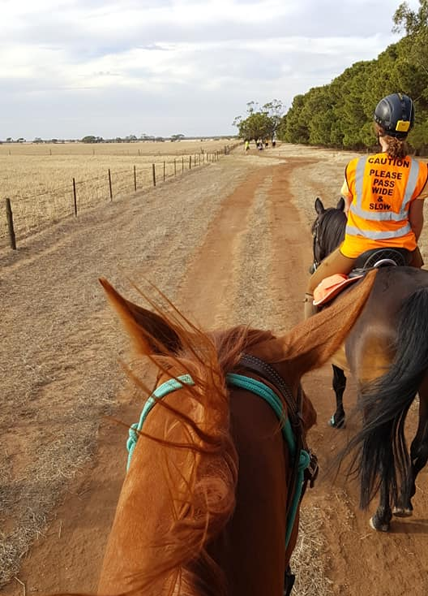
Just a few came for the BBQ and thanks to William for cooking it and the girls who bought salads and Melissa for the lovely cake.Just as I finished the briefing Kathy and Tamara came and took some pictures and farewelled us on our journey.

Teena led the way up the drive and out the gate. We were met up at the main road by our traffic wardens Grant and William who got us safely across. I did this ride back to front from the one we had earlier and it was most enjoyable. Well into the ride I offered them the chance of a trot and half of the ride had an enjoyable trot and a canter. Some of us stayed back and just walked as 1 or 2 horses got a bit excited. Poor Bec’s horse was not used to being at the rear of the ride and got a little excited so she ended up walking him home. Again the boys escorted us safely across the main road and we were homeward bound.

The moon came out whilst we were riding and the evening was beautiful a slight breeze and lovely temperature we were so lucky as it had been a hot week. We saw a few roos in the distance at one stage but they were busy grazing and did not worry us.

We all had our reflective vests and torches but did not really have to utilize them as we had no traffic other than when we had to cross the main and the 2 way radios were carried but again there as a precaution but a very important part of our equipment along with the first aid bags. Very good idea and glad they were found.

A few riders stayed back for tea, coffee and cake the rest went home as some had a long way to go.
Thanks to all riders who came and again made it a very enjoyable night out.

2019 MEMBERSHIP APPLICATIONS & FEES
Membership for 2019 is due = Adult/Family $110, Junior (under 18) $50, Social (non riding) $40.

Please join online via ATHRA.com.au
- Membership of Gawler THRC can only be made online
- When re-joining have your current member number to hand & select Member Login and Renewal (the committee can assist if your unable to find your member number).
- ATHRA no longer mails membership cards, so keep a copy (screen shot) of your renewal to show membership if needed (i.e. riding with another club).
- New, renewing and day member notification emails are sent to Club contacts, so that each Club is aware of membership transactions.
- Family Membership for 2019 is now available ONLINE. A Family in this regard is one adult riding member who is the parent or legal guardian of one riding child. ATHRA has waived the junior/child member fee to lower the overall cost for families and encourage more members to join.
- When completed can you please help us by letting us know the PIC # of where your horses are kept - we need this information when completing forms but this is not available from the ATHRA web site.
N.B – you can change your member details at any time by updating via your membership profile on ATHRA online.

Reminder - If you did not renew before February you have been removed from this "members only" page but will still be able to access the "Gawler trail horse riders club" page. You will be reinstated to “members only” once membership is received
See you out there for another exciting year of socialising & riding in our great state🐎

CLUB UNIFORM
Just a reminder to all Members – Our club uniform currently comprises of a lime yellow high-vis shirt (long or short sleeve). This is to help promote the safety of our riders especially whilst riding in shared zones such as on roads.

Club Badges are available for purchase by members $12 each (& yes you can have more than 1). They are available with the sign in book – take your badge from the bag & place your money in the badge bag. You can put your badge on your high vis top or even on your Saddle blanket – it’s up to you.

Can members please look to wear the club uniform at all club rides (on & off road), & whilst it is not mandatory it is preferred & is a good promotion for the club. A lime yellow high-vis safety vest is also suitable to be worn in place of a shirt or over the top of other gear (& visible in all weather).

Club members & their visitors are required to wear Safety Helmets whilst mounted - helmet must comply with S/NZS 3838:2006 safety standard and be no more than five years old. When buying a helmet always check the date of manufacture as this determines the age of the helmet.
Horse Health & Wellbeing

Stemming the Stink - Extract from Thehorse.com
In summer months, urine and manure smells from gravel or sand paddocks can get pretty intense and bothersome. Plus, studies show that breathing ammonia is unhealthy for horses and humans alike. Here are some tips for controlling odors in your confinement area.
The most important thing is to start with healthy soils and good topography before you put down footing. Don’t begin by dumping gravel or sand on top of muck or in a low, wet area and then wonder why it smells bad. Be certain the surface has a good, even slope. Any depressions in the underlying soils, however slight, can cause water and urine to pool under the gravel, potentially causing odors.
Next, a good manure management program will go a long way toward avoiding odor issues. Pick up manure on a regular basis in all confinement and high-traffic areas.
Still smell funky? The simplest and cheapest solution might be to drag or harrow the confinement area. This helps aerate the footing, allowing aerobic microbes to flourish and break down organics.
A variety of useful products are also available that you can spray or sprinkle on urine spots to neutralize odors. Two examples are:
- Beneficial microorganisms These microbial sprays contain “friendly” bacteria, enzymes, and/or fungi. They come in concentrated solutions that you dilute with water and spray onto smelly paddock areas using a garden sprayer. Beneficial microbes break down ammonia and organic material that cause odors and attract flies. You can apply these safe solutions as often as necessary and before or after rainfall. They are available at organic garden supply companies or in horse supply catalogues.
- Zeolite products Zeolites are naturally occurring minerals found in clay that bind with ammonia in urine. Many stall deodorizer products, which look like finely ground kitty litter, contain zeolite and are sold at feed and supply stores.

NEWSLETTER DEADLINE
The deadline for any items that members want printed in the March 2019 newsletter will be Thursday 21 February so please ensure that your emails reach Kath kathryn.mccullagh@hotmail.com before that date to avoid disappointment.

Policies
A reminder to all members that our club has some policies that we endorse. These include a NON SMOKING, SAFETY & HOT WEATHER policy. These can all be viewed on the ATHRA web site, via the state page - www.athra.com.au.
Previous Newsletters, photos & club information can also be viewed at any time on the ATHRA web site.
WEATHER
The ride host/leader for the day will have the final say regarding weather (including inclement weather).
The hot weather policy states, if the weather forecast in ELIZABETH for the next day is to be over 32 deg (as per the news the night before) the club rally/ride will be cancelled (unless the ride is scheduled to commence prior to 9am or after 6pm). This is for the safety of all riders and horses. Also, any club rides in FOREST areas on TOTAL FIRE BAN days will be cancelled.
Please check with the Trail Boss if in any doubt. They have the final word!
CLUB UNIFORM
Our club uniform currently comprises of a lime yellow high-vis shirt (long or short sleeve), club badges available for $12. Gawler Club Members & their visitors are required to wear Safety Helmets whilst mounted - helmet must be no more than five years old from Date of Manufacture.
RIDE FEE & DAY MEMBERS
ATHRA members - a ride fee of $2 per ride is applicable.
Non ATHRA Members (Day Members) – a ride fee of $25/person/day is applicable ($10 to club on the day & $15 to ATHRA with pre-registration) (Non-refundable fee, maximum 2 days as a day member).
The important things to note: 1. Day Members must be sponsored and accompanied at all times by an ATHRA member during the ride or event.
2. The Sponsoring member must make the Day Member aware of ATHRA rules and requirements of the Code of Conduct.
3. They may only sponsor 1 Day Member per ride.
4. By participating as a sponsor, the sponsoring member acknowledges responsibility for the conduct and behaviour of the Day Member
5. Day Members must contact the trail boss to discuss attendance & then pre-register with ATHRA Online at least 3 days prior to ride.
RIDE HOST CHECKLIST
A ride host’s checklist is in the green bag, in which is kept the sign in book, ride fee tin, saddle bags, first aid kits, safety vests, etc. Trail Bosses are to check the list to make sure all is in order prior to your ride. It is also the Hosts responsibility to ensure a ride report is arranged to be submitted to Newsletter Editor prior to next publication date.

DISCLAIMER
The material in this newsletter is for the benefit and information of our members. The items are in the nature of general comments only and are not to be used, relied or acted upon without written permission of GTHRC. The club accepts no responsibility for any errors or omissions or for any damage suffered as a result of any person acting without written advice. All opinions and views in the newsletter are not necessarily the view of the club, but are personal opinions only.

