President: Alison Swindale – 0427 671 240
Vice President:
Angela Witherdin – 0418 234 854
Secretary: Francie Maclean – 0407 660 334
Treasurer: Donna Smith – 0429 642 351
Newsletter:
Helen Woods – helenwds@gmail.com

Save the date
Christmas Party
Date: 23rd – 24th November 2019
Venue: Nundle Pony Club

July Ride
Date: 28th July 2019
Venue: To be advised

Future Rides
Currently, we do not have ride locations for the following dates:
28th July
25th August
22nd September
27 October
24th November

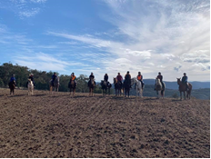

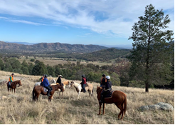

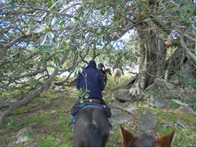

Ride Report
This month by Sally Hawxwell
This was my second ride with the Tamworth Bushrangers and again it was an absolutely, super day. Lovely weather, divine venue, and down to earth, fun loving group of people who love horse riding.
Francie and Duncan’s property and the neighbouring properties we rode on were simply magical. Superb Granite sculptures, watched over by ancient fig trees, paddocks and bushland, birds and kangaroos, a real aboriginal presence there and a sad history, (Makes me really want to know more)
Easy, happy riding. What more could one ask for on a Sunday?
Francie and Alison were the "Hosts with the Most". and we finished the day with a pleasant lunch under the Giant Kurrajong Tree with the beautiful valley echoing outrageous laughter.
Thanks everyone. It was good for the soul. Sally

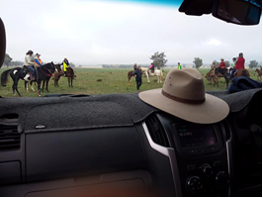
Trail Boss Ride Report
Roslyn - Big Sky Trailblazers Horse Riding Club, Gunnedah
A big weekend was enjoyed by all who attended the Trail Boss Course held over the Queen’s Birthday weekend at the lovely Trewlawny Station just outside Somerton.
Excellent facilities were made available to all. Pam Lamshed was our accredited trainer for the weekend and made sure we were all aware of what was expected from us to achieve a pass for the course. Well done to Pam.
Thirteen riders took part in the very in-depth course which covered so many aspects of all that is required to guide folks through a safe and enjoyable ride. The weather held off for us and wasn’t too cool each early morning start time.
The facilities were terrific with well maintained bunk houses, kitchen area and a conference room for our classroom exercises. Our ridden section wasn’t too difficult, and most had no problem with the requests made by Pam.
Out on the trail riding course which was well handled with a few of us having to provide real life scenarios so we could all learn how to handle different circumstances. We all got through with flying colours.
Everyone was very supportive of each other.
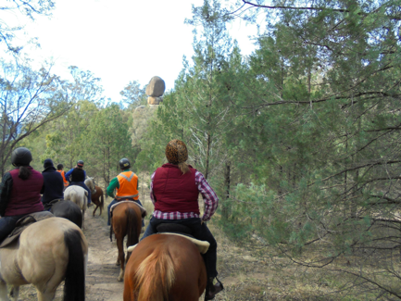
Note from Editor
Following his successful accreditation to Trail Boss/Ride Coordinator status Level 1, Kevin Paddison of Gunnedah Club debuted as trail boss and led Tamworth’s Bushrangers on their June ride.
Congratulations and well-done Kevin.
Francie also achieved Trail Boss/Ride Coordinator status Level 1. The only member of Bushrangers to apply.

FAREWELL
Best wishes to Bushranger member Clayton who with wife Vicki and magnificent gelding Cruise recently moved away to the Hunter.
We will miss Claytons expertise on the trail and Vicki’s excellent skills as a provider of yummy treats.
Take care Clayton and keep in touch when you can.

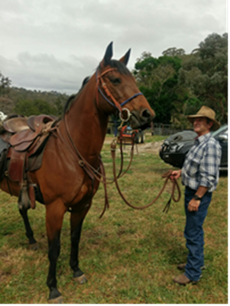

GETWELL
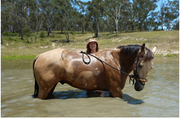
Thoughts are with our beloved and most treasured, treasurer Donna, who injured herself whilst bush walking. We wish Donna a speedy recovery xxx
PS Best to stick to horse riding I think!!

